

Requirement & Design Specification

**Eyespire**

**Version: 2.1**

– Da Nang, June–2025

# Record of Changes

| **Version** | **Date** | **A* M, D** | **In charge** | **Change Description** |
| --- | --- | --- | --- | --- |
| V1.0 | 05/24/2025 | A | AnNV | Add Use Cases |
| V1.0 | 05/24/2025 | A | TuanCM | Write II.1 - Product Overview |
| V1.0 | 05/24/2025 | A | MinhNPH | Write II.2.2.2 - Actors - Uses case - Descriptions |
| V1.0 | 05/30/2025 | A | PhuongTDD | Context Diagram |
| V1.0 | 06/02/2025 | A | PhuongTDD | Add UC 01 to UC 11 |
| V1.0 | 06/02/2025 | A | LuongTT | Add UC 45 to UC 57 |
| V1.0 | 06/02/2025 | A | AnNV | Add UC-34 to UC- 44 |
| V1.0 | 06/05/2025 | A | MinhNPH | Add UC-23 to UC-33 |
| V1.0 | 06/05/2025 | A | AnNV | Add 5.1 Business Rule |
| V1.0 | 06/06/2025 | A | PhuongTDD | Add 2.2.1 - Use case diagram |
| V1.0 | 06/06/2025 | A | PhuongTDD | Add 3.1.1 Screen Flows |
| V1.0 | 06/06/2025 | M | PhuongTDD | Modify Context Diagram |
| V1.0 | 06/06/2025 | A | PhuongTDD | Add 3.1.2 Screen Description, 3.1.3 Screen Authorization, 3.1.4 Non-screen Functions |
| V1.0 | 06/06/2025 | A | LuongTT | Add 3.2.2 View Patient Appointments, 3.3.1 View Work Schedule, 3.4.1 View Medical Record, 3.5.1 Patient Record Screen, 3.12.2 Customer Feedback Screen |
| V1.0 | 07/06/2025 | A | PhuongTDD | Add 4. Non-Functional Requirements |
| V1.0 | 07/06/2025 | A | PhuongTDD | Add 3.2.1- View My Appointments and 3.4.2 - My Medical Record |
| V1.0 | 07/06/2025 | A | LuongTT | Add 3.1.5 Entity Relationship Diagram |
| V1.0 | 07/06/2025 | A | LuongTT | Add 3.15.1 Personal Profile Screen(Doctor) |
| V1.0 | 08/06/2025 | A | PhuongTDD | Add 3.4.2 My medical Record, 3.8.1 My payment history. Add 5.2 Common Requirements, 5.3 Application Messages List, 5.4 Other Requirements |
| V1.0 | 08/06/2025 | A | MinhNPH | Add 3.2.3 View Patient appointment (Admin Dashboard Screen), 3.3.2 Manage Work schedule (Admin Dashboard Screen), 3.7.1 View users, 3.12.1 View personnels, 3.13.1 View Services, 3.14.1 View statistics, 3.15.3 Personal Profile Screen (Admin) |
| V1.0 | 08/06/2025 | A | AnNV | Add 3.9 Store Management, 3.10 Message, 3.11 Feedback |
| V1.0 | 08/06/2025 | A | TuanCM | Add 3.2.4 View Patient appointment (Receptionist Dashboard Screen), 3.3.3 Manage Work schedule (Receptionist Dashboard Screen), 3.10.2 Send Message (Receptionist Dashboard screen), 3.10.2 Send Message (Receptionist Dashboard screen), 3.15.2 Personal Profile Screen (Receptionist) |
| V1.0 | 08/06/2025 | A | TuanCM | Add UC 12 to UC 22 |

*A - Added M - Modified D - Deleted

Table of Contents

Record of Changes 2

I. Overview 11

1. User Requirements 11

1.1 Actors 11

1.2 Use Cases 11

2. Overall Functionalities 26

2.1 Screens Flow 26

2.2 Screen Descriptions 30

2.3 Screen Authorization 37

2.4 Non-UI Functions 39

3. System High Level Design 41

3.1 Database Design 41

3.2 Code Packages 43

II. Requirement Specifications 47

1. Authentication 47

1.1 UC-01_Sign In. 47

1.2 UC-02_Sign Out. 51

1.3 UC-03_ Register. 52

1.4 UC-04_ Forgot_Password. 55

1.5 UC-05_View_Profile. 59

1.6 UC-06_Change_Password. 61

1.7 UC-08_Update_Profile. 64

2. Appointment 67

2.1 Book An Appointment 67

2.2 View Appointment List 68

2.3 View Appointment Detail 70

2.4 Update appointment status 73

2.5 Arrange doctor's appointments 73

2.6 Create Doctor’s Work Schedule 76

2.7 Edit doctor work schedule 78

2.8 Filter Appointment List 81

2.9 Search Appointment 82

3. Treatment 86

3.1 Create Patient Records 86

3.2 Update Medical Record 89

3.3 View Record 91

3.4 View Patient Record History 94

4. Order 94

4.1 Add products to cart 94

4.2 View Cart List 95

4.3 Clear cart 98

4.4 Delete products from cart 98

4.5 View order list 100

4.6 View order status 100

4.7 View order details 102

4.8 Create Order 103

4.9 Update order 105

4.10 Delete order 106

5. Discussing 107

5.1 Chat with ChatBox 107

5.2 View Message 110

5.3 Send Message 113

5.4 View Contact List 116

5.5 Search Contact 118

6. Payment 121

6.1 Make Payment 121

6.2 View Payment list 121

6.3 View Payment detail 121

6.4 Make Refund 121

6.5 View Refund List 121

6.6 View Refund Detail 121

7. Feedback 121

7.1 Provide Appointment feedback 121

7.2 View Appointment Feedback 124

7.3 Provide Product Feedback 127

7.4 View Product Feedback 129

8. Medical Service 130

8.1 Create Medical Service 130

8.2 Update Medical Service 132

8.3 Delete Medical Service 134

8.4 View Medical Service List 137

8.5 View Medical Service Details 138

8.6 Search Medical Service 141

9. Store 144

9.1 Search Products 144

9.2 Filter Product List 146

9.3 View Product List 146

9.4 Add Products To Store 148

9.5 Delete Products From Store 150

9.6 Edit Product 151

10. System Management 153

10.1 View User Statistics 153

10.2 View Account Detail 155

10.3 View Useage Statistics 158

10.4 Update Account Status 158

10.5 View Store Statistics 161

10.6 Create Staff--> Send Notification Email 163

10.7 View Appointment Statistics Reports 165

10.8 View Product Sales Statistics 167

III. Design Specifications 170

1. Authentication 170

1.1 Sign In 170

1.2 Sign Out 171

1.4 Forgot Password 174

1.5 View Profile 175

1.6 Change Password 176

1.8 Update Profile 177

2. Appointments 177

2.1 Book an appointments 177

2.2 View Appointment List 178

2.3 View appointment Detail 178

2.4 Update appointment status 178

[2.5 Arrange doctor's appointments   
UI Design 179](#_heading=h.e13ofe27te3a)

2.6 Edit doctor work schedule 179

2.7 Create doctor's schedule 179

2.8 Filter appointment list 179

2.9 Search appointment 180

3. Treatment 180

3.1 Create Patient Records 180

3.2 Update Patient Records 180

3.3 View Records 181

3.4 View Patient Record History 181

4. Order 181

4.1 Add products to Cart Records 181

4.2 View Card List 182

4.3 Clear Cart 182

4.4 View Order List 182

4.5 View Order Status 183

4.6 View Order Details 183

4.7 Update Order 183

4.8 Create Order 184

4.9 Delete Order 184

5 .Discussing 184

5.1 Chat with Chatbox 184

5.2 View Message 185

5.3 Send Message 185

5.4 View Contact List 185

5.5 Search Contact 186

6. Payment 186

6.1 Make Payment 186

6.2 View Payment List 186

6.3 View Payment Detail 187

6.4 Make Repayment 187

6.5 View Repayment List 187

[6.6 View Repayment details  
UI Design 187](#_heading=h.6cv8deoggplc)

7.Feedback 188

7.1 Provide Appointment Feedback 188

7.2 View Appointment Feedback 188

7.3 Provide Product Feedback 188

7.4 View Product Feedback 189

8. Medical Service 189

8.1 Create Medical Service 189

8.2 Update Medical Service 189

8.3 Delete Medical Service 190

8.4 View List Medical Service 190

8.5 View Medical Service Details 190

8.6 Search Medical Services 190

9. Store 191

9.1 Search Product 191

9.2 Filter Product List 191

9.3 View Product List 191

9.4 Add Products to Store 192

9.5 Delete Products From Store 192

9.6 Edit Product 192

10. System Management 193

10.1 View User Statistics 193

10.2 View Account Detail 193

10.3 View Useage Statistics 193

10.4 Update Account Status 193

10.5 View Store Statistics 194

10.6 Create Staff 194

10.7 View Appointment Statistics Reports 194

10.8 View Product Sales Statistics 195

IV. Appendix 195

1. Assumptions & Dependencies 195

2. Limitations & Exclusions 195

3. Business Rules 195

4. .. 205

# I. Overview

## 1. User Requirements

### 1.1 Actors

| **#** | **Actor** | **Description** |
| --- | --- | --- |
| 1 | Patient | Search and view medical service details, book or cancel service appointments, view and download medical records as PDFs, order products, add or remove products from the cart, view order status and details, provide feedback on services or orders, sign in, sign out, view and update personal profile, and change password. |
| 2 | Receptionist | View appointment lists, confirm or reject appointment requests, update appointment statuses, and arrange schedules for doctors. |
| 3 | Doctor | View personal appointments, create, edit, or delete patient medical records, review patient record history, schedule re-examination appointments, sign in or sign out, view and update personal profiles, and change passwords. |
| 4 | Store manager | View and update order statuses, add, delete, or edit product details, view and delete customer feedback on products, sign in, sign out, view and update personal profile, and change password. |
| 5 | Admin | Ban user accounts, create or delete medical services, create or delete staff accounts, view appointment reports and product sales statistics, and change passwords. |
| 6 | Guest | Search and view medical service details, and register for a new account. |

### 1.2 Use Cases

#### a. Diagram(s)

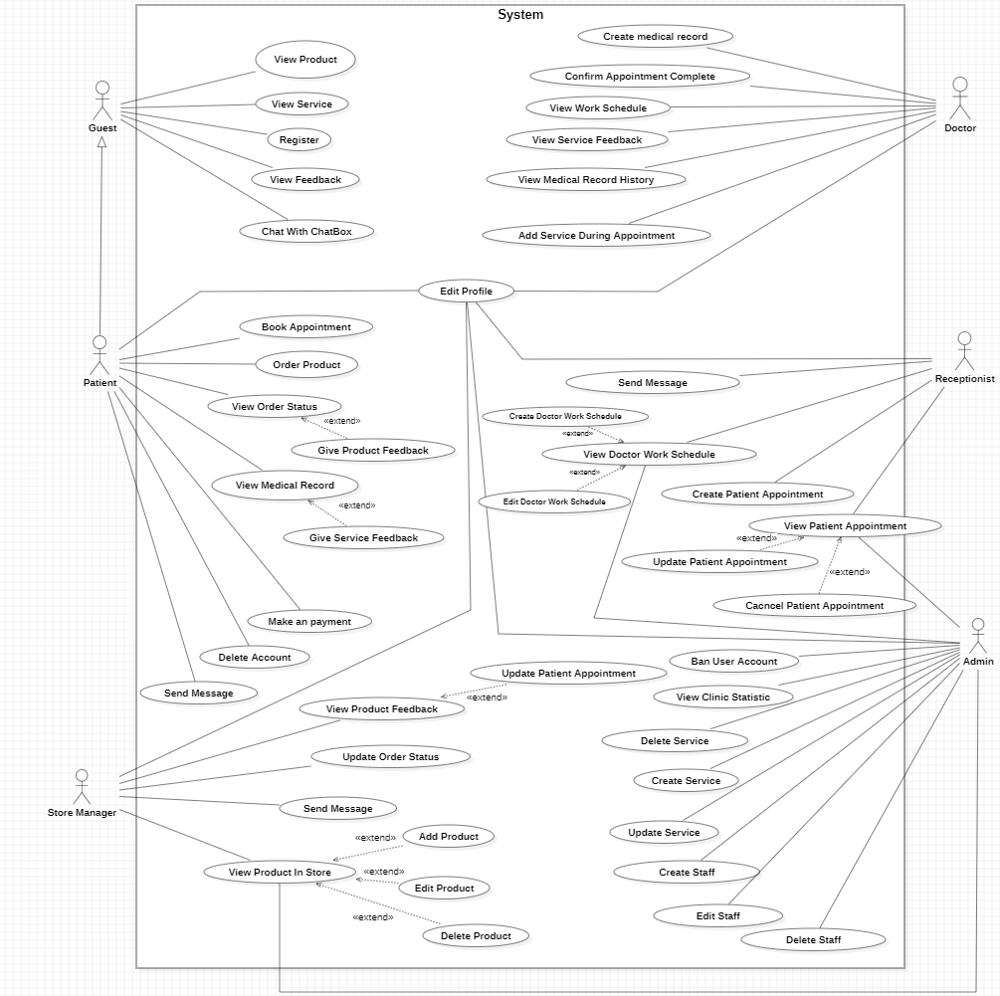

**Authentication**

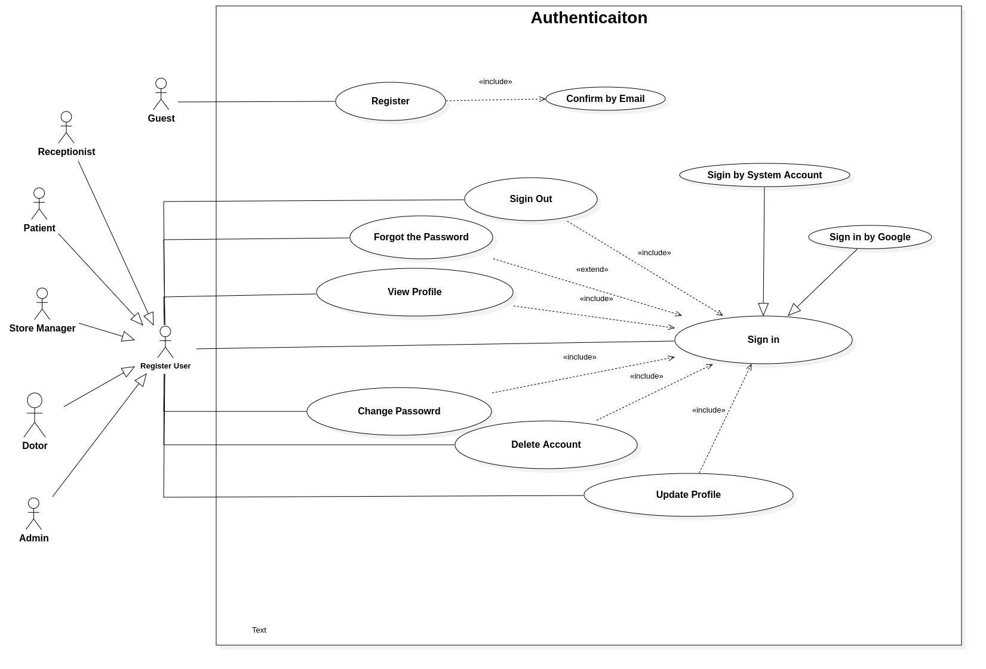

**Appointment**

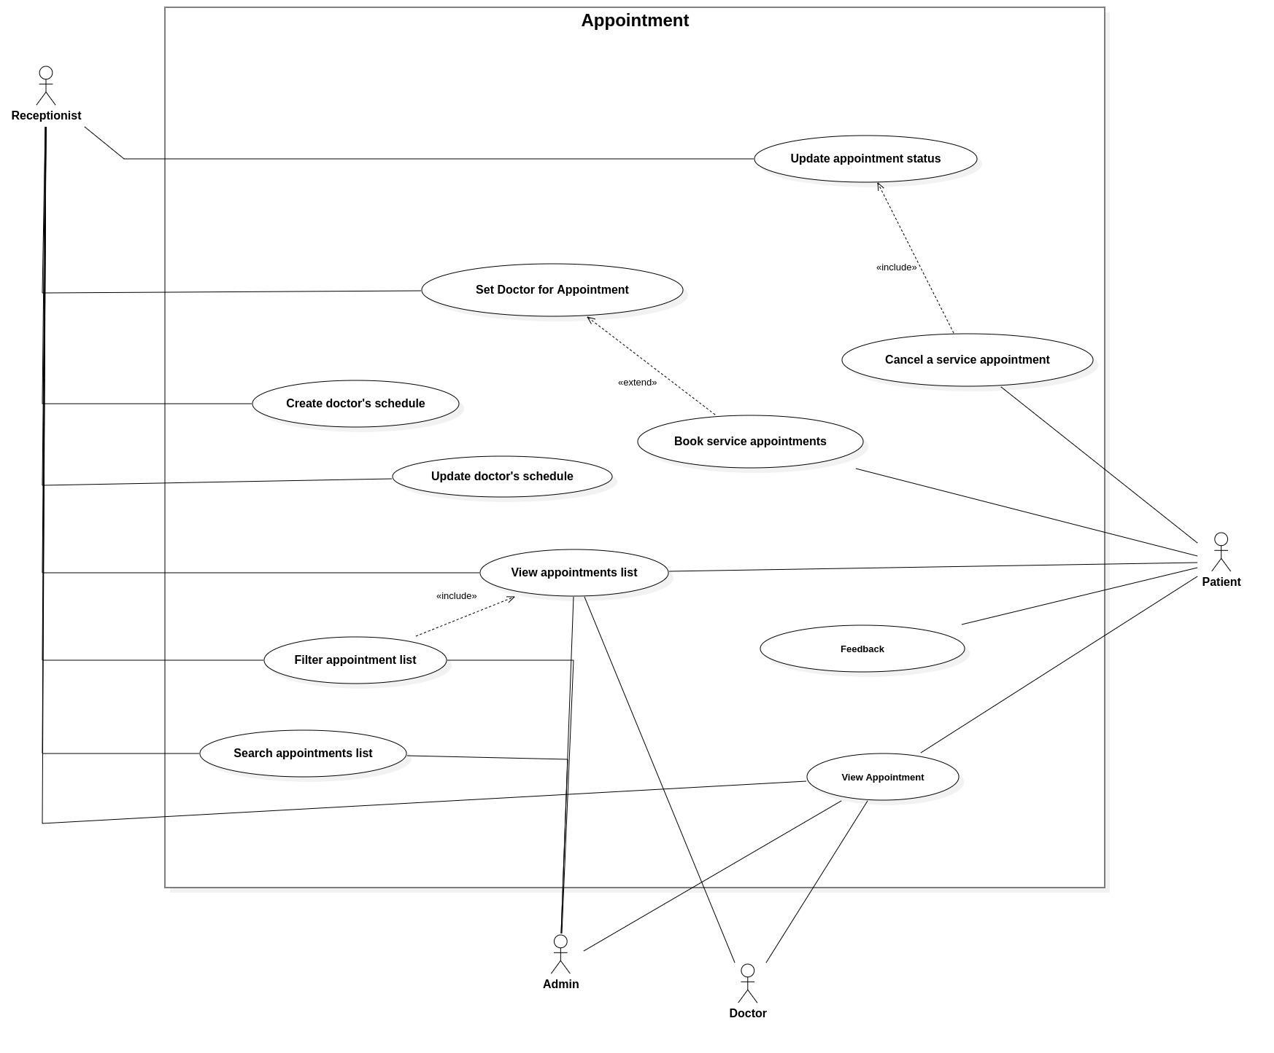

**Medical Service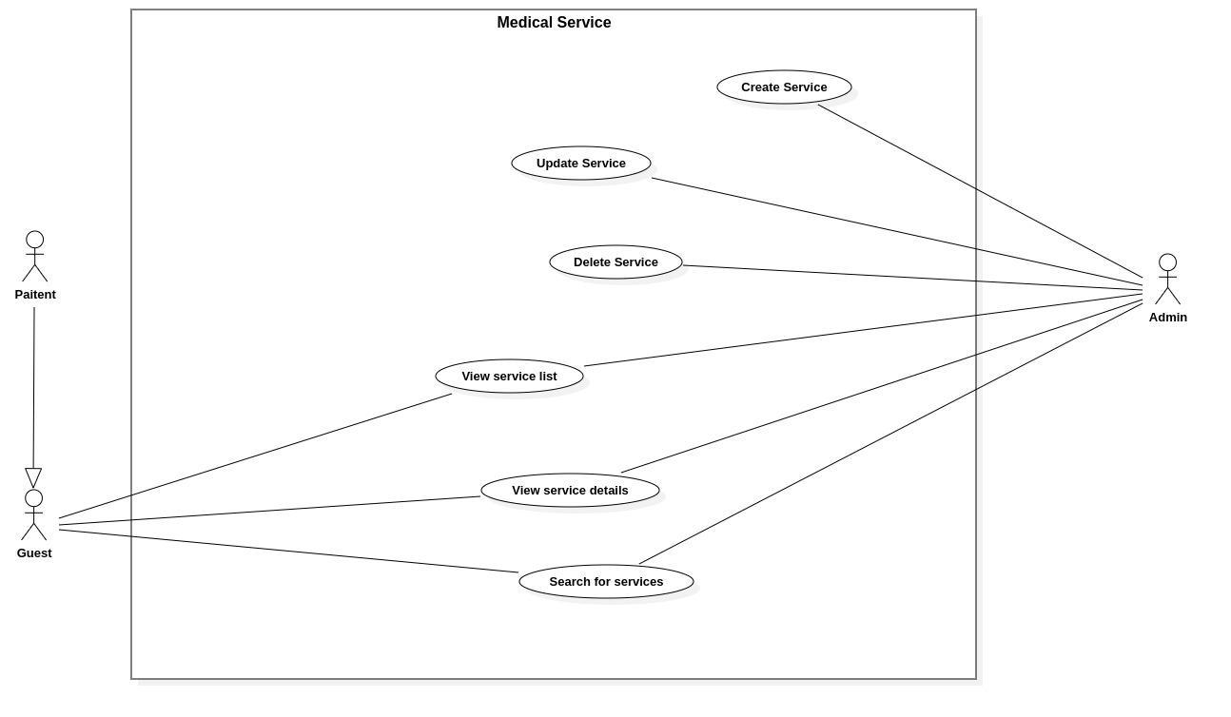Shopping & Ordering**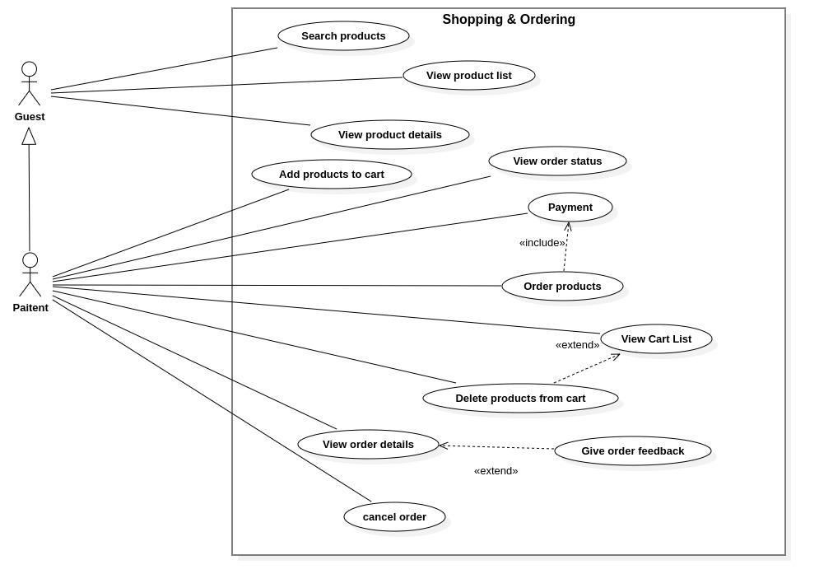

#### **Store Management**

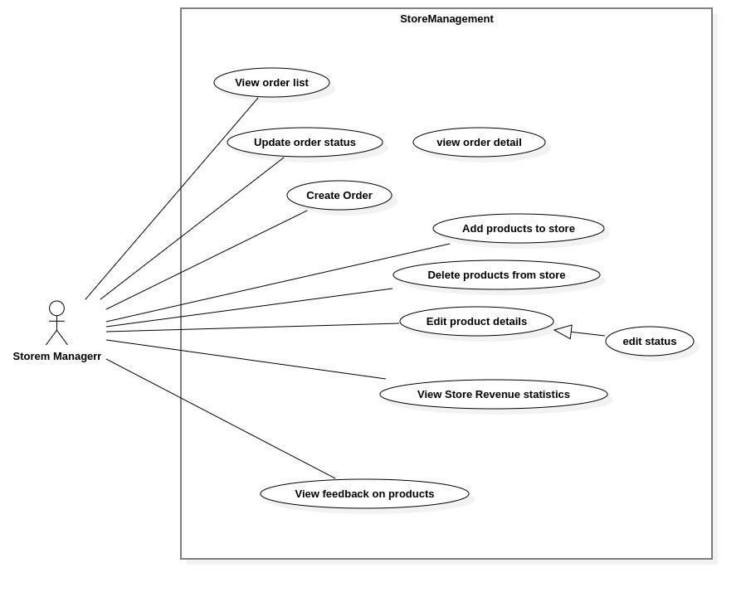

#### **Treatment**

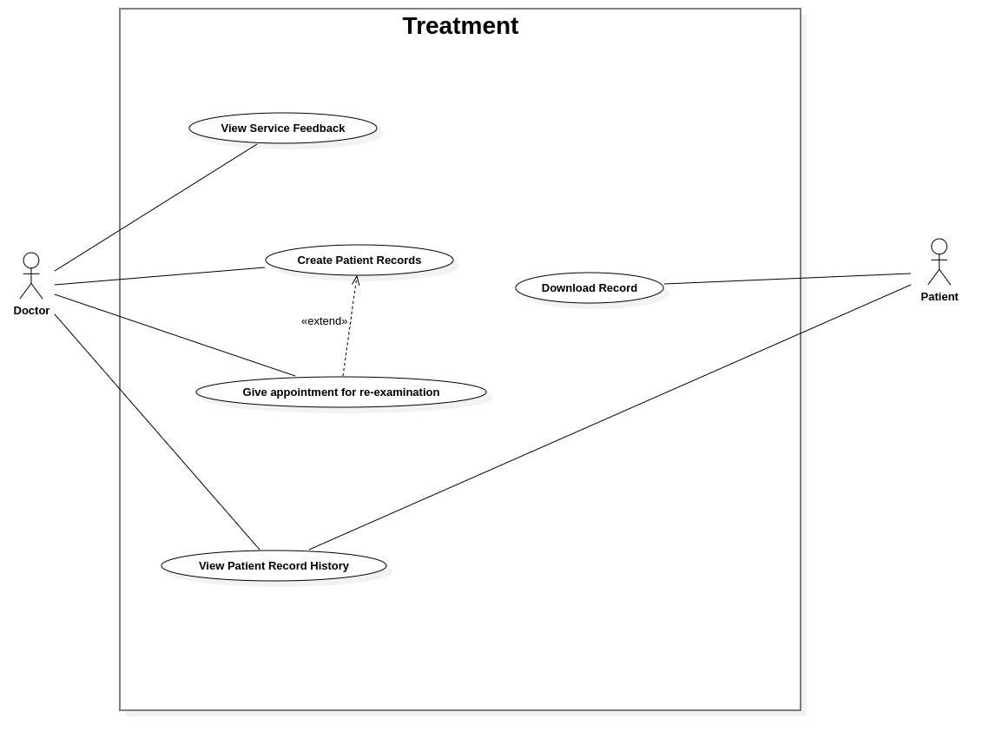

#### **Discussing**

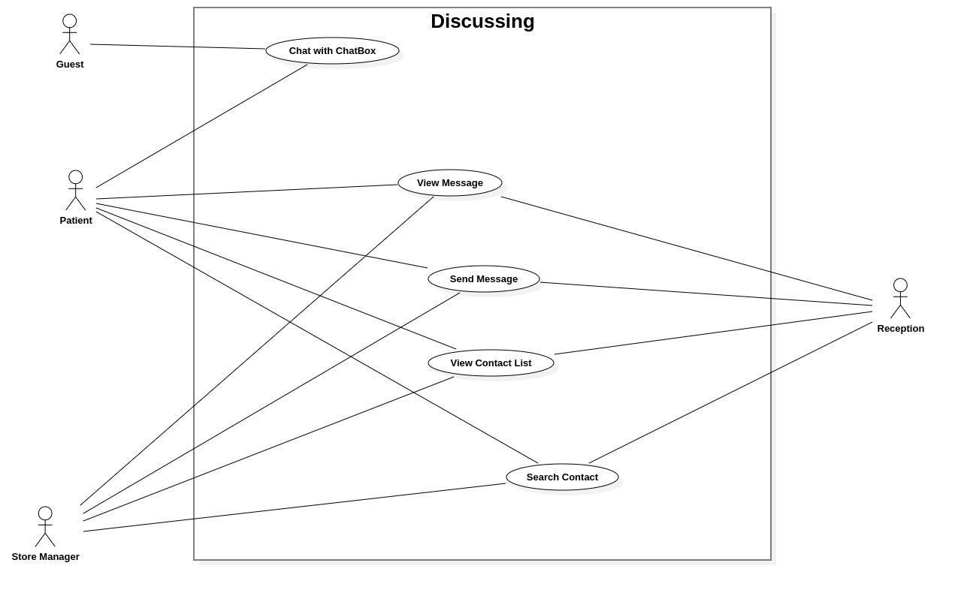

#### **System Management**

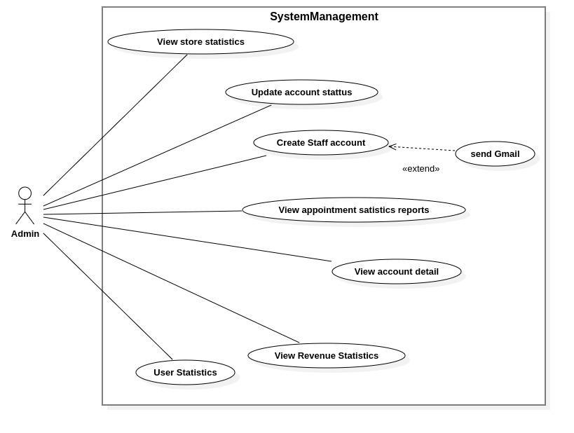

#### b.Descriptions

| **ID** | **Use Case** | **Actor** | **Use Case Description** |
| --- | --- | --- | --- |
| UC-Auth-01 | Sign In | Doctor, Patient, Store Manager, Admin | Enables users to log into the system using valid credentials. |
| UC-Auth-02 | Sign Out | Doctor, Patient, Store Manager, Admin | Allows users to securely log out of the system. |
| UC-Auth-03 | Register | Guest | Enables guests to create a new account in the system. |
| UC-Auth-04 | Forgot Password | Doctor, Patient, Store Manager, Admin | Allows users to reset their password if forgotten. |
| UC-Auth-05 | View Profile | Doctor, Patient, Store Manager, Admin | Enables users to view their profile information. |
| UC-Auth-06 | Change Password | Doctor, Patient, Store Manager, Admin | Allows users to update their account password. |
| UC-Auth-07 | Update Profile | Doctor, Patient, Store Manager, Admin | Enables users to modify their profile details. |
| UC-App-01 | Book An Appointment | Patient | Allows patients to schedule a new appointment with a doctor. |
| UC-App-02 | View Appointments List | Receptionist, Admin, Patient, Doctor | Displays a list of appointments for authorized users. |
| UC-App-03 | View Appointment Detail | Receptionist, Admin, Patient, Doctor | Shows detailed information about a specific appointment. |
| UC-App-04 | Update Appointment Status | Receptionist, Patient | Allows updating the status of an appointment (e.g., confirmed, canceled). |
| UC-App-05 | Arrange Doctor's Appointments | Receptionist | Enables receptionists to organize appointments for doctors. |
| UC-App-06 | Edit Doctor Work Schedule | Receptionist | Allows receptionists to modify a doctor's work schedule. |
| UC-App-07 | Create Doctor's Schedule | Receptionist | Enables receptionists to create a new schedule for doctors. |
| UC-App-08 | Filter Appointment List | Receptionist, Admin, Patient | Allows filtering the appointment list based on specific criteria. |
| UC-App-09 | Search Appointment | Receptionist, Admin, Patient | Enables searching for appointments using specific parameters. |
| UC-Treat-01 | Create Medical Record | Doctor | Allows doctors to create a new medical record for a patient. |
| UC-Treat-02 | Update Medical Record | Doctor | Enables doctors to update existing medical records. |
| UC-Treat-03 | View Medical Record | Patient | Allows patients to view their own medical records. |
| UC-Treat-04 | View Patient Medical Record History | Doctor | Enables doctors to view a patient’s medical record history. |
| UC-Order-01 | Add Product to Cart | Patient | Allows patients to add products to their shopping cart. |
| UC-Order-02 | View Cart List | Patient | Displays the list of products in the patient’s cart. |
| UC-Order-03 | Clear Cart | Patient | Enables patients to remove all products from their cart. |
| UC-Order-04 | Delete Product From Cart | Patient | Allows patients to remove a specific product from their cart. |
| UC-Order-05 | View Order List | Patient, Store Manager | Displays a list of orders for authorized users. |
| UC-Order-06 | View Order Status | Patient, Store Manager | Shows the status of a specific order. |
| UC-Order-07 | View Order Details | Patient, Store Manager | Displays detailed information about a specific order. |
| UC-Order-08 | Update Order | Store Manager | Allows store managers to modify order details. |
| UC-Order-09 | Create Order | Patient, Store Manager | Enables creation of a new order for products. |
| UC-Order-10 | Cancel Order | Patient, Store Manager | Allows cancellation of an existing order. |
| UC-Disc-01 | Chat with ChatBox | Patient | Enables patients to interact with a chatbot for assistance. |
| UC-Disc-02 | View Message | Patient, Receptionist, Store Manager | Displays messages exchanged in the chat system. |
| UC-Disc-03 | Send Message | Patient, Receptionist, Store Manager | Allows sending messages within the chat system. |
| UC-Disc-04 | View Contact List | Patient, Receptionist, Store Manager | Displays a list of contacts available for communication in the system. |
| UC-Disc-05 | Search Contact | Patient, Receptionist, Store Manager | Enables searching for specific contacts within the system. |
| UC-Pay-01 | Make Payment | Patient | Enables patients to make payments for services or products. |
| UC-Pay-02 | View Payment List | Patient, Receptionist | Displays a list of payments made. |
| UC-Pay-03 | View Payment Detail | Patient, Receptionist | Shows detailed information about a specific payment. |
| UC-Pay-04 | Make Refund | Receptionist | Allows receptionists to process refunds for payments. |
| UC-Pay-05 | View Refund List | Receptionist | Displays a list of processed refunds. |
| UC-Pay-06 | View Refund Detail | Receptionist | Shows detailed information about a specific refund. |
| UC-Feed-01 | Provide Appointment Feedback | Patient | Allows patients to submit feedback on appointments. |
| UC-Feed-02 | View Appointment Feedback | Doctor, Receptionist | Displays feedback provided for appointments. |
| UC-Feed-03 | Provide Product Feedback | Patient | Enables patients to submit feedback on purchased products. |
| UC-Feed-04 | View Product Feedback | Store Manager | Displays feedback provided for products. |
| UC-MedServ-01 | Create Medical Service | Admin | Allows admins to create a new medical service. |
| UC-MedServ-02 | Update Medical Service | Admin | Enables admins to modify existing medical services. |
| UC-MedServ-03 | Delete Medical Service | Admin | Allows admins to remove a medical service from the system. |
| UC-MedServ-04 | View Medical Service List | Admin, Receptionist, Patient | Displays a list of available medical services. |
| UC-MedServ-05 | View Medical Service Details | Admin, Receptionist, Patient | Shows detailed information about a specific medical service. |
| UC-MedServ-06 | Search Medical Service | Admin, Receptionist, Patient | Enables searching for medical services using specific parameters. |
| UC-Store-01 | Search Products | Patient | Allows patients to search for products in the store. |
| UC-Store-02 | Filter Product List | Patient | Enables patients to filter the product list based on specific criteria. |
| UC-Store-03 | View Product List | Patient | Displays a list of available products in the store. |
| UC-Store-04 | Add Products To Store | Store Manager, Admin | Allows adding new products to the store inventory. |
| UC-Store-05 | Delete Products From Store | Store Manager, Admin | Enables removal of products from the store inventory. |
| UC-Store-06 | Edit Product | Store Manager, Admin | Allows modification of product details in the store. |
| UC-Sys-01 | View User Statistics | Admin | Displays statistics related to user activity in the system. |
| UC-Sys-02 | View Account Detail | Admin | Shows detailed information about a specific user account. |
| UC-Sys-03 | View Usage Statistics | Admin | Displays statistics on system usage. |
| UC-Sys-04 | Update Account Status | Admin | Allows admins to update the status of user accounts (e.g., active, suspended). |
| UC-Sys-05 | View Store Statistics | Admin, Store Manager | Displays statistics related to store performance and sales. |
| UC-Sys-06 | Create Staff | Admin | Enables admins to create staff accounts and send notification emails. |
| UC-Sys-07 | View Appointment Statistics Reports | Admin | Displays reports on appointment-related statistics. |
| UC-Sys-08 | View Product Sales Statistics | Admin | Displays statistics on product sales in the store. |

## 2. Overall Functionalities

### 2.1 Screens Flow

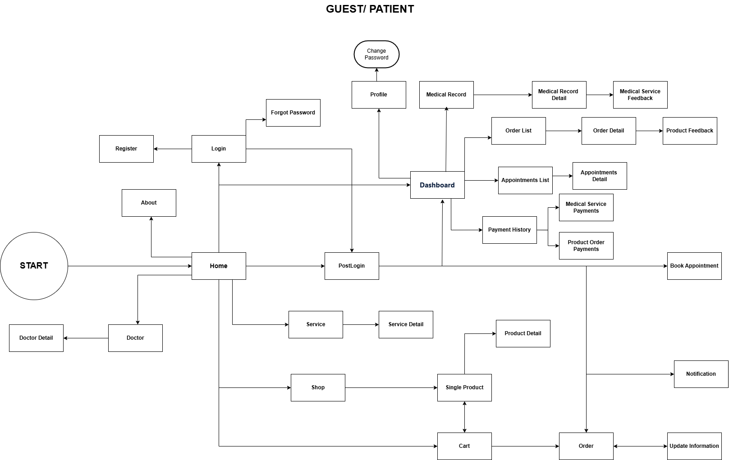**Guest/ Patient Screen Flow**

**Doctor Screen Flow**

**Receptionist Screen Flow**

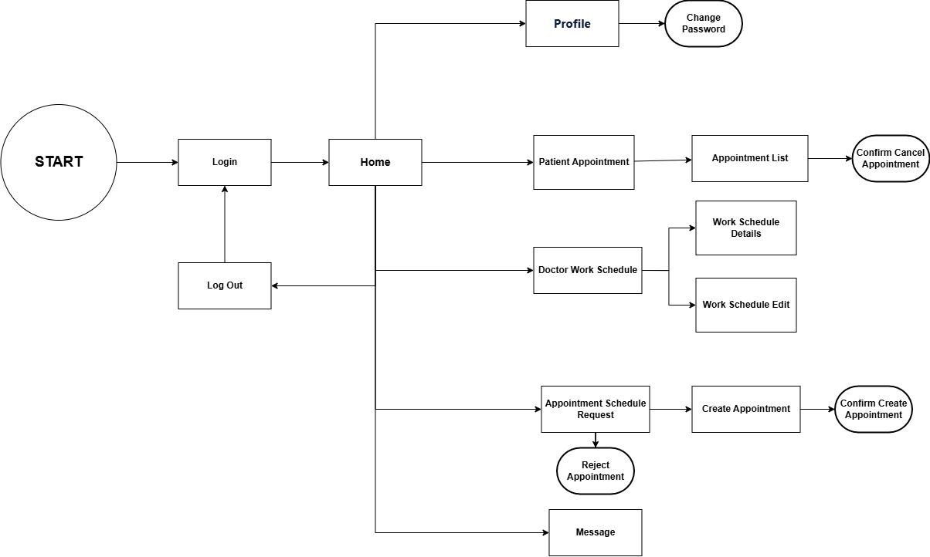

**Store Manager Screenflow**

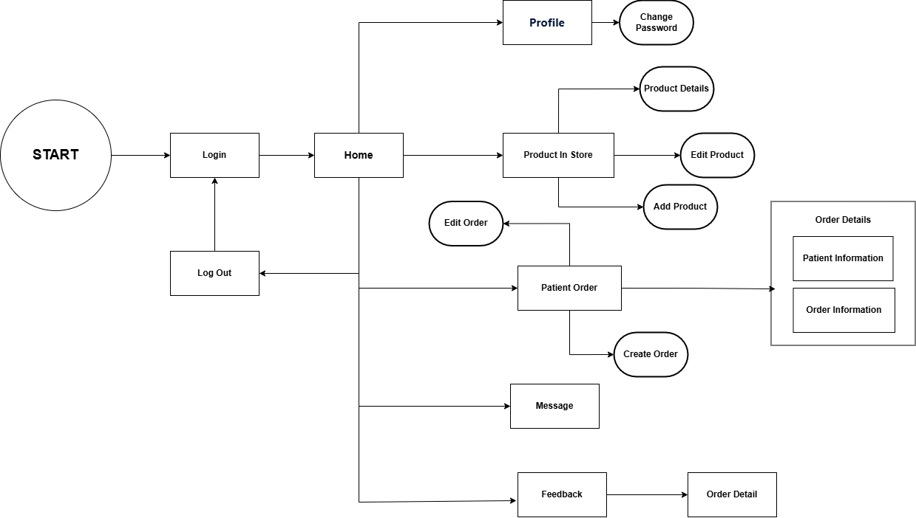

**Admin Screen Flow**

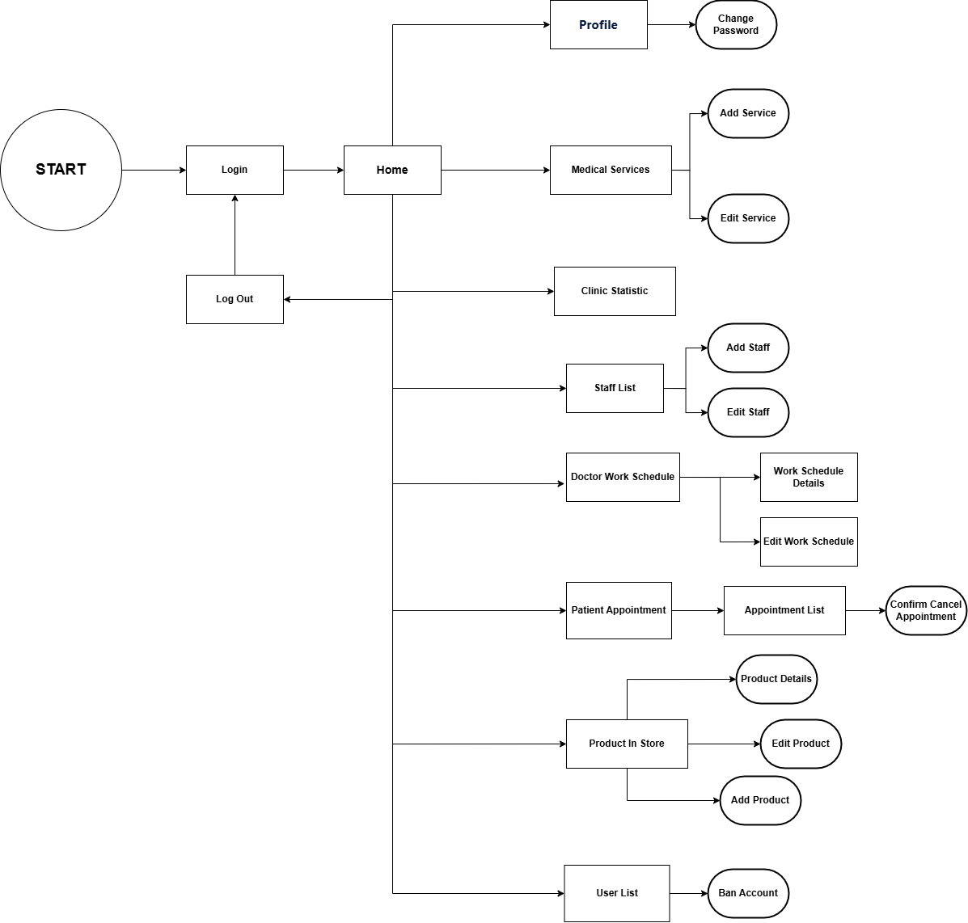

### 2.2 Screen Descriptions

**Guest/ Patient Screen Flow**

| **#** | **Feature** | **Screen** | **Description** |
| --- | --- | --- | --- |
| 1 | Appointment Booking | Book Appointment | Allows patients to enter personal information, select a time slot, describe their condition, and submit a booking request. |
| 2 | Appointment Tracking | My Appointments | Displays a list of the patient’s scheduled appointments with details and allows cancellation if permitted. |
| 3 | Appointment Management | View Appointments | Enables receptionist/admin to view all appointments, filter by criteria, and access appointment details. |
| 4 | Appointment Processing | Confirm/Reject Appointment | Allows receptionists to confirm pending appointments (by selecting a doctor and adding notes) or reject them with reasons. |
| 5 | Medical Record Management | Medical Record | Allows doctors to create, update, and view medical records for each patient, including diagnosis and treatment history. |
| 6 | Product Browsing | Product List | Displays a list of available eye care products with name, price, and description for patients and guests. |
| 7 | Order Creation | Order Product | Allows patients to add selected products to a shopping cart and place an order. |
| 8 | Order Tracking | Order Status | Allows patients to track the status of their orders (e.g., processing, shipped, completed, or canceled). |
| 9 | Order Management | Manage Orders | Enables store managers to view all orders and update their status accordingly. |
| 10 | Product Management | Manage Products | Allows store managers/admins to add, edit, or delete products from the store inventory. |
| 11 | Service Feedback | Service Feedback | Enables patients to rate and provide feedback on the medical services they have received. |
| 12 | Product Feedback | Product Feedback | Enables patients to give feedback on purchased products, and allows store managers to moderate it. |
| 13 | Messaging | Message Box | Provides a messaging interface for patients to communicate with receptionists or store managers. |
| 14 | Schedule Management | Doctor Schedule | Enables admins/receptionists to create or update doctors' working schedules (days, time slots). |
| 15 | Admin Tools | Admin Dashboard | Allows administrators to manage users, services, staff accounts, and access system configurations. |
| 16 | Reports | Appointment Report | Displays statistical data for appointments (e.g., totals, status breakdowns) for administrators. |
| 17 | Reports | Sales Report | Shows product sales statistics (e.g., revenue, popular products) to help admin track performance. |

**Doctor Screen Flow**

| **#** | **Feature** | **Screen** | **Description** |
| --- | --- | --- | --- |
| 1 | Login | Login | Screen where the doctor enters login credentials to access the system. |
| 2 | Dashboard | Dashboard | The main screen after login, providing navigation to all core doctor functions. |
| 3 | View Profile | Profile | Displays the doctor's personal profile and information. |
| 4 | Change Password | Change Password | Allows the doctor to update their account password. |
| 5 | Log Out | Log Out | Logs the doctor out of the system and ends the session. |
| 6 | View Appointments | Patient Appointment | Lists all upcoming patient appointments assigned to the doctor. |
| 7 | Appointment Details | Appointment Detail | Shows detailed information about a selected appointment. |
| 8 | View Patient Records | Patient Record | Displays a list of medical records for the doctor’s patients. |
| 9 | Record Details | Record Details | Provides full medical record details including patient info, diagnosis, and notes. |
| 10 | Create Medical Record | Create Medical Record | Interface for creating a new medical record for a patient. |
| 11 | View Patient Feedback | Patient Feedback | Shows feedback or reviews submitted by patients. |
| 12 | View Work Schedule | Work Schedule | Displays the doctor’s work schedule, including shifts and availability. |

**Receptionist Screen Flow**

| **#** | **Feature** | **Screen** | **Description** |
| --- | --- | --- | --- |
| 1 | Login | Login | Screen where the receptionist enters credentials to access the system. |
| 2 | Home Navigation | Home | Main screen providing access to all receptionist features. |
| 3 | View Profile | Profile | Displays the receptionist’s personal profile and information. |
| 4 | Change Password | Change Password | Allows the receptionist to update their account password. |
| 5 | Logout | Log Out | Logs the receptionist out of the system and ends the session. |
| 6 | Manage Patient Appointments | Patient Appointment | Allows viewing of patient appointments. |
| 7 | View Appointment List | Appointment List | Displays a list of all scheduled appointments. |
| 8 | Cancel Appointment | Confirm Cancel Appointment | Confirmation screen for canceling an appointment. |
| 9 | Manage Doctor Work Schedule | Doctor Work Schedule | Main entry point to manage doctor schedules. |
| 10 | View Work Schedule Details | Work Schedule Details | Shows the current work schedule for doctors. |
| 11 | Edit Work Schedule | Work Schedule Edit | Interface for updating or editing a doctor's schedule. |
| 12 | Handle Appointment Requests | Appointment Schedule Request | Displays appointment requests from patients needing confirmation. |
| 13 | Create Appointment | Create Appointment | Allows the receptionist to create a new appointment. |
| 14 | Confirm Appointment Creation | Confirm Create Appointment | Confirmation screen after creating an appointment. |
| 15 | Reject Appointment Request | Reject Appointment | Used to reject a patient’s appointment request. |
| 16 | View Messages | Message | Shows internal messages or communication received by the receptionist. |

**Store Manager Screenflow**

| **#** | **Feature** | **Screen** | **Description** |
| --- | --- | --- | --- |
| 1 | Login | Login | Screen where the store manager enters credentials to access the system. |
| 2 | Home Navigation | Home | Main screen providing access to all store management functionalities. |
| 3 | View Profile | Profile | Displays the store manager’s personal profile and information. |
| 4 | Change Password | Change Password | Allows the store manager to update their account password. |
| 5 | Logout | Log Out | Logs the store manager out of the system and ends the session. |
| 6 | View Product List | Product in Store | Displays all medical products currently available in the store. |
| 7 | View Product Details | Product Details | Shows detailed information about a selected product. |
| 8 | Edit Product | Edit Product | Allows the store manager to modify an existing product’s information. |
| 9 | Add Product | Add Product | Interface for adding a new product to the store. |
| 10 | Manage Orders | Patient Order | Displays a list of all orders placed by patients. |
| 11 | Create Order | Create Order | Allows the store manager to create a new product order for a patient. |
| 12 | Edit Order | Edit Order | Interface for modifying existing patient orders. |
| 13 | View Order Details | Order Details | Displays full order details, including patient and order-specific information. |
| 14 | View Messages | Message | Displays internal messages received by the store manager. |
| 15 | View Feedback | Feedback | Shows feedback submitted by patients regarding orders or products. |
| 16 | View Specific Feedback | Order Detail | Shows detailed view of feedback linked to a specific order. |

**Admin Screen Flow**

| **#** | **Feature** | **Screen** | **Description** |
| --- | --- | --- | --- |
| 1 | Login | Login | Screen where the admin enters credentials to access the system. |
| 2 | Home Navigation | Home | Main dashboard that links to all admin functionalities. |
| 3 | View Profile | Profile | Displays the admin’s personal profile and information. |
| 4 | Update Profile | Update Profile | Allows the admin to update their profile details. |
| 5 | Change Password | Change Password | Allows the admin to update their account password. |
| 6 | Logout | Log Out | Logs the admin out of the system and ends the session. |
| 7 | User Management | User Management | Central area for managing user accounts. |
| 8 | View User Details | User Detail | Shows detailed information of a selected user. |
| 9 | Update User Info | Update User Information | Allows editing/updating of user details. |
| 10 | Add User | Add User | Interface to add a new user to the system. |
| 11 | Service Management | Service Management | Main area to manage the list of services offered. |
| 12 | View Service Details | Service Detail | Displays detailed information of a selected service. |
| 13 | Update Service | Update Service | Allows updating service information. |
| 14 | Add Service | Add Service | Interface for adding a new service to the system. |
| 15 | View Notifications | Notifications | Displays all system notifications relevant to the admin. |
| 16 | Report Management | Reports Management | Central screen to access system reports. |
| 17 | Service Report | Service Report | Generates and displays reports related to services. |
| 18 | Product Report | Product Report | Generates and displays reports related to medical products. |
| 19 | Feedback Management | Feedback Management | Allows the admin to view and manage user or patient feedback. |

### 2.3 Screen Authorization

| **Screen** | **Patient** | **Doctor** | **Store Manager** | **Receptionist** | **Admin** |
| --- | --- | --- | --- | --- | --- |
| **Login / Register** | X | X | X | X | X |
| **Home Page** | X | X | X | X | X |
| **Book Appointment** | X |  |  |  |  |
| **My Appointments** | X | X |  |  |  |
| **Appointment Management** |  |  |  | X | X |
| Query All Data |  |  |  | X | X |
| Update Data |  |  |  | X | X |
| Reject/Confirm Appointment |  |  |  | X | X |
| **Medical Record** |  | X |  |  |  |
| Create |  | X |  |  |  |
| Update |  | X |  |  |  |
| View | X | X |  |  |  |
| **Schedule Management** |  |  |  | X | X |
| Create |  |  |  | X | X |
| Update |  |  |  | X | X |
| **Product Management** |  |  | X |  | X |
| Add Product |  |  | X |  | X |
| Edit Product |  |  | X |  | X |
| Delete Product |  |  | X |  | X |
| **Order Management** | X |  | X |  |  |
| Create Order | X |  | X |  |  |
| View Order | X |  | X |  | X |
| Update Status |  |  | X |  |  |
| **Feedback Management** | X | X | X |  |  |
| **Messaging System** | X |  | X | X |  |
| Send Message | X |  | X |  |  |
| Reply Message | X |  | X | X |  |
| **Profile Management** | X | X | X | X | X |
| Update Profile | X | X | X | X | X |
| **Admin Management Panel** |  |  |  |  | X |
| User Ban/Delete |  |  |  |  | X |
| Create Staff |  |  |  |  | X |
| Delete Staff |  |  |  |  | X |
| Create Service |  |  |  |  | X |
| Delete Service |  |  |  |  | X |
| **Report Dashboard** |  |  |  |  | X |

### 2.4 Non-UI Functions

| **#** | **Feature** | **System Function** | **Description** |
| --- | --- | --- | --- |
| 1 | Appointment Management | Appointment Reminder Service | A scheduled job that sends SMS/email reminders to patients 24 hours before their confirmed appointments. |
| 2 | Authentication | Email Verification API | Verifies user email addresses during account registration and password recovery. |
| 3 | Appointment Management | Auto-Expire Pending Appointments | A cron job that automatically cancels pending appointments after 48 hours if not confirmed by reception. |
| 4 | Product Ordering | Order Status Notification | Sends real-time email/SMS updates to patients when their product order status changes (e.g., shipped, delivered). |
| 5 | Feedback | Feedback Moderation Service | Background service that flags inappropriate feedback for review by admins or store managers. |
| 6 | Reporting | Appointment Report Generator | A backend job that aggregates appointment data (daily/weekly/monthly) and generates statistical summaries. |
| 7 | Reporting | Product Sales Report Generator | Generates revenue and product performance metrics for admins to monitor sales. |
| 8 | Chat Support | ChatBot Auto-Responder | Responds to common patient/guest queries instantly via pre-trained rules or AI. |
| 9 | System Maintenance | Data Backup Scheduler | Performs automated backups of the system database on a scheduled basis to ensure data recovery. |
| 10 | Security | Session Timeout Handler | Automatically logs out inactive users after a configured timeout period for security reasons. |

## 3. System High Level Design

### 3.1 Database Design

#### a. Database Schema

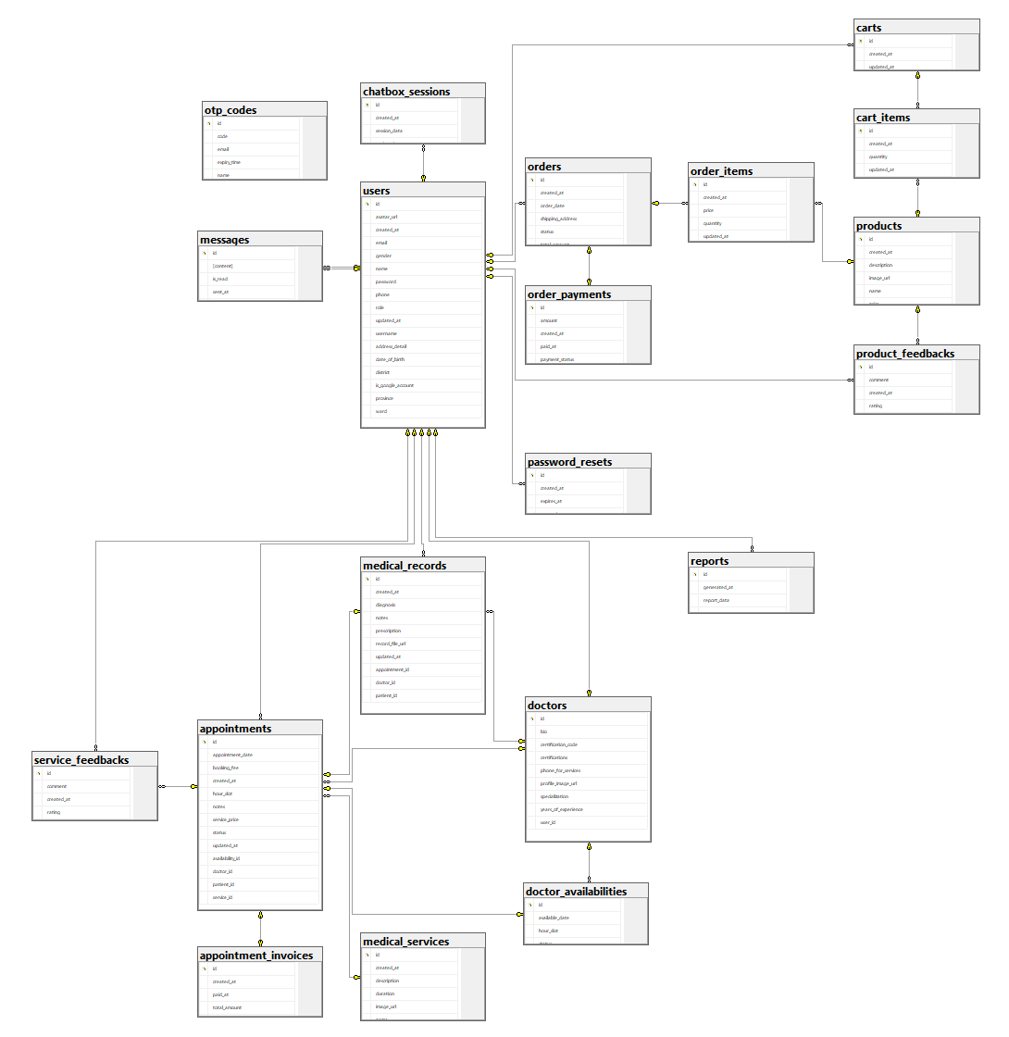

#### b. Table Descriptions

### 

| **No** | **Table** | **Description** |
| --- | --- | --- |
| 01 | users | Contains information about users (patients, doctors, staff, etc.)  - Primary keys: id  - Foreign keys: None |
| 02 | doctors | Stores details about doctors, such as specialization and certifications  - Primary keys: id  - Foreign keys: user_id (references users.id) |
| 03 | doctor_availabilities | Stores availability schedules for doctors  - Primary keys: id  - Foreign keys: doctor_id (references doctors.id) |
| 04 | medical_services | Contains medical services offered in the clinic  - Primary keys: id  - Foreign keys: None |
| 05 | appointments | Stores patient appointments with doctors  - Primary keys: id  - Foreign keys: patient_id (references users.id), doctor_id (references doctors.id), availability_id (references doctor_availabilities.id), service_id (references medical_services.id) |
| 06 | appointment_invoices | Contains invoices related to appointments  - Primary keys: id  - Foreign keys: appointment_id (references appointments.id) |
| 07 | medical_records | Stores medical records for each appointment  - Primary keys: id  - Foreign keys: appointment_id (references appointments.id), patient_id (references users.id), doctor_id (references doctors.id) |
| 08 | service_feedbacks | Stores feedback about services from patients  - Primary keys: id  - Foreign keys: appointment_id (references appointments.id), patient_id (references users.id) |
| 09 | products | Contains information about products sold in the clinic  - Primary keys: id  - Foreign keys: None |
| 10 | product_feedbacks | Contains feedback about products from patients  - Primary keys: id  - Foreign keys: product_id (references products.id), patient_id (references users.id) |
| 11 | carts | Stores shopping carts for patients  - Primary keys: id  - Foreign keys: patient_id (references users.id) |
| 12 | cart_items | Stores items added to carts by patients  - Primary keys: id  - Foreign keys: cart_id (references carts.id), product_id (references products.id) |
| 13 | orders | Stores information about orders placed by patients  - Primary keys: id  - Foreign keys: patient_id (references users.id) |
| 14 | order_items | Stores the items included in an order  - Primary keys: id  - Foreign keys: order_id (references orders.id), product_id (references products.id) |
| 15 | order_payments | Contains payment details for orders  - Primary keys: id  - Foreign keys: order_id (references orders.id) |
| 16 | messages | Stores messages between users (patients, doctors, staff)  - Primary keys: id  - Foreign keys: sender_id (references users.id), receiver_id (references users.id) |
| 17 | chatbox_sessions | Stores chat sessions for users  - Primary keys: id  - Foreign keys: user_id (references users.id) |
| 18 | password_resets | Stores password reset tokens for users  - Primary keys: id  - Foreign keys: user_id (references users.id) |
| 19 | reports | Stores generated reports (appointments, sales, etc.)  - Primary keys: id  - Foreign keys: generated_by (references users.id) |
| 20 | otp_codes | Stores OTP codes for email verification  - Primary keys: id  - Foreign keys: None |

### 

### 3.2 Code Packages

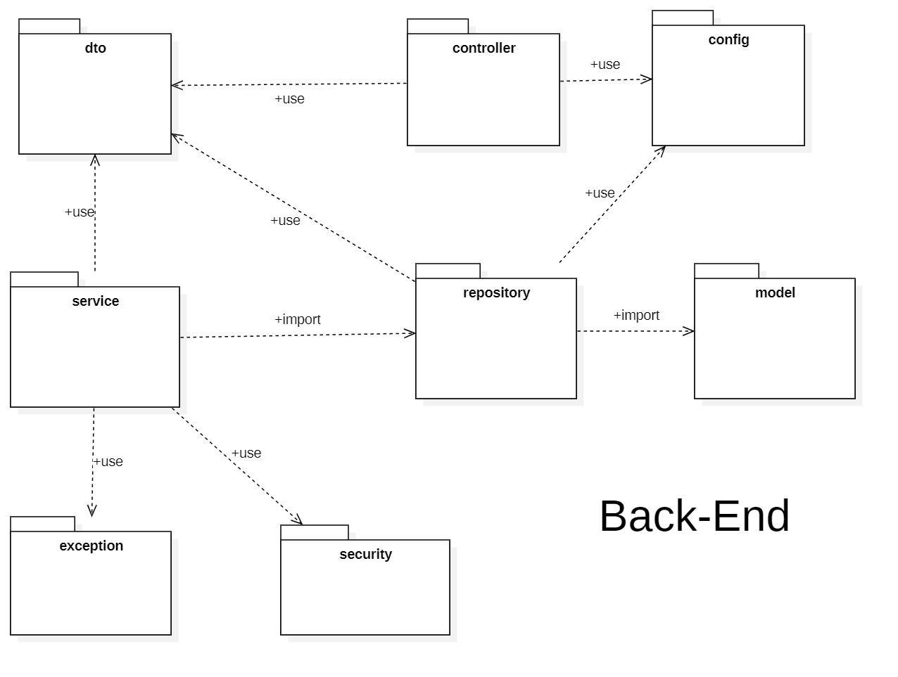

***Package descriptions***

| **No** | **Package** | **Description** |
| --- | --- | --- |
| 1 | controller | Handles incoming HTTP requests and maps them to appropriate service methods. |
| 2 | service | Contains business logic; processes data between controller, repository, and DTO. |
| 3 | repository | Interfaces to communicate with the database (typically using JPA/Hibernate). |
| 4 | model | Defines the data entities and maps them to database tables. |
| 5 | dto | Data Transfer Objects used to encapsulate and transfer data across layers. |
| 6 | config | Application configuration classes, such as CORS, Web MVC, Swagger, etc. |
| 7 | exception | Handles custom exceptions and global error responses. |
| 8 | security | Security configuration and filters (e.g., JWT, authentication, authorization). |

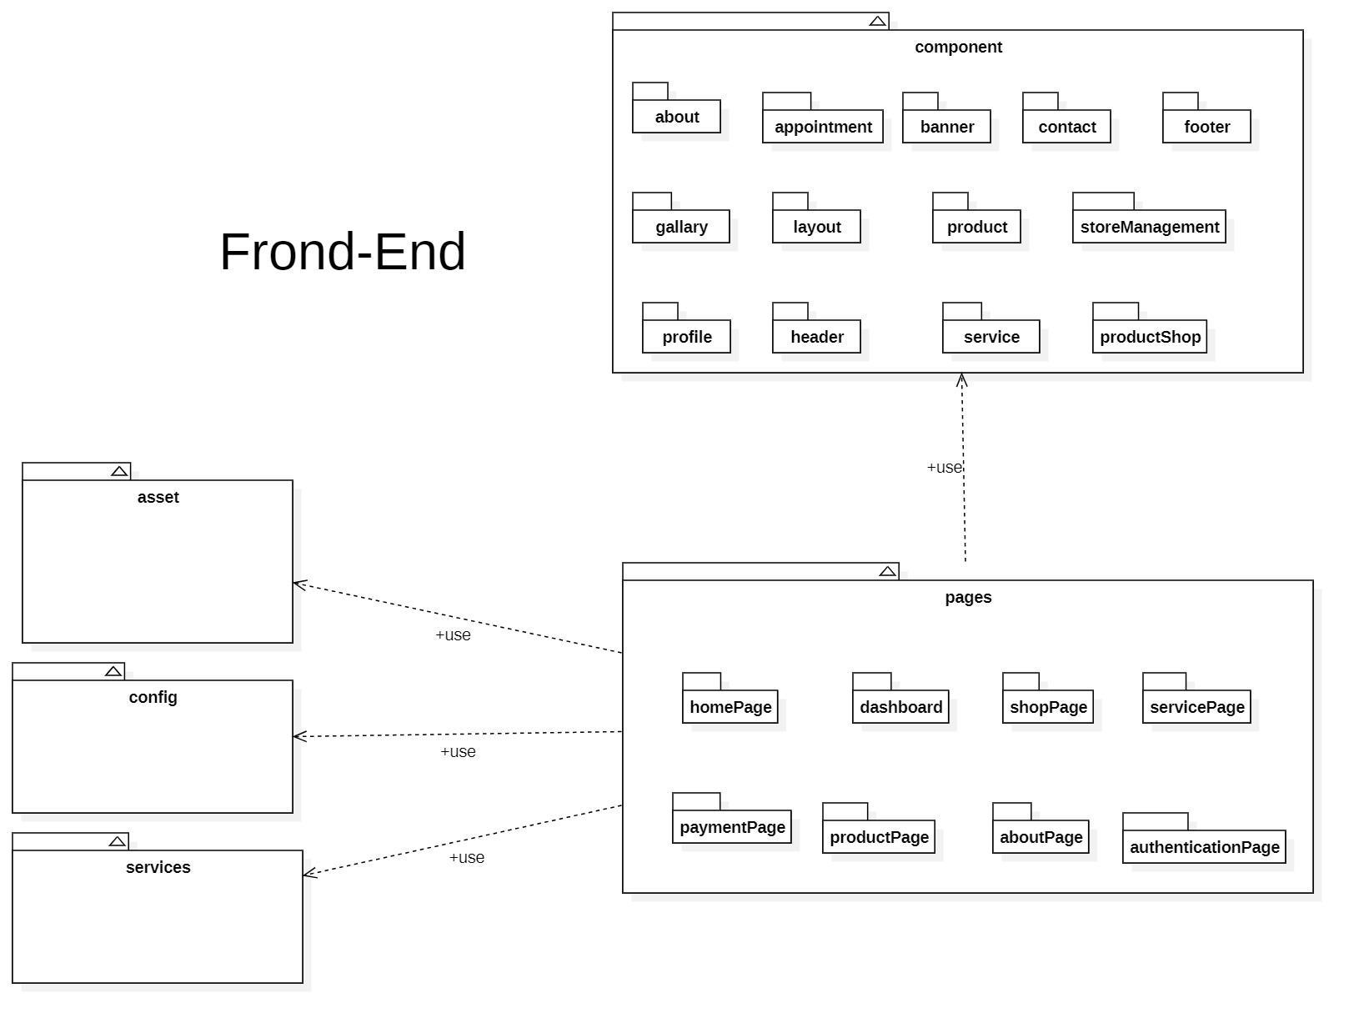

***Package descriptions***

| **No** | **Package** | **Description** |
| --- | --- | --- |
| **1** | **component** | **Contains all reusable UI components used across different pages.** |
| 1.1 | about | UI components for displaying About section content. |
| 1.2 | appointment | Components for handling appointment forms and schedules. |
| 1.3 | banner | Visual banner components typically shown on the homepage. |
| 1.4 | contact | Contact form UI elements and layout. |
| 1.5 | footer | The footer section appears across the app. |
| 1.6 | gallery | Components for image and media gallery displays. |
| 1.7 | layout | Reusable layout components such as containers, grids, etc. |
| 1.8 | product | Product display components like cards or previews. |
| 1.9 | storeManagement | Admin or vendor UI for managing store inventory and settings. |
| 1.10 | profile | Components related to user profile view and edit. |
| 1.11 | header | Navigation bar and header section used across pages. |
| 1.12 | service | UI components for listing and describing services. |
| 1.13 | productShop | Product browsing UI tailored to the shop interface. |
| **2** | **pages** | **Contains page-level components, each mapping to an application route.** |
| 2.1 | homePage | The landing page with general app overview and banners. |
| 2.2 | dashboard | Admin or user dashboard with analytical or overview info. |
| 2.3 | shopPage | Main shopping interface showing list of products. |
| 2.4 | servicePage | Shows available services to users. |
| 2.5 | paymentPage | Checkout page handling order and payment flow. |
| 2.6 | productPage | Detailed product page with full information and actions. |
| 2.7 | aboutPage | A full “About Us” section with more content than component/about. |
| 2.8 | authenticationPage | Handles user login, signup, forgot password, etc. |
| **3** | **services** | **Contains logic for interacting with backend APIs (e.g., Axios, Fetch).** |
| **4** | **config** | **Global settings like environment config, route constants, etc.** |
| **5** | **asset** | **Static assets including images, fonts, icons used throughout the project.** |

# II. Requirement Specifications

## 1. Authentication

### 1.1 **UC-01_Sign In.**

### 

#### a. Functionalities

**Functional Description Template**

| **Use Case Specification** | | | |
| --- | --- | --- | --- |
| **Use Case ID and Name:** | Sign In | | |
| **Created By:** | Trần Đình Duy Phương | **Date Created:** | June-02, 2025 |
| **Primary Actor:** | Doctor, Patient, Store Manager | **Secondary Actors:** | Gmail Authentication Service |
| **Trigger:** | The user selects the sign-in option and chooses to log in using their credentials (email/username and password) or Gmail authentication. | | |
| **Description:** | This use case allows a user (Doctor, Patient, or Store Manager) to log into the system using their email/username and password or by authenticating via Gmail to access their respective functionalities. | | |
| **Preconditions:** | **PRE-1**: The user has a registered account with valid credentials in the system, or a Gmail account linked to their system profile.  **PRE-2**: The system must be operational and accessible (e.g., website is online).  **PRE-3**: The user has an active internet connection.  **PRE-4**: The Gmail Authentication Service is available and configured with the system. | | |
| **Post–conditions:** | **POST-1**: The user successfully logs into the system and is redirected to their designated dashboard or homepage.  **POST-2**: The system logs the login activity for security and auditing purposes.  **POST-3**: The user’s session is established with appropriate access rights based on their role (Doctor, Patient, or Store Manager). | | |
| **Normal Flow:** | 1. The user navigates to the login page of the system. 2. The user enters their email/username and password in the provided fields. 3. The user submits the login request by clicking the "Sign In" button. 4. The system validates the credentials against the database. 5. Upon successful validation, the system logs the user in and redirects them to their role-specific dashboard. 6. The system displays a welcome message (e.g., "Welcome, [User Role]!"). | | |
| **Alternative Flows:** | **01.1-AF**: Login with Gmail Authentication  a. At step 2 of the Normal Flow, the user selects the "Sign In with Gmail" option.  b. The system redirects the user to the Gmail Authentication Service login page.  c. The user enters their Gmail credentials and authorizes the system to access their Gmail profile.  d. The Gmail Authentication Service validates the credentials and sends an authentication token to the system.  e. The system verifies the token and matches the Gmail account to a registered user profile.  f. Upon successful validation, the system logs the user in and redirects them to their role-specific dashboard.  g. The system displays a welcome message (e.g., "Welcome, [User Role]!").  **01.2-AF**: Invalid credentials (Email/Username and Password)  a. At step 4 of the Normal Flow, if the credentials are incorrect, the system displays a message: "Invalid email/username or password. Please try again."  b. The user may re-enter credentials, select the "Forgot Password" option, or try Gmail authentication.  **01.3-AF**: Invalid Gmail authentication  a. At step d of 1-AF, if the Gmail credentials are incorrect or authorization fails, the Gmail Authentication Service returns an error to the system.  b. The system displays a message: "Gmail authentication failed. Please try again or use email/username and password."  c. The user may retry Gmail authentication or switch to email/username and password login.  **01.4-AF**: Account locked  a. At step 4 of the Normal Flow or step e of 1-AF, if the account is locked due to multiple failed attempts, the system displays a message: "Account locked. Please contact support."  b. The use case ends, and the user must contact support to unlock the account.  **01.5-AF**: System error during login  a. At step 4 of the Normal Flow or step e of 1-AF, if the system encounters an error (e.g., database issue), the system displays an error message: "Unable to process login. Please try again later."  b. The user acknowledges the error and may retry or exit the section. | | |
| **Exceptions:** | **01-EF**: System or network failure  At any time, if the system cannot connect to the database or the Gmail Authentication Service, it displays an error message: "Unable to process login. Please try again later." | | |
| **Priority:** | **High** | | |
| **Frequency of Use:** | **High** (frequently used by Doctors, Patients, and Store Managers to access the system). | | |
| **Business Rules:** | **BR-19**, **BR-20**, **BR-21**, **BR-22** | | |
| **Other Information:** | Login data is used for security tracking and may be analyzed to monitor user activity (subject to privacy regulations). | | |

#### b. Business Rules

| **ID** | **Business Rule** | **Business Rule Description** |
| --- | --- | --- |
| **BR-19** | User account requirements | Users must have an account with a unique email/username and password, or a linked Gmail account. |
| **BR-20** | Account security enforcement | The system must enforce password complexity and account security (e.g., multi-factor authentication if enabled). |
| **BR-21** | Role-based access control | Access rights are role-based (Doctor, Patient, Store Manager) and restrict users to their designated functionalities. |
| **BR-22** | Gmail authentication compliance | Gmail authentication must comply with the Gmail Authentication Service’s security protocols. |

### **1.2 UC-02_Sign Out.**

#### a. Functional Description

| **Use Case Specification** | | | |
| --- | --- | --- | --- |
| **Use Case ID and Name:** | Sign Out | | |
| **Created By:** | Trần Đình Duy Phương | **Date Created:** | June-05, 2025 |
| **Primary Actor:** | Doctor, Patient, Store Manager | **Secondary Actors:** | None |
| **Trigger:** | The user selects the sign-out option from the system interface to end their session. | | |
| **Description:** | This use case allows a user (Doctor, Patient, or Store Manager) to log out of the system, terminating their current session and requiring re-authentication for future access. | | |
| **Preconditions:** | **PRE-1**: The user is currently logged into the system with an active session.  **PRE-2**: The system must be operational and accessible (e.g., website or mobile app is online).  **PRE-3**: The user has an active internet connection. | | |
| **Post–conditions:** | **POST-1**: The user’s session is successfully terminated, and they are logged out of the system.  **POST-2**: The system clears the user’s session data and redirects them to the login page.  **POST-3**: The system logs the logout activity for security and auditing purposes. | | |
| **Normal Flow:** | 1. The user navigates to their account settings or dashboard and selects the "Sign Out" option. 2. The system processes the logout request and terminates the user’s session. 3. The system clears all session-related data (e.g., authentication tokens). 4. The system redirects the user to the login page. | | |
| **Alternative Flows:** | **02-AF**: System error during logout  a. At step 2 of the Normal Flow, if the system encounters an error (e.g., server issue), the system displays an error message: "Unable to sign out. Please try again later."  b. The user acknowledges the error and may retry or close the session manually. | | |
| **Exceptions:** | **02-EF**: System or network failure  At any time, if the system cannot process the logout due to a network issue or server failure, it displays an error message: "Unable to sign out. Please try again later." | | |
| **Priority:** | **High** | | |
| **Frequency of Use:** | **High** (used whenever users finish their session) | | |
| **Business Rules:** | **BR-23, BR-24**, **BR-25** | | |
| **Other Information:** | Logout data is used for security tracking and session management (subject to privacy regulations). | | |
| **Assumptions:** | * The user is aware of the sign-out option and its location in the interface. * The system supports secure session termination and redirection. | | |

#### b. Business Rules

| **ID** | **Business Rule** | **Business Rule Description** |
| --- | --- | --- |
| **BR-23** | Sign-out permissions | Only authenticated users can initiate a sign-out action. |
| **BR-24** | Secure session termination | The system must securely terminate the session and clear all sensitive data. |
| **BR-25** | Logout availability | Logout must be available from all user interfaces (e.g., dashboard, settings). |

### **1.3 UC-03_ Register.**

#### a. Functional Description

| **Use Case Specification** | | | |
| --- | --- | --- | --- |
| **Use Case ID and Name:** | Register | | |
| **Created By:** | Cao Minh Tuấn | **Date Created:** | June-02, 2025 |
| **Primary Actor:** | Guest | **Secondary Actors:** | Admin |
| **Trigger:** | User wants to create new account | | |
| **Description:** | This use case allows a new user to create an account in the system by providing required personal information such as username, password, and email. The system validates the input data, checks for uniqueness, and creates the account if all conditions are met. A confirmation email may be sent to verify the user’s email address. | | |
| **Preconditions:** | **PRE-1:** User does not have an account in the system (not registered or not logged in).  **PRE-2:** The system is accessible (server is up and running, database is available).  **PRE-3:** The registration form is working and displaying correctly on the user interface. | | |
| **Post–conditions:** | **POST-1**:A new user account is created and stored in the system.  **POST-2**:The user receives a confirmation email (optional).  **POST-3**:The user can now log in using the registered credentials.  **POST-4**: If registration fails, an appropriate error message is displayed, and no account is created**.** | | |
| **Normal Flow:** | 1. The user accesses the registration page 2. The user enters the required information (e.g., username, password, email, etc.). 3. The user clicks the "Register" (Submit) button. 4. The system validates the input data (format, required fields, length, etc.). 5. The system checks the uniqueness of the username and email in the database. 6. If the data is valid and does not already exist, the system creates a new account and saves the user information. 7. The system sends a confirmation email (if applicable). 8. The system notifies the user of successful registration and redirects to the login page or homepage. | | |
| **Alternative Flows:** | **1-AF: User inputs invalid or incomplete data**  a. The system detects missing or incorrectly formatted fields (e.g., invalid email format, password too short).  b. The system displays appropriate error messages indicating which fields need correction.  c. The user corrects the input and resubmits.  **2-AF: Username or email already exists**  a. The system finds that the entered username or email is already registered.  b. The system notifies the user that the username/email is taken and prompts to enter a different one.  c. The user provides a new username/email and resubmits.  **3-AF: Confirmation email fails to send (optional)**  a. The system creates the account successfully but encounters an error sending the confirmation email.  b. The system notifies the user that the account is created but email confirmation may be delayed.  c. The user can still log in but may need to verify email later.  **4-AF: System or database failure**  a. The system encounters an unexpected error (e.g., database down) during registration.  b. The system displays an error message: "Registration failed. Please try again later."  c. The use case ends without creating an account. | | |
| **Exceptions:** | **1-EF: System or database failure during registration**   * If the system cannot connect to the database or encounters an unexpected error while creating the account, * The system displays an error message:  *"Registration failed due to a system error. Please try again later."* * The registration process is aborted, and no account is created.   **2-EF: Network failure during submission**   * If the user’s network connection is lost while submitting the registration form, * The system notifies the user that submission failed due to connection issues, * The user is prompted to retry once the network is restored.   **3-EF: Email service unavailable (if email confirmation is required)**   * If the email server is down or unreachable when sending confirmation, * The system logs the failure and informs the user that email confirmation may be delayed, * The account is still created but marked as unverified until email confirmation is completed. | | |
| **Priority:** | **High** | | |
| **Frequency of Use:** | **Medium to Low** | | |
| **Business Rules:** | **BR-19**  **BR-20**  **BR-26**  **BR-27**  **BR-28** | | |
| **Other Information:** | * The system may provide CAPTCHA verification to prevent automated or bot registrations. * Password strength meter can be implemented to guide users in creating strong passwords. * Optional fields such as phone number or address may be included but are not mandatory. * The registration page should be responsive and accessible on different devices (mobile, tablet, desktop). * Future enhancements could include social media login integration (Google, Facebook, etc.). | | |
| **Assumptions:** | * The user has access to a device with internet connection to reach the registration page. * The user can provide valid and accurate personal information during registration. * The system’s email service is operational for sending confirmation emails. * The system database is available and responsive to store user data. * The registration form interface works correctly across supported browsers and devices. * Users understand and accept the terms and conditions of the service before registering. | | |

#### 

#### b. Business Rules

| **ID** | **Business Rule** | **Business Rule Description** |
| --- | --- | --- |
| **BR-19** | User account requirements | Users must have an account with a unique email/username and password, or a linked Gmail account. |
| **BR-20** | Account security enforcement | The system must enforce password complexity and account security (e.g., multi-factor authentication if enabled). |
| **BR-26** | Terms of service agreement | The user must agree to the terms of service before completing the registration. |
| **BR-27** | Email verification requirement | The account must require email verification to activate the account (email confirmation is mandatory). |
| **BR-28** | Unverified account restrictions | Unverified accounts will not be allowed to log in or will have limited privileges. |

### **1.4 UC-04_ Forgot_Password.**

#### a. Functional Description

### 

| **Use Case Specification** | | | |
| --- | --- | --- | --- |
| **Use Case ID and Name:** | Forgot Password | | |
| **Created By:** | Cao Minh Tuấn | **Date Created:** | June-02, 2025 |
| **Primary Actor:** | Registered User (User already has an account) | **Secondary Actors:** | Email Service |
| **Trigger:** | The user clicks on the "Forgot Password" link on the login page. | | |
| **Description:** | This use case allows a registered user (Doctor, Patient, or Store Manager) who has forgotten their password to securely reset it. The user initiates the password recovery process, verifies their identity via email or SMS, and sets a new password to regain access to their account. | | |
| **Preconditions:** | * **PRE-1:** The user has an existing account in the system with a valid registered email or phone number. * **PRE-2:** The user is not logged in to the system. * **PRE-3:** The system is accessible (server is up and running, email service is available). * **PRE-4:** The user has access to the email or phone number linked to the account. | | |
| **Post–conditions:** | * **POST-1:** The user's password is successfully reset, and the new password is stored in the system. * **POST-2:** The user can log in using the new password. * **POST-3:** If the password reset fails, the system displays an appropriate error message, and no password change occurs. | | |
| **Normal Flow:** | 1.The user accesses the "Forgot Password" page from the login screen.  2.The user enters their registered email address or phone number.  3.The user clicks the "Submit" button to initiate the password reset process.  4.The system verifies that the email or phone number is associated with an existing account.  5.If the email/phone number is valid, the system sends a password reset link or an OTP to the provided contact method.  6.The user receives the reset link or OTP.  7.The user clicks the reset link (if applicable) or enters the OTP on the system’s password reset page.  8.The user enters a new password (and confirms it).  9.The system validates the new password (checks for strength, length, and required characters).  10.If the new password is valid, the system updates the user's password and confirms the change.  11.The system redirects the user to the login page with a notification that the password has been successfully reset. | | |
| **Alternative Flows:** | **1-AF: Invalid or incomplete email/phone number**   * a. The system detects that the entered email or phone number does not exist in the database. * b. The system displays an error message: "No account found with this email/phone number." * c. The user is prompted to re-enter their details or register if they don’t have an account.   **2-AF: Invalid OTP or expired reset link**   * a. The user enters an incorrect OTP or an expired reset link. * b. The system displays an error message: "Invalid OTP or expired link. Please try again." * c. The user is prompted to request a new reset link or OTP.   **3-AF: New password does not meet requirements**   * a. The user enters a new password that does not meet the required criteria (e.g., password is too short or lacks a special character). * b. The system displays an error message explaining the password requirements. * c. The user corrects the password and resubmits.   **4-AF: Email service is unavailable**   * a. The system encounters an issue when sending the reset email (e.g., email server is down). * b. The system logs the failure and informs the user that the email may be delayed. * c. The user is advised to retry the password reset later. | | |
| **Exceptions:** | **1-EF: Network failure during submission**   * If the user’s network connection is lost while submitting the password reset request,  The system notifies the user that submission failed due to connection issues.  The user is prompted to retry once the network is restored.   **2-EF: System or database failure**   * If the system encounters an error while verifying the user’s email/phone number or updating the password,  The system displays an error message: "Password reset failed due to a system error. Please try again later."  No changes are made to the user’s account.   **3-EF: OTP expiration**   * If the OTP has expired before the user can use it,  The system displays a message: "OTP has expired. Please request a new one."  The user is prompted to request a new OTP.. | | |
| **Priority:** | **High** | | |
| **Frequency of Use:** | **Medium to Low** | | |
| **Business Rules:** | **BR-20**  **BR-29**  **BR-30**  **BR-31** | | |
| **Other Information:** | * The system may implement CAPTCHA verification to prevent automated password reset requests. * Password reset requests can be limited to a certain number of attempts per day to prevent abuse. * The system may log all password reset requests for auditing and security purposes. * The user should be notified via email about the password reset request for additional security. | | |
| **Assumptions:** | * The user has access to a device with an internet connection to request the password reset. * The user can provide the correct email or phone number linked to their account. * The email service is operational to send password reset links or OTPs. * The system’s database and user data are available and accessible during the reset process. | | |

#### b. Business Rules

| **ID** | **Business Rule** | **Business Rule Description** |
| --- | --- | --- |
| **BR-20** | Account security enforcement | The system must enforce password complexity and account security (e.g., multi-factor authentication if enabled). |
| **BR-29** | Valid contact for account recovery | The user must provide a valid email address or phone number associated with an existing account. |
| **BR-30** | Expiring reset links/OTPs | Password reset links and OTPs must expire after a set time (e.g., 30 minutes). |
| **BR-31** | Single-use reset links | If the reset link is used, it can only be used once. |

### **1.5 UC-05_View_Profile.**

#### a. Functional Description

### 

| **Use Case Specification** | | | |
| --- | --- | --- | --- |
| **Use Case ID and Name:** | View Profile | | |
| **Created By:** | Cao Minh Tuấn | **Date Created:** | June-02, 2025 |
| **Primary Actor:** | Doctor, Patient, Store Manager, Admin | **Secondary Actors:** | System (for retrieving and displaying profile information) |
| **Trigger:** | User wants to view their profile information. | | |
| **Description:** | This use case allows the user (Doctor, Patient, Store Manager, Admin) to view their profile details, including personal information, appointment history, treatment records, and order history (if applicable). The system displays the data from the user’s profile stored in the database. | | |
| **Preconditions:** | * **PRE-1:** The user is logged into the system with valid credentials. * **PRE-2:** The user has a registered profile in the system. * **PRE-3:** The system is accessible (server is up and running). | | |
| **Post–conditions:** | * **POST-1:** The user’s profile information is displayed on the screen. * **POST-2:** The user can review and update their profile if necessary (depending on role). * **POST-3:** If the user is an Admin, they may have the ability to view other users' profiles. | | |
| **Normal Flow:** | 1.The user logs into the system with valid credentials.  2.The user navigates to the profile section.  3.The system retrieves the user's profile data (personal details, appointment history, etc.).  4.The system displays the profile information on the screen.  5.The user reviews the displayed profile information.  6.The system allows the user to update the profile if applicable (for editable fields like contact information). | | |
| **Alternative Flows:** | **1-AF: User does not have profile information**   * a. If the user has not completed their profile, the system displays a message: "Your profile is incomplete. Please update your details." * b. The user is prompted to fill in the missing information.   **2-AF: User cannot access profile**   * a. If the system detects an issue with loading the profile (e.g., system error or missing data), it displays an error message: "Unable to load your profile. Please try again later." * b. The user is notified of the error and can attempt to access the profile again later. | | |
| **Exceptions:** | **1-EF: System Error**   * If the system encounters an error while retrieving or displaying the profile,  The system displays an error message: "Error loading profile. Please try again later."  The use case ends without displaying the profile information.   **2-EF: Unauthorized Access**   * If the user attempts to access another user's profile (for non-Admin users),  The system displays a message: "You do not have permission to view this profile."  The use case ends without displaying any profile information. | | |
| **Priority:** | **Medium** | | |
| **Frequency of Use:** | **High** | | |
| **Business Rules:** | **BR-32**  **BR-33** | | |
| **Other Information:** | * The profile page should be responsive and accessible across different devices (mobile, tablet, desktop). * Some profile data may be protected and require additional security measures, such as role-based access control. | | |
| **Assumptions:** | * The user has a valid account and is authenticated before accessing their profile. * The profile data is stored correctly in the system and is retrievable when needed. | | |

#### b. Business Rules

| **ID** | **Business Rule** | **Business Rule Description** |
| --- | --- | --- |
| **BR-32** | Profile viewing permissions | The user can only view their own profile, except for Admin users, who can view all user profiles. |
| **BR-33** | Admin profile management | Admins should have the ability to view and edit other users’ profiles for management purposes. |

### **1.6 UC-06_Change_Password.**

#### a. Functional Description

### 

| **Use Case Specification** | | | |
| --- | --- | --- | --- |
| **Use Case ID and Name:** | Change Password | | |
| **Created By:** | Cao Minh Tuấn | **Date Created:** | June-02, 2025 |
| **Primary Actor:** | Doctor, Patient, Store Manager, Admin | **Secondary Actors:** | System (for verifying old password, validating the new one, and updating the database) |
| **Trigger:** | User wants to change their password for security or personal reasons. | | |
| **Description:** | This use case allows the user (Doctor, Patient, Store Manager, Admin) to change their password after logging into the system. The system ensures that the new password meets security criteria (e.g., minimum length, inclusion of special characters) and updates the user’s credentials in the database. | | |
| **Preconditions:** | * **PRE-1:** The user is logged into the system with valid credentials. * **PRE-2:** The user has access to their profile settings. * **PRE-3:** The system is accessible (server is up and running). * **PRE-4:** The user knows their current password (for security verification). | | |
| **Post–conditions:** | * **POST-1:** The user’s password is updated in the system. * **POST-2:** The user is notified that the password has been successfully changed. * **POST-3:** The user may be logged out automatically after the password change for security reasons, requiring them to log in again with the new password. | | |
| **Normal Flow:** | 1. The user navigates to the "Change Password" section in their account settings. 2. The system prompts the user to enter their current password. 3. The user enters their current password. 4. The system verifies that the current password is correct. 5. The user enters a new password and confirms it. 6. The system validates the new password (e.g., checks if it meets length and complexity requirements). 7. If the new password is valid, the system updates the password in the database. 8. The system notifies the user that the password has been successfully changed. 9. The user may be prompted to log in again with the new password. | | |
| **Alternative Flows:** | **1-AF: Incorrect current password**   * a. The user enters an incorrect current password. * b. The system displays an error message: "The current password is incorrect. Please try again." * c. The user is prompted to re-enter the correct current password.   **2-AF: New password does not meet criteria**   * a. The user enters a new password that does not meet the required criteria (e.g., password is too short, lacks special characters). * b. The system displays an error message: "The new password does not meet the required criteria. Please ensure it meets the minimum length and includes a special character." * c. The user corrects the password and resubmits.   **3-AF: Password change fails due to system error**   * a. The system encounters an error while updating the password (e.g., database connection issue). * b. The system displays an error message: "There was an error changing your password. Please try again later." * c. The user is prompted to retry the password change. | | |
| **Exceptions:** | **1-EF: User is unable to access the system**   * If the user is not logged in or their session expires while trying to change the password,  The system displays a message: "You must be logged in to change your password."  The use case ends without updating the password.   **2-EF: Network failure during password change**   * If there is a network issue during the password change process,  The system notifies the user that the request failed due to connection issues and prompts the user to retry once the network is restored. | | |
| **Priority:** | **High** | | |
| **Frequency of Use:** | **Medium** | | |
| **Business Rules:** | **BR-34**  **BR-20** | | |
| **Other Information:** | * The password change page should include guidelines for creating strong passwords to enhance security. * If the user forgets their password, they should be able to use the "Forgot Password" feature to reset it before attempting to change it. | | |
| **Assumptions:** | * The user has access to their account and knows their current password. * The user’s internet connection is stable during the password change process. * The system’s password change functionality is operational and secure. | | |

#### b. Business Rules

| **ID** | **Business Rule** | **Business Rule Description** |
| --- | --- | --- |
| **BR-34** | Password change verification | The user must provide the correct current password to change their password. |
| **BR-20** | Account security enforcement | The system must enforce password complexity and account security (e.g., multi-factor authentication if enabled). |

### **1.7 UC-08_Update_Profile.**

#### a. Functional Description

### 

| **Use Case Specification** | | | |
| --- | --- | --- | --- |
| **Use Case ID and Name:** | Update Profile | | |
| **Created By:** | Cao Minh Tuấn | **Date Created:** | June-02, 2025 |
| **Primary Actor:** | Doctor, Patient, Store Manager, Admin | **Secondary Actors:** | System (for verifying the account deletion request and updating the database) |
| **Trigger:** | User wants to update their profile information. | | |
| **Description:** | This use case allows the user (Doctor, Patient, Store Manager, Admin) to update their personal profile information such as name, contact details, address, and other relevant information. The system validates the updated data and stores it in the database. The user can update their profile for personal or professional reasons. | | |
| **Preconditions:** | * **PRE-1:** The user is logged into the system with valid credentials. * **PRE-2:** The user has a registered profile in the system. * **PRE-3:** The system is accessible (server is up and running). * **PRE-4:** The user has access to the profile settings page. | | |
| **Post–conditions:** | * **POST-1:** The user’s profile is updated in the system with the new data. * **POST-2:** The system confirms that the profile has been successfully updated. * **POST-3:** The updated profile data is now accessible in the user's account. | | |
| **Normal Flow:** | 1. The user navigates to the "Profile Settings" page from their account. 2. The system displays the user’s current profile information. 3. The user makes necessary changes to the profile fields (e.g., name, email, phone number, etc.). 4. The user clicks the "Save" or "Update" button to submit the changes. 5. The system validates the updated data (e.g., checks for valid email format, phone number, and required fields). 6. If the data is valid, the system updates the user's profile information in the database. 7. The system displays a confirmation message: "Profile updated successfully." 8. The user can view the updated profile information on the same page. | | |
| **Alternative Flows:** | **1-AF: User submits invalid data**   * a. The user enters invalid data (e.g., an invalid email format, phone number). * b. The system detects the invalid data and displays an error message: "Please enter valid information for the fields marked in red." * c. The user corrects the data and resubmits the profile update.   **2-AF: User cancels profile update**   * a. The user decides not to save the changes and cancels the update. * b. The system discards the changes and returns the user to the previous page or profile settings.   **3-AF: System error during profile update**   * a. The system encounters an error while updating the profile (e.g., database failure or server issue). * b. The system displays an error message: "There was an issue updating your profile. Please try again later." * c. The user is prompted to retry the update. | | |
| **Exceptions:** | **1-EF: User is not authenticated**   * If the user is not logged in or their session expires while trying to update the profile,  The system displays a message: "You must be logged in to update your profile."  The use case ends without updating the profile.   **2-EF: Network failure during profile update**   * If the system encounters a network issue while submitting the updated data,  The system displays a message: "Network error. Please try again later."  The user is prompted to retry the update once the network connection is restored. | | |
| **Priority:** | **Medium** | | |
| **Frequency of Use:** | **High** | | |
| **Business Rules:** | **BR-38**  **BR-39** | | |
| **Other Information:** | * The profile update page should include guidelines to help the user input correct and valid data (e.g., password requirements, valid email format). * Some fields may be editable only by certain roles (e.g., Admin may be able to edit more fields for other users, but a patient can only update their personal information). | | |
| **Assumptions:** | * The user has valid credentials to log in and update their profile. * The profile data is correctly stored in the database and can be retrieved and updated when needed. * The system performs necessary security checks to ensure that only authorized users can update their profiles. | | |

#### b. Business Rules

## 

| **ID** | **Business Rule** | **Business Rule Description** |
| --- | --- | --- |
| **BR-38** | Profile update permissions | Only the profile owner (or an Admin with management rights) is allowed to update the profile. |
| **BR-39** | Profile data validation | Updated data must be validated (format checks, required fields, etc.). |

## 2. Appointment

### 2.1 Book An Appointment

#### a. Functional Description

### 

| **Use Case Specification** | | | |
| --- | --- | --- | --- |
| **Use Case ID and Name:** | UC-15: Book an appointment | | |
| **Created By:** | Trần Đình Duy Phương | **Date Created:** | June-02, 2025 |
| **Primary Actor:** | Patient | **Secondary Actors:** | Receptionist |
| **Trigger:** | A patient wants to schedule a medical appointment by submitting personal details, preferred time, specific doctor and service. | | |
| **Description:** | This use case allows a patient to request an appointment by selecting a doctor, preferred services, time slot, and submitting personal information. Doctors may adjust or add services during consultation. | | |
| **Preconditions:** | **PRE-1:** The patient accesses the booking interface.  **PRE-2:** The doctor has an available schedule.  **PRE-3:** The selected services are available. | | |
| **Post–conditions:** | **POST-1:** Appointment is submitted and marked as "Pending".  **POST-2:** Receptionist is notified to confirm or adjust. | | |
| **Normal Flow:** | 1. Patient accesses booking interface.  2. Patient selects a preferred doctor.  3. System displays available time slots.  4. Patient selects a time slot.  5. Patient selects service(s).  6. Patient enters contact info and condition description.  7. Patient submits booking request.  8. System saves requests and notifies the receptionist. | | |
| **Alternative Flows:** | **8-AF:** Patient submits incomplete form  a. The system prompts the patient to complete all required fields. b. Patient resubmits the form**.** | | |
| **Exceptions:** | **8-EF:** System/database error during submission   * The system displays an error: “Unable to submit an appointment. Please try again later.” | | |
| **Priority:** | **High** | | |
| **Frequency of Use:** | **High** | | |
| **Business Rules:** | **BR-16**  **BR-19**  **BR-21**  **BR-39** | | |
| **Other Information:** | Patients may receive confirmation emails or messages once the appointment is confirmed.  Optional CAPTCHA can be added to prevent spam submissions. | | |
| **Assumptions:** | Patients can choose a doctor and service from available options. | | |

#### b. Business Rules

| **BR** | **Business Rule** | **Business Rule Description** |
| --- | --- | --- |
| **BR-16** | Patient appointment selection | Patients can choose date/time, doctor, or service. |
| **BR-19** | User account requirements | Users must have an account with a unique email/username and password, or a linked Gmail account. |
| **BR-21** | Role-based access control | Access rights are role-based (Doctor, Patient, Store Manager) and restrict users to their designated functionalities. |
| **BR-39** | Profile data validation | Updated data must be validated (format checks, required fields, etc.). |

### 2.2 View Appointment List

#### a. Functional Description

| **Use Case Specification** | | | |
| --- | --- | --- | --- |
| **Use Case ID and Name:** | View Appointment List | | |
| **Created By:** | Trần Đình Duy Phương | **Date Created:** | June-02, 2025 |
| **Primary Actor:** | Receptionist/ Admin | **Secondary Actors:** | Doctor |
| **Trigger:** | A receptionist or admin wants to view the list of appointments booked by patients in order to manage clinic operations and doctor schedules. | | |
| **Description:** | This use case allows the receptionist/admin to view all patients with existing appointments (Confirmed, Completed, Cancelled). They can click on a patient to see appointment details and optionally update or cancel the appointment. | | |
| **Preconditions:** | * **PRE-1:** The receptionist or admin is logged into the system with valid credentials. * **PRE-2:** At least one appointment has been booked in the system. | | |
| **Post–conditions:** | **POST-1:** List of patients with appointments is shown.  **POST-2:** Receptionist/Admin can view and optionally update/cancel each appointment. | | |
| **Normal Flow:** | 1. The receptionist or admin logs into the system. 2. Navigates to the "Patient Appointments" page.. 3. System displays a list of patients with appointments (Confirmed, Completed, Cancelled). 4. Receptionist selects a patient. 5. System displays their appointments. 6. Receptionists or admin can view, update details, or cancel. | | |
| **Alternative Flows:** | **1-AF**: No appointments in the system  a. System displays: “No appointments found.”  b. The use case ends. | | |
| **Exceptions:** | **1-EF**: Network or database failure  The system displays an error message: "Unable to load appointment list. Please try again later."" | | |
| **Priority:** | **High** | | |
| **Frequency of Use:** | **High** (used daily to manage clinic operations) | | |
| **Business Rules:** | **BR-1**  **BR-2**  **BR-6**  **BR-18**  **BR-19**  **BR-61** | | |
| **Other Information:** | Advanced filters and export options (e.g., Excel/PDF) can be provided. | | |

#### b. Business Rules

| **BR** | **Business Rule** | **Business Rule Description** |
| --- | --- | --- |
| **BR-1** | Role-based appointment viewing | Only users with the role of "admin" or "receptionist" can view all appointments. |
| **BR-2** | Real-time appointment updates | Appointment data must be updated in real time. |
| **BR-6** | Appointment detail updates | Only receptionists or admins can update appointment details. |
| **BR-18** | Real-time appointment detail updates | The system must ensure appointment details are updated in real-time. |
| **BR-19** | User account requirements | Users must have an account with a unique email/username and password, or a linked Gmail account. |
| **BR-61** | Cancellation notifications | The system must notify relevant staff or update schedules after a cancellation. |

### 2.3 View Appointment Detail

#### a. Functional Description

### 

| **Use Case Specification** | | | |
| --- | --- | --- | --- |
| **Use Case ID and Name:** | View Appointment Detail | | |
| **Created By:** | Nguyễn Phạm Hoàng Minh | **Date Created:** | June-02, 2025 |
| **Primary Actor:** | Patient | **Secondary Actors:** | Receptionist, Admin (for support/viewing all appointments) |
| **Trigger:** | The Patient selects an appointment from their appointment list to view detailed information. | | |
| **Description:** | This use case enables the Patient to view full details of their scheduled appointment, including doctor, service, date/time, and appointment status. It also supports basic navigation (e.g., back, exit) and provides feedback in case of missing or failed data retrieval. | | |
| **Preconditions:** | **PRE-1:** The patient must have an active, authenticated account.  **PRE-2:** The patient must have at least one scheduled appointment in the system.  **PRE-3:** The system must be operational and connected to the appointment database.  **PRE-4:** The patient must have appropriate access rights (role = Patient) as defined in the system. | | |
| **Post–conditions:** | **POST-1:** The patient successfully views full appointment details.  **POST-2:** The system may log the view activity for audit or analytics purposes.  **POST-3:** If no appointment is available, the system displays an informative message without breaking user experience. | | |
| **Normal Flow:** | 1. The patient navigates to the “My Appointments” section. 2. The system fetches and displays the list of the patient's upcoming and past appointments. 3. The patient selects a specific appointment from the list. 4. The system retrieves full details of the selected appointment. 5. The system displays appointment details, including:  * Doctor name * Service name * Appointment date and time * Appointment status * Location (if applicable)  1. The patient can navigate back to the appointment list or exit the section. | | |
| **Alternative Flows:** | **02.1-AF: No appointments available**   * a. At Step 2, if the patient has no appointments, the system displays:    "You have no scheduled appointments." * b. The patient is returned to the dashboard or home section.   **02.2-AF: Appointment not found / Invalid selection**   * a. At Step 4, if the system cannot find the appointment due to a data inconsistency, the system displays:    "Unable to retrieve appointment details. Please try again later." * b. The patient is given an option to return to the appointment list.   **02.3-AF: System error while retrieving data**   * a. At Step 4, if the system experiences a server/database error, the system displays:    "An error occurred while loading your appointment. Please try again." * b. The system logs the error internally and allows retry or exit. | | |
| **Exceptions:** | **02-EF: Session expired or unauthorized access**   * a. If the patient is not authenticated or the session has expired, the system redirects them to the login page with a message:    "Your session has expired. Please log in again." | | |
| **Priority:** | **High** | | |
| **Frequency of Use:** | **High** (patients frequently check appointment details for confirmation and updates) | | |
| **Business Rules:** | **BR-19**  **BR-21**  **BR-18**  **BR-125**  **BR-126**  **BR-127**  **BR-128**  **BR-57** | | |
| **Other Information:** | * View history can be used to personalize user experience or detect issues. * The system should follow privacy standards when displaying sensitive appointment data. | | |
| **Assumptions:** | * The user accessing this use case has already passed login and role verification. * The appointment list is stored in a centralized and accessible appointment database. * Each appointment is uniquely identifiable by a system-generated appointment ID. * The system time is synchronized and accurate to reflect real-time appointment status (e.g., "Pending", "Completed"). * There are no ongoing system maintenance or downtime activities during the interaction. * All relevant UI components (e.g., buttons, list views) are functioning correctly on the frontend. | | |

#### b. Business Rules

| **BR** | **Business Rule** | **Business Rule Description** |
| --- | --- | --- |
| **BR-19** | User account requirements | Users must have an account with a unique email/username and password, or a linked Gmail account. |
| **BR-21** | Role-based access control | Access rights are role-based (Doctor, Patient, Store Manager) and restrict users to their designated functionalities. |
| **BR-18** | Real-time appointment detail updates | The system must ensure appointment details are updated in real-time. |
| **BR-125** | Patient appointment visibility | Only authenticated patients can view their own appointments. |
| **BR-126** | No-appointment notification | If no appointments are scheduled, the system must inform the patient with an appropriate message. |
| **BR-127** | Data retrieval failure handling | If the system fails to retrieve data, it must display a clear error and allow retry. |
| **BR-128** | Appointment view navigation | Patients can freely exit the appointment view section or navigate back to previous sections without affecting session or data. |
| **BR-57** | Medical record content | The record must include all relevant medical data (e.g., diagnosis, treatment history) and comply with privacy regulations. |

### 2.4 Update appointment status

#### a. Functional Description

### 

| **Use Case Specification** | | | |
| --- | --- | --- | --- |
| **Use Case ID and Name:** | Update Appointment Status | | |
| **Created By:** | Nguyễn Phạm Hoàng Minh | **Date Created:** | June-02, 2025 |
| **Primary Actor:** | Receptionist, Patient | **Secondary Actors:** | Doctor (notified of status changes) |
| **Trigger:** | The Receptionist or Patient wants to update the status of an appointment (e.g., to confirm, cancel, or reschedule) due to changes in availability or other reasons. | | |
| **Description:** | This use case enables Receptionists and Patients to update the status of an existing appointment in the system. The status can be updated to values such as “Confirmed,” “Canceled,” “Completed,” or “No-Show.” Patients can only update their own appointments, while Receptionists can update appointments for any patient. The system validates the status change, updates the appointment record, logs the activity, and sends notifications to relevant parties (e.g., Patient, Doctor, Admin) if configured. The process ensures compliance with security and privacy regulations. | | |
| **Preconditions:** | * **PRE-1:** The user (Receptionist or Patient) must be authenticated and logged into the system with appropriate permissions (role = Receptionist or Patient). * **PRE-2:** The system must be operational and connected to the appointment database. * **PRE-3:** At least one appointment record must exist in the system (for the Patient’s account if accessed by a Patient, or for any patient if accessed by a Receptionist). * **PRE-4:** A valid, secure user session must be active for updating the appointment status. * **PRE-5:** The appointment must be in a state that allows status updates (e.g., not already “Completed” or “Canceled” for certain actions). | | |
| **Post–conditions:** | * **POST-1:** The appointment status is successfully updated in the system. * **POST-2:** The system logs the appointment status update activity with timestamp, user ID (patient or receptionist), and appointment ID for auditing purposes. * **POST-3:** The appointment data remains unchanged except for the status and related metadata (e.g., update timestamp). * **POST-4:** The appointment data is encrypted and complies with security and privacy regulations. * **POST-5:** Notifications are sent to relevant parties (e.g., Patient, Doctor, Admin) if configured. | | |
| **Normal Flow** | 1. The user (Receptionist or Patient) navigates to the “Appointments” or “My Appointments” section in the system. 2. The system displays a list of appointment records, including details such as:    * Appointment ID    * Patient name (anonymized for Receptionists, if required)    * Doctor name    * Date and time    * Current status (e.g., Scheduled, Confirmed, Canceled)    * For Patients: only their own appointments are shown.    * For Receptionists: appointments for all patients are shown. 3. The user selects an appointment to update its status. 4. The system displays the appointment details and a list of valid status options (e.g., Confirmed, Canceled, Completed, No-Show) based on the current status and user role. 5. The user selects a new status and provides any required information (e.g., reason for cancellation). 6. The system validates the status update (e.g., ensures the new status is allowed, checks time constraints). 7. The system updates the appointment status and saves the changes with a timestamp and user ID. 8. The system displays a confirmation message: “Appointment [Appointment ID] status updated to [New Status].” 9. The system sends notifications to relevant parties (e.g., Patient, Doctor, Admin) if configured. 10. The user navigates back to the appointment list or exits to the dashboard. | | |
| **Alternative Flows:** | * **04.1-AF: No appointment records available** a. At Step 2, if no appointment records exist (for the Patient’s account or all patients for Receptionists), the system displays: “No appointment records found.” b. The user can navigate back or exit. * **04.2-AF: Invalid status update** a. At Step 6, if the selected status is invalid (e.g., changing a “Completed” appointment to “Scheduled”), the system displays: “Invalid status update. Please select a valid status.” b. The user can select another status or exit. * **04.3-AF: Data update failure** a. At Step 7, if the system fails to update the appointment status due to a database or server issue, it displays: “Unable to update appointment status at the moment. Please try again later.” b. The system logs the error, and the user can retry or exit. | | |
| **Exceptions:** | * **04-EF: Unauthorized access** a. If an unauthorized user (e.g., Doctor, Store Manager) attempts to access this use case, the system displays: “You are not authorized to update appointment statuses.” b. The user is redirected to the login page or dashboard. * **04-EF2: Session expired** a. If the user’s session expires during the process, the system redirects to the login page with a message: “Your session has expired. Please log in again.” | | |
| **Priority:** | **High** | | |
| **Frequency of Use:** | **Medium** (only when user access needs to be restricted or reinstated) | | |
| **Business Rules:** | **BR-19**  **BR-21**  **BR-27**  **BR-101**  **BR-127** | | |
| **Other Information:** | * The system may restrict certain status updates based on time constraints (e.g., cancellations allowed only within 24 hours of the appointment). * Appointment status updates may trigger related actions, such as refund processing (integrating with UC-Pay-04: Make Refund) for canceled appointments with payments. * The system ensures compliance with privacy regulations by anonymizing patient-specific data in appointment lists viewed by Receptionists. * Admins may audit appointment status update activities for compliance or operational oversight. * This use case integrates with UC-Pay-01 (Make Payment), UC-Pay-04 (Make Refund), UC-Pay-02 (View Payment List), and UC-Pay-03 (View Payment Detail) for appointments involving payments or refunds. | | |
| **Assumptions:** | * The Receptionist and Patient are trained to use the system and understand how to navigate the appointment interface. * The appointment database is secure, accessible, and synchronized in real-time. * The system supports validation for status updates and notification configurations. * The system is not undergoing maintenance during the appointment status update process. * UI components (e.g., appointment lists, status selection forms, buttons) are functional and comply with UX/UI accessibility standards. | | |

#### b. Business Rules

| **BR** | **Business Rule** | **Business Rule Description** |
| --- | --- | --- |
| **BR-19** | User account requirements | Users must have an account with a unique email/username and password, or linked Gmail. |
| **BR-21** | Role-based access control | Access rights are role-based and restrict users to their designated functionalities. |
| **BR-27** | Email verification requirement | Email verification is required to activate an account. |
| **BR-101** | Unique email requirement | Email must be unique in the system. |
| **BR-127** | Data retrieval failure handling | If the system fails to retrieve data, it must display a clear error and allow retry. |

### 2.5 Arrange doctor's appointments

#### a. Functional Description

### 

| **Use Case Specification** | | | |
| --- | --- | --- | --- |
| **Use Case ID and Name:** | Arrange Doctor’s Appointments | | |
| **Created By:** | Nguyễn Phạm Hoàng Minh | **Date Created:** | June-02, 2025 |
| **Primary Actor:** | Receptionist | **Secondary Actors:** | Patient (indirect), Doctor (notified) |
| **Trigger:** | The receptionist wants to schedule a medical appointment for a patient with a doctor. | | |
| **Description:** | This use case allows a receptionist to arrange a doctor’s appointment on behalf of a patient. The receptionist selects the doctor, service, date, and time, and enters the patient's details (if not already registered). The system checks for availability and confirms the appointment. | | |
| **Preconditions:** | * **PRE-1**: The receptionist must be logged in and have a valid role with scheduling permission. * **PRE-2**: The patient must be registered in the system with complete required information. * **PRE-3**: The doctor must be available at the selected date and time. * **PRE-4**: The appointment system must be online and connected to the database. * **PRE-5**: The selected service must be associated with the selected doctor. | | |
| **Post–conditions:** | **POST-1**: A new appointment is successfully created in the system.  **POST-2**: The patient and doctor are notified of the new appointment.  **POST-3**: The appointment appears in the patient’s upcoming appointments list. | | |
| **Normal Flow:** | 1. The receptionist navigates to the "Arrange Appointment" screen. 2. The system displays a form with doctor, service, date, time, and patient fields. 3. The receptionist selects a doctor, service, and available time slot. 4. The receptionist enters or confirms the patient information. 5. The system validates all fields and checks availability. 6. The system creates the appointment and shows a confirmation message. 7. Notifications are sent to the doctor and patient. | | |
| **Alternative Flows:** | * **03.1-AF: Doctor not available**  a. At Step 5, if the doctor is not available at the selected time, the system displays:      *“The selected doctor is unavailable at this time. Please choose another slot.”*  b. The receptionist selects a new time slot. * **03.2-AF: Patient not registered**  a. At Step 4, if the patient is not found in the system, the receptionist is prompted to register the patient first.  b. Once registered, the flow continues from Step 4. * **03.3-AF: Service not offered by doctor**  a. At Step 3, if the service is not linked to the selected doctor, the system shows:      *“This service is not provided by the selected doctor.”*  b. The receptionist selects a valid combination. | | |
| **Exceptions:** | **03-EF: System error during submission**  a. At Step 6, if the system fails to create the appointment due to a server/database issue, it displays:      “Unable to arrange the appointment. Please try again later.”  b. The receptionist can retry or cancel the process. | | |
| **Priority:** | **High** | | |
| **Frequency of Use:** | **High** (used daily by receptionists) | | |
| **Business Rules:** | **BR-1, BR-6, BR-8, BR-9, BR-11, BR-12, BR-13, BR-17, BR-18, BR-19, BR-21,BR-27, BR-101, BR-121**  **BR-127** | | |
| **Other Information:** | * The system may suggest time slots based on doctor availability or patient preference history. * Audit logs may record appointment creation activity. * Must comply with data privacy laws regarding patient and doctor details. | | |
| **Assumptions:** | * The receptionist has access to full scheduling functionality and correct permissions. * All doctor schedules are up to date and synchronized in the system. * Each appointment is uniquely identified and timestamped in the database. * Notifications (SMS/email) are configured and functioning. * UI forms are validated and responsive to user actions. | | |

#### b. Business Rules

| **BR** | **Business Rule** | **Description** |
| --- | --- | --- |
| **BR-1** | Role-based appointment viewing | Only users with the role of "admin" or "receptionist" can view all appointments. |
| **BR-6** | Appointment detail updates | Only receptionists or admins can update appointment details. |
| **BR-8** | Doctor schedule alignment | The assignment of a doctor must align with the doctor’s schedule. |
| **BR-9** | Doctor availability for appointments | The selected doctor to confirm the appointment must be available at the designated time. |
| **BR-11** | Conflict-free schedule changes | Changes must not conflict with existing appointments (unless an override is allowed). |
| **BR-12** | Doctor schedule creation | Only admins or receptionists can create Doctor’s schedules. |
| **BR-13** | No duplicate schedules | Duplicate scheduling with an existing schedule is not allowed. |
| **BR-17** | Pending appointment status | Appointments must be marked "Pending" until reviewed by the receptionist. |
| **BR-18** | Real-time appointment detail updates | The system must ensure appointment details are updated in real-time. |
| **BR-19** | User account requirements | Users must have an account with a unique email/username and password, or a linked Gmail account. |
| **BR-21** | Role-based access control | Access rights are role-based (Doctor, Patient, Store Manager) and restrict users to their designated functionalities. |
| **BR-27** | Email verification requirement | The account must require email verification to activate the account (email confirmation is mandatory). |
| **BR-101** | Unique email requirement | Email must be unique in the system. |
| **BR-121** | Re-examination notifications | Patients must be notified once the re-examination is scheduled. |
| **BR-127** | Data retrieval failure handling | If the system fails to retrieve data, it must display a clear error and allow retry. |

### 2.6 Create Doctor’s Work Schedule

#### a. Functional Description

### 

| **Use Case Specification** | | | |
| --- | --- | --- | --- |
| **Use Case ID and Name:** | Create a Doctor's Work Schedule. | | |
| **Created By:** | Trần Đình Duy Phương | **Date Created:** | June-02, 2025 |
| **Primary Actor:** | Receptionist | **Secondary Actors:** | None |
| **Trigger:** | The receptionist wants to create a work schedule for a doctor to manage availability for patient appointments. | | |
| **Description:** | This use case allows receptionists to create a new schedule for a doctor, including available working days and time slots. | | |
| **Preconditions:** | **PRE-1:** Receptionist is logged into the system with valid credentials.  **PRE-2:** The target doctor exists in the system. | | |
| **Post–conditions:** | **POST-1:** A new schedule is successfully saved and associated with the doctor.  **POST-2:** The doctor’s available time slots are visible in the system for patients to book. | | |
| **Normal Flow:** | 1. Log into the system. 2. Navigate to the “Doctor Schedules” or “Create Schedule” page. 3. Select a doctor from the list. 4. Define the working days and available time slots. 5. Submit the schedule. 6. The system saves the schedule and confirms the action. | | |
| **Alternative Flows:** | **6-AF:** Missing Required Fields   * The system highlights missing information and prevents submission. | | |
| **Exceptions:** | **6-EF:** Database or Server Error   * System shows error message: “Unable to save schedule. Please try again later.” | | |
| **Priority:** | **Medium** | | |
| **Frequency of Use:** | **Medium** | | |
| **Business Rules:** | **BR-8**  **BR-10**  **BR-11**  **BR-12**  **BR-13**  **BR-19**  **BR-39** | | |
| **Other Information:** | Advanced scheduling options (e.g., repeating weekly, exceptions for holidays) can be added in future versions.  Integration with calendar sync (e.g., Google Calendar) is under consideration. | | |
| **Assumptions:** | * Receptionist is using an authenticated clinic-provided device. * All schedule data is saved to a secure database. | | |

#### b. Business Rules

| **BR** | **Business Rule** | **Business Rule Description** |
| --- | --- | --- |
| **BR-8** | Doctor schedule alignment | The assignment of a doctor must align with the doctor’s schedule. |
| **BR-10** | Doctor schedule modification | Only Admin/Receptionist is permitted to modify a doctor’s schedule. |
| **BR-11** | Conflict-free schedule changes | Changes must not conflict with existing appointments (unless an override is allowed). |
| **BR-12** | Doctor schedule creation | Only admins or receptionists can create Doctor’s schedules. |
| **BR-13** | No duplicate schedules | Duplicate scheduling with an existing schedule is not allowed. |
| **BR-19** | User account requirements | Users must have an account with a unique email/username and password, or a linked Gmail account. |
| **BR-39** | Profile data validation | Updated data must be validated (format checks, required fields, etc.). |

### 2.7 Edit doctor work schedule

#### a. Functional Description

### 

| **Use Case Specification** | | | |
| --- | --- | --- | --- |
| **Use Case ID and Name:** | Edit Doctor Work Schedule | | |
| **Created By:** | Nguyễn Phạm Hoàng Minh | **Date Created:** | June-02, 2025 |
| **Primary Actor:** | Receptionist | **Secondary Actors:** | Doctor (schedule owner), Admin (for monitoring or auditing) |
| **Trigger:** | The Receptionist needs to modify an existing doctor’s work schedule to update availability, time slots, or other schedule details. | | |
| **Description:** | This use case enables a Receptionist to edit an existing doctor’s work schedule in the system. The Receptionist can modify details such as dates, time slots, duration, or notes, ensuring no conflicts with existing schedules or appointments. The system validates inputs, updates the schedule, maintains a version history (if applicable), and notifies relevant parties (e.g., doctor or admin). The updated schedule is stored securely and logged for auditing purposes. | | |
| **Preconditions:** | * **PRE-1:** The Receptionist must be authenticated and logged into the system with appropriate permissions (role = Receptionist). * **PRE-2:** The doctor for whom the schedule is being edited must be registered in the system with a unique doctor ID. * **PRE-3:** An existing schedule for the doctor must be available in the system. * **PRE-4:** The system must be operational and connected to the scheduling database. * **PRE-5:** No conflicting appointments exist for the modified time slots (if applicable). | | |
| **Post–conditions:** | * **POST-1:** The doctor’s schedule is successfully updated and stored in the system. * **POST-2:** The system logs the schedule update activity with timestamp, Receptionist ID, and doctor ID for auditing purposes. * **POST-3:** The doctor and/or admin are notified of the schedule changes (if configured). * **POST-4:** The updated schedule is available for appointment booking or reflects changes in existing appointments. | | |
| **Normal Flow** | 1. The Receptionist navigates to the “Doctor Schedule” or “Scheduling” section in the system. 2. The system displays a list of registered doctors with existing schedules. 3. The Receptionist selects a doctor by name or ID. 4. The system displays the doctor’s current schedule with editable fields, including:    * Date(s)    * Time slot(s) (start and end times)    * Duration (e.g., 30-minute slots)    * Optional notes (e.g., special instructions) 5. The Receptionist modifies the necessary fields and submits the changes. 6. The system validates the input (e.g., checks for time conflicts with other schedules or existing appointments, valid date formats). 7. The system saves the updated schedule, associates it with the doctor, and displays a confirmation message: “Schedule for [Doctor Name] successfully updated.” 8. The system sends notifications to the doctor and/or admin (if configured). 9. The Receptionist navigates back to the scheduling dashboard or exits. | | |
| **Alternative Flows:** | * **06.1-AF: Doctor not registered** a. At Step 3, if the selected doctor is not found in the system, the system displays: “Doctor not found. Please register the doctor or select another.” b. The Receptionist is prompted to select another doctor or exit. * **06.2-AF: No existing schedule** a. At Step 3, if no schedule exists for the selected doctor, the system displays: “No schedule found for this doctor. Please create a new schedule.” b. The Receptionist is redirected to the schedule creation function or exits. * **06.3-AF: Schedule conflict detected** a. At Step 6, if the modified schedule conflicts with an existing schedule or booked appointment, the system displays: “The selected time slot conflicts with an existing schedule or appointment. Please choose a different time.” b. The Receptionist adjusts the time slots and resubmits. * **06.4-AF: Invalid or incomplete input** a. At Step 6, if required fields are missing or invalid (e.g., incorrect date format, missing time slots), the system displays: “Please complete all required fields correctly before submitting.” b. The Receptionist corrects the input and resubmits. | | |
| **Exceptions:** | * **06-EF: System error during schedule update** a. At Step 7, if the system fails to save the updated schedule due to a database or server issue, it displays: “Unable to update doctor’s schedule. Please try again later.” b. The system logs the error, and the Receptionist can retry or exit. * **06-EF2: Unauthorized access** a. If an unauthorized user (e.g., Patient, Doctor) attempts to access this use case, the system displays: “You are not authorized to edit doctor schedules.” b. The user is redirected to the login page or dashboard. * **06-EF3: Session expired** a. If the Receptionist’s session expires during the process, the system redirects to the login page with a message: “Your session has expired. Please log in again.” | | |
| **Priority:** | **High** | | |
| **Frequency of Use:** | **High** (Receptionists frequently edit doctor schedules to accommodate changes in availability or appointments) | | |
| **Business Rules:** | **BR-1**  **BR-19**  **BR-21**  **BR-27**  **BR-101**  **BR-127** | | |
| **Other Information:** | * The system may provide a calendar view to assist Receptionists in identifying and editing time slots. * Schedule edits may include options to modify recurring patterns (e.g., weekly availability). * Admins may audit schedule edit activities for compliance or operational oversight. * The system may allow Receptionists to add or update special notes (e.g., “no evening appointments”) during editing. * The system ensures that existing appointments affected by schedule changes are flagged for rescheduling (if necessary). | | |
| **Assumptions:** | * The Receptionist is trained to use the system and understands how to edit doctor schedules. * The scheduling database is secure, accessible, and synchronized in real-time. * Doctors are registered in the system with unique IDs and associated profiles. * The system supports validation for date and time formats to prevent errors. * The system is not undergoing maintenance during the schedule editing process. * UI components (e.g., forms, calendar views, buttons) are functioning and comply with UX/UI accessibility standards. | | |

#### b. Business Rules

| **BR** | **Business Rule** | **Business Rule Description** |
| --- | --- | --- |
| **BR-1** | Role-based appointment viewing | Only users with the role of "admin" or "receptionist" can view all appointments. |
| **BR-19** | User account requirements | Users must have an account with a unique email/username and password, or linked Gmail. |
| **BR-21** | Role-based access control | Access rights are role-based and restrict users to their designated functionalities. |
| **BR-27** | Email verification requirement | Email verification is required to activate an account. |
| **BR-101** | Unique email requirement | Email must be unique in the system. |
| **BR-127** | Data retrieval failure handling | If the system fails to retrieve data, it must display a clear error and allow retry. |

### 2.8 Filter Appointment List

#### a. Functional Description

| **Use Case Specification** | | | |
| --- | --- | --- | --- |
| **Use Case ID and Name:** | Filter Appointment List | | |
| **Created By:** | Trần Đình Duy Phương | **Date Created:** | June-02, 2025 |
| **Primary Actor:** | Admin / Receptionist | **Secondary Actors:** | None |
| **Trigger:** | A receptionist or admin wants to quickly locate appointments based on certain criteria (e.g., date, doctor, status) to manage scheduling and patient flow more efficiently. | | |
| **Description:** | This use case allows the receptionist or admin to apply filters to the list of appointments. Filters may include appointment date, assigned doctor, medical service, or appointment status. This helps streamline operations and decision-making. | | |
| **Preconditions:** | **PRE-1:** The receptionist or admin is logged into the system.  **PRE-2:** There is at least one appointment available in the system. | | |
| **Post–conditions:** | **POST-1:** The appointment list is successfully filtered and displayed based on the selected criteria. | | |
| **Normal Flow:** | 1. The receptionist/admin logs into the system. 2. Navigate to the “View Appointments” page. 3. System displays the full list of appointments. 4. Selects one or more filter criteria (e.g., date, doctor, status). 5. Filters and updates the list of appointments. 6. Review the filtered results. | | |
| **Alternative Flows:** | **7-AF:** No matching results  a. The system displays the message: “No appointments match the selected criteria.”  b. The user can change filter criteria or reset the filter. | | |
| **Exceptions:** | **7-EF:** Filter function fails due to network or database error  -The system shows an error message: “Unable to apply filters. Please try again later.” | | |
| **Priority:** | **Medium** | | |
| **Frequency of Use:** | **Medium** | | |
| **Business Rules:** | **BR-14**  **BR-19**  **BR-39** | | |
| **Other Information:** | Filters may support combined conditions (e.g., "Confirmed appointments by Dr. Smith today").  The system may provide a reset filter button to return to the full list. | | |
| **Assumptions:** | * The receptionist/admin has access to a stable internet connection. * The appointment list is pre-loaded or available in the system. | | |

#### b. Business Rules

| **BR** | **Business Rule** | **Business Rule Description** |
| --- | --- | --- |
| **BR-14** | Real-time filter application | Filters must be applied in real time. |
| **BR-19** | User account requirements | Users must have an account with a unique email/username and password, or a linked Gmail account. |
| **BR-39** | Profile data validation | Updated data must be validated (format checks, required fields, etc.). |

### 2.9 Search Appointment

#### a. Functional Description

### 

| **Use Case Specification** | | | |
| --- | --- | --- | --- |
| **Use Case ID and Name:** | Search Appointment | | |
| **Created By:** | Nguyễn Phạm Hoàng Minh | **Date Created:** | June-02, 2025 |
| **Primary Actor:** | Receptionist, Admin, Patient | **Secondary Actors:** | Doctor (appointment owner, if applicable) |
| **Trigger:** | The Receptionist, Admin, or Patient wants to search for appointments using specific parameters such as date, doctor, patient name, or appointment status. | | |
| **Description:** | This use case enables Receptionists, Admins, and Patients to search for appointments in the system using various parameters. Receptionists and Admins can search for all appointments, while Patients can only search for their own appointments. The system retrieves and displays matching appointment details, including date, time, doctor, patient, and status, in a filterable and sortable list. The system logs the search activity for auditing purposes and ensures compliance with privacy regulations. | | |
| **Preconditions:** | * **PRE-1:** The user (Receptionist, Admin, or Patient) must be authenticated and logged into the system with appropriate permissions (role = Receptionist, Admin, or Patient). * **PRE-2:** The system must be operational and connected to the appointment database. * **PRE-3:** For Patients, at least one appointment must exist associated with their unique patient ID. * **PRE-4:** For Receptionists and Admins, at least one appointment must exist in the system. | | |
| **Post–conditions:** | * **POST-1:** The user successfully views a list of appointments matching the search parameters. * **POST-2:** The system logs the search activity with timestamp and user ID for auditing purposes. * **POST-3:** Appointment data remains unchanged during the search process. * **POST-4:** The viewed appointment data remains encrypted and complies with privacy regulations. | | |
| **Normal Flow** | 1. The user (Receptionist, Admin, or Patient) navigates to the “Search Appointments” or “Appointments” section in the system. 2. The system displays a search form with parameters, such as:    * Date range    * Doctor name or ID (for Receptionists/Admins)    * Patient name or ID (for Receptionists/Admins)    * Appointment status (e.g., scheduled, completed, canceled) 3. The user enters search parameters and submits the form. 4. The system validates the input (e.g., valid date formats, existing doctor/patient IDs). 5. The system retrieves appointments matching the parameters:    * For Patients, only their own appointments are retrieved.    * For Receptionists and Admins, all relevant appointments are retrieved. 6. The system displays the results in a list with details, including:    * Appointment date and time    * Doctor name    * Patient name (for Receptionists/Admins)    * Status 7. The user can sort or filter the results (e.g., by date or status) or select an appointment to view full details. 8. The user navigates back to the search form or exits to the dashboard. | | |
| **Alternative Flows:** | * **09.1-AF: No appointments found** a. At Step 5, if no appointments match the search parameters, the system displays: “No appointments found matching your criteria.” b. The user can modify the search parameters or exit. * **09.2-AF: Invalid or incomplete input** a. At Step 4, if the input is invalid (e.g., incorrect date format), the system displays: “Please provide valid search parameters.” b. The user corrects the input and resubmits. * **09.3-AF: Data fetch failure** a. At Step 5, if the system fails to retrieve appointments due to a database or server issue, it displays: “Unable to load appointments at the moment. Please try again later.” b. The system logs the error, and the user can retry or exit. | | |
| **Exceptions:** | * **09-EF: Unauthorized access** a. If an unauthorized user (e.g., Store Manager) attempts to access this use case, the system displays: “You are not authorized to search appointments.” b. The user is redirected to the login page or dashboard. * **09-EF2: Session expired** a. If the user’s session expires during the process, the system redirects to the login page with a message: “Your session has expired. Please log in again.” | | |
| **Priority:** | **High** | | |
| **Frequency of Use:** | **High** (Receptionists and Admins frequently search for appointments to manage schedules; Patients often check their own appointments) | | |
| **Business Rules:** | **BR-1**  **BR-19**  **BR-21**  **BR-27**  **BR-101**  **BR-110**  **BR-125**  **BR-126**  **BR-127** | | |
| **Other Information:** | * UI supports search filters and sorting (e.g., by date, doctor, status). * Results may be paginated or grouped by doctor or date. * Admins can audit user search logs. * All appointment data displayed respects privacy regulations. | | |
| **Assumptions:** | * All users are trained to use the search interface. * Appointment and user data are stored securely and indexed for search. The system backend supports efficient querying for the specified parameters. * Patients only have access to their own data and cannot manipulate search scope. * The appointment module is integrated with a real-time backend. | | |

#### b. Business Rules

| **BR** | **Business Rule** | **Business Rule Description** |
| --- | --- | --- |
| **BR-1** | Role-based appointment viewing | Only users with the role of "admin" or "receptionist" can view all appointments. |
| **BR-19** | User account requirements | Users must have an account with a unique email/username and password, or linked Gmail. |
| **BR-21** | Role-based access control | Access rights are role-based and restrict users to their designated functionalities. |
| **BR-27** | Email verification requirement | The account must require email verification to be active. |
| **BR-101** | Unique email requirement | Each user account must use a unique email. |
| **BR-110** | Unique patient ID | Patient ID must be unique and auto-generated by the system. |
| **BR-125** | Patient appointment visibility | Only authenticated patients can view their own appointments. |
| **BR-126** | No-appointment notification | If no appointments are found, the system must inform the patient with an appropriate message. |
| **BR-127** | Data retrieval failure handling | If the system fails to retrieve data, it must display an error and allow retry. |

## 3. Treatment

### 3.1 Create Patient Records

#### a. Functional Description

### 

| **Use Case Specification** | | | |
| --- | --- | --- | --- |
| **Use Case ID and Name:** | Create Patient Records | | |
| **Created By:** | Nguyễn Phạm Hoàng Minh | **Date Created:** | June-02, 2025 |
| **Primary Actor:** | Doctor | **Secondary Actors:** | Admin (for monitoring or auditing), Patient (data owner) |
| **Trigger:** | The doctor needs to create a new medical record for a patient during or after an appointment. | | |
| **Description:** | This use case allows a doctor to create a new patient record in the system, including essential medical and personal information such as patient ID, name, contact details, medical history, diagnosis, and treatment details. The system ensures the record is securely stored, uniquely identified, and compliant with privacy regulations.. | | |
| **Preconditions:** | * **PRE-1:** The doctor must be authenticated and logged into the system with appropriate permissions (role = Doctor). * **PRE-2:** The patient must be registered in the system with a unique ID and basic information (e.g., name, contact details). * **PRE-3:** The system must be operational and connected to the medical record database. * **PRE-4:** The doctor must have completed or be in the process of conducting an appointment with the patient. | | |
| **Post–conditions:** | * **POST-1:** A new patient record is successfully created and stored in the system, associated with the patient’s unique ID. * **POST-2:** The system logs the creation activity with timestamp, doctor ID, and patient ID for auditing purposes. * **POST-3:** The patient record is encrypted and complies with privacy regulations. | | |
| **Normal Flow** | 1. The doctor navigates to the “Patient Records” or “Create Record” section in the system. 2. The system displays a form with fields for patient information (e.g., name, ID), medical history, diagnosis, treatment details, and other relevant data. 3. The doctor selects or confirms the patient’s ID from the system (linked to an existing patient profile). 4. The doctor enters the medical details, including diagnosis, treatment plan, and any notes. 5. The system validates the input data (e.g., required fields, format checks). 6. The system creates the patient record, assigns a unique record ID, and saves it to the database. 7. The system displays a confirmation message: “Patient record successfully created for [Patient Name].” 8. The doctor can navigate back to the patient list or dashboard. | | |
| **Alternative Flows:** | * **05.1-AF: Patient not registered** a. At Step 3, if the patient is not found in the system, the system displays: “Patient not found. Please register the patient first.” b. The doctor is prompted to initiate patient registration or select another patient. c. Once the patient is registered, the flow resumes from Step 3. * **05.2-AF: Invalid or incomplete input** a. At Step 5, if required fields are missing or data is invalid (e.g., incorrect format), the system displays: “Please complete all required fields correctly before submitting.” b. The doctor corrects the input and resubmits. * **05.3-AF: Duplicate record prevention** a. At Step 6, if a record for the same appointment already exists, the system displays: “A record for this appointment already exists. Please update the existing record.” b. The doctor is redirected to the existing record for editing. | | |
| **Exceptions:** | * **05-EF: System error during record creation** a. At Step 6, if the system fails to create the record due to a database or server issue, it displays: “Unable to create patient record. Please try again later.” b. The system logs the error for debugging, and the doctor can retry or exit. * **05-EF2: Unauthorized access** a. If an unauthorized user (e.g., Patient, Receptionist) attempts to access this use case, the system displays: “You are not authorized to create patient records.” b. The user is redirected to the login page or dashboard. | | |
| **Priority:** | **High** | | |
| **Frequency of Use:** | **High** (used frequently by doctors during or after patient appointments) | | |
| **Business Rules:** | **BR-19**  **BR-21**  **BR-27**  **BR-57**  **BR-58**  **BR-109**  **BR-110**  **BR-114**  **BR-115**  **BR-127** | | |
| **Other Information:** | * The system may suggest default fields or templates for common medical record entries to streamline the creation process. * Patient records may be linked to appointment details for easy reference. * The system may allow Admins to audit or review newly created records for quality control. * Data entered must comply with healthcare privacy regulations (e.g., HIPAA, if applicable). | | |
| **Assumptions:** | * The doctor is trained to use the system and understands the required fields for medical records. * Patient information (e.g., name, ID) is already available in the system from prior registration. * The medical record database is secure, encrypted, and accessible in real-time. * Each patient record is uniquely identifiable by a system-generated record ID. * The system supports validation for medical data formats (e.g., dates, medical codes). * The system is not undergoing maintenance during the record creation process. | | |

#### b. Business Rules

| **BR** | **Business Rule** | **Business Rule Description** |
| --- | --- | --- |
| **BR-19** | User account requirements | Users must have an account with a unique email/username and password, or a linked Gmail. |
| **BR-21** | Role-based access control | Access rights are role-based (Doctor, Patient, etc.) and restrict users to their roles. |
| **BR-27** | Email verification requirement | The account must be verified via email before becoming active. |
| **BR-57** | Medical record content | The record must include relevant medical data and comply with privacy regulations. |
| **BR-58** | Medical record security | The system must encrypt the PDF file during download to ensure data security. |
| **BR-109** | Patient record creation | Only authorized doctors can create new patient records. |
| **BR-110** | Unique patient ID | Patient ID must be unique and auto-generated by the system. |
| **BR-114** | Medical record update logging | All updates must be logged with user ID and timestamp. |
| **BR-115** | Version history maintenance | The system must maintain version history for audit purposes. |
| **BR-127** | Data retrieval failure handling | If the system fails to retrieve data, it must display a clear error and allow retry. |

### 3.2 Update Medical Record

#### a. Functional Description

### 

| **Use Case Specification** | | | |
| --- | --- | --- | --- |
| **Use Case ID and Name:** | Create Medical Record | | |
| **Created By:** | Nguyễn Phạm Hoàng Minh | **Date Created:** | June-02, 2025 |
| **Primary Actor:** | Doctor | **Secondary Actors:** | Patient (data owner, read-only access) |
| **Trigger:** | The Doctor needs to create a new medical record for a patient following an appointment or initial consultation. | | |
| **Description:** | This use case enables a Doctor to create a new medical record for a patient in the system. The record includes details such as medical history, diagnosis, treatment plans, and notes. The system validates inputs, assigns a unique record ID, logs the creation activity, and ensures compliance with privacy regulations. The record is stored securely and linked to the patient’s unique ID. | | |
| **Preconditions:** | * **PRE-1:** The Doctor must be authenticated and logged into the system with appropriate permissions (role = Doctor). * **PRE-2:** The patient must be registered in the system with a unique patient ID. * **PRE-3:** The system must be operational and connected to the medical record database. * **PRE-4:** The patient must have at least one completed or ongoing appointment with the Doctor. | | |
| **Post–conditions:** | * **POST-1:** A new medical record is successfully created and stored for the patient. * **POST-2:** The system logs the record creation activity with timestamp, Doctor ID, and patient ID for auditing purposes. * **POST-3:** The medical record is assigned a unique record ID and linked to the patient’s ID. * **POST-4:** The medical record is encrypted and complies with privacy regulations. | | |
| **Normal Flow** | 1. The Doctor navigates to the “Patient Records” or “Create Record” section in the system. 2. The system displays a list of patients associated with the Doctor’s appointments. 3. The Doctor selects a patient by name or ID. 4. The system displays a form with fields for the new medical record, including:    * Medical history    * Diagnosis    * Treatment plans    * Notes (optional)    * Appointment date (linked to the record) 5. The Doctor fills in the form and submits the record. 6. The system validates the input (e.g., required fields, valid formats). 7. The system saves the medical record, assigns a unique record ID, and displays a confirmation message: “Medical record for [Patient Name] successfully created.” 8. The Doctor navigates back to the patient list or exits to the dashboard. | | |
| **Alternative Flows:** | * **01.1-AF: Patient not registered** a. At Step 3, if the selected patient is not found in the system, the system displays: “Patient not found. Please register the patient or select another.” b. The Doctor is prompted to select another patient or exit. * **01.2-AF: Invalid or incomplete input** a. At Step 6, if required fields are missing or invalid (e.g., incorrect format), the system displays: “Please complete all required fields correctly before submitting.” b. The Doctor corrects the input and resubmits. * **01.3-AF: No associated appointment** a. At Step 3, if the patient has no associated appointments with the Doctor, the system displays: “No appointments found for this patient. Please ensure an appointment exists.” b. The Doctor is prompted to select another patient or exit. | | |
| **Exceptions:** | * **01-EF: System error during record creation** a. At Step 7, if the system fails to save the record due to a database or server issue, it displays: “Unable to create medical record. Please try again later.” b. The system logs the error, and the Doctor can retry or exit. * **01-EF2: Unauthorized access** a. If an unauthorized user (e.g., Patient, Receptionist) attempts to access this use case, the system displays: “You are not authorized to create medical records.” b. The user is redirected to the login page or dashboard. * **01-EF3: Session expired** a. If the Doctor’s session expires during the process, the system redirects to the login page with a message: “Your session has expired. Please log in again.” | | |
| **Priority:** | **High** | | |
| **Frequency of Use:** | **High** (Doctors frequently create medical records during or after patient consultations) | | |
| **Business Rules:** | **BR-19**  **BR-21**  **BR-27**  **BR-57**  **BR-58**  **BR-101**  **BR-109**  **BR-110**  **BR-114**  **BR-127** | | |
| **Other Information:** | * The system may provide templates or suggestions for common medical record fields to streamline the creation process. * New records may be linked to specific appointments for easy reference. * Admins may audit record creation activities for quality control or compliance checks. * The system ensures compliance with healthcare privacy regulations (e.g., HIPAA, if applicable). | | |
| **Assumptions:** | * The Doctor is trained to use the system and understands the required fields for creating medical records. * Patients are registered in the system with unique IDs and associated profiles. * The medical record database is secure, encrypted, and accessible in real-time. * The system supports validation for medical data formats (e.g., dates, medical codes). * The system is not undergoing maintenance during the record creation process. * UI components (e.g., forms, buttons) are functioning and comply with UX/UI accessibility standards. | | |

#### b. Business Rules

| **BR** | **Business Rule** | **Business Rule Description** |
| --- | --- | --- |
| **BR-19** | User account requirements | Users must have an account with a unique email/username and password, or a linked Gmail account. |
| **BR-21** | Role-based access control | Access rights are role-based (Doctor, Patient, Store Manager) and restrict users to their designated functionalities. |
| **BR-27** | Email verification requirement | The account must require email verification to activate the account (email confirmation is mandatory). |
| **BR-57** | Medical record content | The record must include all relevant medical data (e.g., diagnosis, treatment history) and comply with privacy regulations. |
| **BR-58** | Medical record security | The system must encrypt the PDF file during download to ensure data security. *(Also applicable to stored records)* |
| **BR-101** | Unique email requirement | Email must be unique in the system. |
| **BR-109** | Patient record creation | Only authorized doctors can create new patient records. |
| **BR-110** | Unique patient ID | Patient ID must be unique and auto-generated by the system. |
| **BR-114** | Medical record update logging | All updates must be logged with user ID and timestamp. *(Applies also to creation logs)* |
| **BR-127** | Data retrieval failure handling | If the system fails to retrieve data, it must display a clear error and allow retry. |

### 3.3 View Record

#### a. Functional Description

### 

| **Use Case Specification** | | | |
| --- | --- | --- | --- |
| **Use Case ID and Name:** | View Record | | |
| **Created By:** | Nguyễn Phạm Hoàng Minh | **Date Created:** | June-02, 2025 |
| **Primary Actor:** | Patient | **Secondary Actors:** | Admin (for monitoring or auditing), Doctor (potential record creator or updater) |
| **Trigger:** | The patient wants to view their own medical record to review details such as diagnoses, treatment plans, or medical history. | | |
| **Description:** | This use case enables a patient to view their own medical record in the system. The system retrieves and displays the current version of the patient’s record, including details such as medical history, diagnoses, treatment plans, and notes entered by doctors. The record is read-only for patients, and sensitive information is presented in a secure and compliant manner. The system logs the viewing activity for auditing purposes. | | |
| **Preconditions:** | * **PRE-1:** The patient must be authenticated and logged into the system with appropriate permissions (role = Patient). * **PRE-2:** The patient must have at least one existing medical record in the system, associated with their unique patient ID. * **PRE-3:** The system must be operational and connected to the medical record database. * **PRE-4:** The medical record must be linked to the patient’s identity and accessible only to them or authorized personnel. | | |
| **Post–conditions:** | * **POST-1:** The patient successfully views their current medical record. * **POST-2:** The system logs the viewing activity with timestamp and patient ID for auditing purposes. * **POST-3:** The medical record remains unchanged during the viewing process. * **POST-4:** The viewed record remains encrypted and complies with privacy regulations. | | |
| **Normal Flow** | 1. The patient navigates to the “My Records” or “Medical Record” section in the system. 2. The system retrieves the patient’s current medical record based on their unique patient ID. 3. The system displays the record details, including:    * Medical history    * Diagnoses    * Treatment plans    * Notes (if permitted for patient viewing)    * Record creation/update date 4. The patient can view the full details of the record in a read-only format. 5. The patient navigates back to the dashboard or exits the section. | | |
| **Alternative Flows:** | * **09.1-AF: No record found** a. At Step 2, if no medical record exists for the patient, the system displays: “No medical record found. Please contact your doctor or administrator.” b. The patient is redirected to the dashboard. * **09.2-AF: Data fetch failure** a. At Step 2, if the system fails to retrieve the record due to a database or server issue, it displays: “Unable to load your medical record. Please try again later.” b. The system logs the error and allows the patient to retry or exit. | | |
| **Exceptions:** | * **09-EF: Unauthorized access** a. If an unauthorized user (e.g., another Patient, Receptionist) attempts to access this use case, the system displays: “You are not authorized to view this content.” b. The user is redirected to the login page or dashboard. * **09-EF2: Session expired** a. If the patient’s session expires during the process, the system redirects to the login page with a message: “Your session has expired. Please log in again.” | | |
| **Priority:** | **High** | | |
| **Frequency of Use:** | **Medium** (patients may periodically check their medical records for personal reference or to prepare for appointments) | | |
| **Business Rules:** | **BR-19**  **BR-21**  **BR-27**  **BR-57**  **BR-58**  **BR-101**  **BR-110**  **BR-127** | | |
| **Other Information:** | * The system may provide a simplified view of the medical record tailored for patient understanding (e.g., avoiding complex medical jargon). * Patients may be allowed to download their record as an encrypted PDF, subject to privacy regulations. * Admins may audit patient record views for compliance or security monitoring. * The system ensures compliance with healthcare privacy regulations (e.g., HIPAA, if applicable). | | |
| **Assumptions:** | * The patient is trained to use the system and understands how to navigate to their medical record. * The medical record is already created and linked to the patient’s unique ID. * The medical record database is secure, encrypted, and accessible in real-time. * The system supports frontend validation for displaying record data. * Certain fields (e.g., doctor-only notes) may be hidden from patients based on system configuration. * The system is not undergoing maintenance during the record viewing process. * UI components (e.g., list views, buttons) are functioning and comply with UX/UI accessibility standards. | | |

#### b. Business Rules

| **BR** | **Business Rule** | **Business Rule Description** |
| --- | --- | --- |
| **BR-19** | User account requirements | Users must have an account with a unique email/username and password, or a linked Gmail account. |
| **BR-21** | Role-based access control | Access rights are role-based (Doctor, Patient, Store Manager) and restrict users to their designated functionalities. |
| **BR-27** | Email verification requirement | The account must require email verification to activate the account. |
| **BR-57** | Medical record content | The record must include all relevant medical data (e.g., diagnosis, treatment history) and comply with privacy regulations. |
| **BR-58** | Medical record security | The system must encrypt the PDF file during download to ensure data security. |
| **BR-101** | Unique email requirement | Email must be unique in the system. |
| **BR-110** | Unique patient ID | Patient ID must be unique and auto-generated by the system. |
| **BR-127** | Data retrieval failure handling | If the system fails to retrieve data, it must display a clear error and allow retry. |

### 3.4 View Patient Medical Record History

#### a. Functional Description

### 

| **Use Case Specification** | | | |
| --- | --- | --- | --- |
| **Use Case ID and Name:** | View Patient Medical Record History | | |
| **Created By:** | Nguyễn Phạm Hoàng Minh | **Date Created:** | June-02, 2025 |
| **Primary Actor:** | Doctor | **Secondary Actors:** | Admin (for monitoring or auditing), Patient (data owner, potential read-only access) |
| **Trigger:** | The Doctor needs to review the historical versions of a patient’s medical record to track changes, diagnoses, or treatments over time. | | |
| **Description:** | This use case enables a Doctor to view the version history of a patient’s medical record, including all previous updates, diagnoses, treatment plans, and notes. The system displays the record history in a chronological or filterable format, ensuring that historical entries are read-only and comply with privacy regulations. The system logs the viewing activity for auditing purposes. | | |
| **Preconditions:** | * **PRE-1:** The Doctor must be authenticated and logged into the system with appropriate permissions (role = Doctor). * **PRE-2:** The patient must have an existing medical record with at least one version in the system, associated with a unique patient ID. * **PRE-3:** The system must be operational and connected to the medical record database. * **PRE-4:** The medical record must be linked to appointments managed by the Doctor. | | |
| **Post–conditions:** | * **POST-1:** The Doctor successfully views the historical versions of the patient’s medical record. * **POST-2:** The system logs the viewing activity with timestamp, Doctor ID, and patient ID for auditing purposes. * **POST-3:** The medical record history remains unchanged during the viewing process. * **POST-4:** The viewed records remain encrypted and comply with privacy regulations. | | |
| **Normal Flow** | 1. The Doctor navigates to the “Patient Records” or “Record History” section in the system. 2. The system displays a list of patients with existing medical records associated with the Doctor’s appointments. 3. The Doctor selects a patient by name or ID. 4. The system retrieves and displays the version history of the selected patient’s medical record, including:    * Version number or ID    * Update date/time    * Updated fields (e.g., diagnosis, treatment details, notes)    * Doctor who made the update 5. The Doctor may filter the history by date, version, or specific field (e.g., diagnosis). 6. The Doctor can select a version to view its full details. 7. The Doctor navigates back to the patient list or exits to the dashboard. | | |
| **Alternative Flows:** | * **04.1-AF: No record found** a. At Step 3, if no medical record exists for the selected patient, the system displays: “No medical record found for this patient.” b. The Doctor is prompted to create a new record or select another patient. * **04.2-AF: No version history available** a. At Step 4, if the patient record exists but has only one version (no update history), the system displays: “No additional version history available for this record.” b. The Doctor is shown the current record and can return to the patient list. * **04.3-AF: Data fetch failure** a. At Step 4 or 6, if the system fails to retrieve the record history due to a database or server issue, it displays: “Unable to load patient record history. Please try again later.” b. The system logs the error and allows the Doctor to retry or exit. | | |
| **Exceptions:** | * **04-EF: Unauthorized access** a. If an unauthorized user (e.g., Patient, Receptionist) attempts to access this use case, the system displays: “You are not authorized to view patient record history.” b. The user is redirected to the login page or dashboard. * **04-EF2: Session expired** a. If the Doctor’s session expires during the process, the system redirects to the login page with a message: “Your session has expired. Please log in again.” | | |
| **Priority:** | **High** | | |
| **Frequency of Use:** | **High** (Doctors frequently review patient record history for accurate diagnosis and treatment planning) | | |
| **Business Rules:** | **BR-19**  **BR-21**  **BR-27**  **BR-57**  **BR-58**  **BR-101**  **BR-110**  **BR-113**  **BR-114**  **BR-115**  **BR-118**  **BR-127** | | |
| **Other Information:** | * The system may highlight changes between versions (e.g., using a diff view) to assist Doctors in tracking updates. * Medical record history may be linked to specific appointments for contextual reference. * Admins may audit record history views for compliance or quality control purposes. * The system ensures compliance with healthcare privacy regulations (e.g., HIPAA, if applicable). | | |
| **Assumptions:** | * The Doctor is trained to use the system and understands how to navigate patient medical record history. * Patient medical records are already created and linked to a unique patient ID with version history maintained. * The medical record database is secure, encrypted, and accessible in real-time. * Each version of a medical record is uniquely identifiable by a version ID. * The system supports filtering and validation for displaying record history data. * The system is not undergoing maintenance during the record history viewing process. * UI components (e.g., list views, filters, buttons) are functioning and comply with UX/UI accessibility standards. | | |

#### b. Business Rules

| **BR** | **Business Rule** | **Business Rule Description** |
| --- | --- | --- |
| **BR-19** | User account requirements | Users must have an account with a unique email/username and password, or a linked Gmail account. |
| **BR-21** | Role-based access control | Access rights are role-based (Doctor, Patient, Store Manager) and restrict users to their designated functionalities. |
| **BR-27** | Email verification requirement | The account must require email verification to activate the account. |
| **BR-57** | Medical record content | The record must include all relevant medical data (e.g., diagnosis, treatment history) and comply with privacy regulations. |
| **BR-58** | Medical record security | The system must encrypt the PDF file during download to ensure data security. *(This also implies secure storage and transmission)* |
| **BR-101** | Unique email requirement | Email must be unique in the system. |
| **BR-110** | Unique patient ID | Patient ID must be unique and auto-generated by the system. |
| **BR-113** | Medical record updates | Only doctors can update medical records. *(Implies versioning is tied to authorized doctor actions)* |
| **BR-114** | Medical record update logging | All updates must be logged with user ID and timestamp. *(Supports audit trail for historical records)* |
| **BR-115** | Version history maintenance | The system must maintain version history for audit purposes. |
| **BR-118** | Historical entry protection | The system must prevent modification of historical entries. |
| **BR-127** | Data retrieval failure handling | If the system fails to retrieve data, it must display a clear error and allow retry. |

## 4. Order

### 4.1 Add products to cart

#### a. Functional Description

### 

| **Use Case Specification** | | | |
| --- | --- | --- | --- |
| **Use Case ID and Name:** | Add products to cart | | |
| **Created By:** | Nguyễn Phạm Hoàng Minh | **Date Created:** | June-02, 2025 |
| **Primary Actor:** | Patient | **Secondary Actors:** | None |
| **Trigger:** | The patient selects the option to add a product to their shopping cart from the product list or details page. | | |
| **Description:** | This use case allows a patient to add selected medical products to their shopping cart for later purchase, enabling them to review and manage items before checkout. | | |
| **Preconditions:** | **PRE-1**: The patient is logged into the system.  **PRE-2**: The product list or product details are displayed (per UC-31 or UC-32), and the patient has selected a product.  **PRE-3**: The system must be operational and accessible (e.g., website is online).  **PRE-4**: The selected product has sufficient stock available. | | |
| **Post–conditions:** | **POST-1**: The selected product is successfully added to the patient’s shopping cart.  **POST-2**: The system updates the cart and reflects the new total (e.g., quantity, price).  **POST-3**: The patient receives a confirmation of the addition (e.g., a cart update notification). | | |
| **Normal Flow:** | 1. The patient navigates to the product list (per UC-31) or product details (per UC-32). 2. The patient selects a product and clicks the "Add to Cart" option. 3. The system checks the product’s availability and adds it to the patient’s shopping cart. 4. The system updates the cart display, showing the added product and updated total. 5. The system notifies the patient with a message: "Product added to cart successfully." 6. The patient continues shopping or proceeds to the cart to review or checkout (per UC-29). | | |
| **Alternative Flows:** | **33.1-AF**: Insufficient stock  a. At step 3 of the Normal Flow, if the selected product has insufficient stock, the system displays a message: "Insufficient stock for [product]. Please adjust your selection."  b. The patient adjusts the quantity or cancels the action and may try again.  **33.2-AF**: System error during addition  a. At step 3 of the Normal Flow, if the system encounters an error while adding the product (e.g., database issue), the system displays an error message: "Unable to add product to cart. Please try again later."  b. The patient acknowledges the error and may retry or exit the section. | | |
| **Exceptions:** | **33-EF**: System or network failure  At any time, if the system cannot connect to the database or there is a network issue, it displays an error message: "Unable to add product to cart. Please try again later." | | |
| **Priority:** | **Medium** | | |
| **Frequency of Use:** | **High** (frequently used by Guests and Patients seeking more information about services).High (frequently used by Patients during the shopping process). | | |
| **Business Rules:** | **BR-72**  **BR-73** | | |
| **Other Information:** | Cart data is used to facilitate the purchase process and may be analyzed for user behavior (subject to privacy regulations). | | |
| **Assumptions:** | * The patient is familiar with the cart functionality in the store interface. * The system supports real-time cart updates and inventory checks. | | |

#### b. Business Rules

| **BR** | **Business Rule** | **Business Rule Description** |
| --- | --- | --- |
| **BR-72** | Real-time cart inventory | The cart must reflect real-time inventory availability. |
| **BR-73** | Cart quantity limits | The system must limit the quantity added based on stock levels. |

### 4.2 View Cart List

#### a. Functional Description

| **Use Case Specification** | | | |
| --- | --- | --- | --- |
| **Use Case ID and Name:** | View Cart List | | |
| **Created By:** | Nguyễn Phạm Hoàng Minh | **Date Created:** | June-02, 2025 |
| **Primary Actor:** | Patient | **Secondary Actors:** | None |
| **Trigger:** | The patient wants to view the list of medical products they have added to their cart before placing an order. | | |
| **Description:** | This use case enables a patient to view the contents of their cart, including medical products they intend to purchase. The cart list displays product details such as name, quantity, price, and total cost. Patients can update the quantity or remove items directly from this view. | | |
| **Preconditions:** | **PRE-1:** The patient is logged in and has the "Patient" role.  **PRE-2:** The patient has previously added at least one product to their cart.  **PRE-3:** The system is connected to the product and cart databases.  **PRE-4:** Product availability and pricing are up to date at the time of viewing. | | |
| **Post–conditions:** | **POST-1:** The patient can review the list of products in their cart with full details.  **POST-2:** The patient may modify quantities or remove items before checkout.  **POST-3:** The cart status is synchronized with the system in real time. | | |
| **Normal Flow:** | 1. The patient logs into the system. 2. The patient navigates to the “Cart” or “My Cart” section. 3. The system retrieves and displays the list of products in the patient’s cart. 4. For each product, the system shows:  * Product name * Quantity * Unit price * Subtotal (quantity × unit price) * Option to update quantity or remove item  1. The system displays the total amount for all items in the cart. 2. The patient can proceed to checkout or return to the product list to add more items. | | |
| **Alternative Flows:** | **36.1-AF: Cart is empty**  a. At Step 3, if there are no products in the cart, the system displays:  *“Your cart is empty.”*  b. The patient is given the option to go to the product list.  **36.2-AF: Item update or removal** a. At Step 4, if the patient updates the quantity or removes an item, the system recalculates the total and updates the cart in real time.  b. The system displays a success message:  *“Cart updated successfully.”* | | |
| **Exceptions:** | **36-EF: Product no longer available**  a. At Step 3 or 4, if a product in the cart has been removed from the product catalog or is out of stock, the system displays:  *“This product is no longer available. Please remove it from your cart.”*  **36-EF-2: System/database error** a. At any point during cart retrieval or modification, if a system error occurs, the system displays:  *“An error occurred while loading your cart. Please try again later.”* | | |
| **Priority:** | **High** | | |
| **Frequency of Use:** | **High (**typically used before every order). | | |
| **Business Rules:** | **BR-129**  **BR-130**  **BR-131**  **BR-132**  **BR-133**  **BR-134** | | |
| **Other Information:** | * The cart should retain state across sessions unless explicitly cleared. * The cart interface should support mobile responsiveness and accessibility standards. * The system may optionally display estimated delivery time and shipping info. | | |
| **Assumptions:** | * The patient is using a supported browser or device to access the cart. * The cart service is implemented as a microservice or integrated module with high availability. * Real-time cart updates are supported through backend APIs. * Cart data is encrypted in transmission and stored securely. * The UI allows intuitive modification (e.g., dropdown or +/- buttons) for quantity change. * The patient can view stock status and subtotal changes instantly. | | |

#### b. Business Rules

#### 

| **BR** | **Business Rule** | **Business Rule Description** |
| --- | --- | --- |
| **BR-129** | Only patients can access cart | Only users with the “Patient” role can access and modify their cart. |
| **BR-130** | Real-time price synchronization | Cart prices must reflect the most recent product pricing and availability. |
| **BR-131** | Unique cart per patient | Each patient has a unique cart linked to their account. |
| **BR-132** | Quantity constraints | Product quantity in cart must not exceed system-defined limits or available stock. |
| **BR-133** | Secure session for cart | Cart access and updates must be performed under a valid, secure user session. |
| **BR-134** | Product data integrity | All product info in the cart must be retrieved from the verified product database. |

### 

### 4.3 Clear cart

#### a. Functional Description

### 

| **Use Case Specification** | | | |
| --- | --- | --- | --- |
| **Use Case ID and Name:** | Clear Cart | | |
| **Created By:** | Nguyễn Phạm Hoàng Minh | **Date Created:** | June-02, 2025 |
| **Primary Actor:** | Patient | **Secondary Actors:** | None |
| **Trigger:** | The Patient wants to remove all products from their cart to start a new selection or cancel their current selections. | | |
| **Description:** | This use case enables a Patient to clear all products from their cart in the system. The system confirms the action, removes all items, and updates the cart to an empty state. The activity is logged for auditing purposes, and the cart remains secure and associated with the Patient’s unique ID. | | |
| **Preconditions:** | * **PRE-1:** The Patient must be authenticated and logged into the system with appropriate permissions (role = Patient). * **PRE-2:** The Patient must have a cart associated with their unique patient ID. * **PRE-3:** The system must be operational and connected to the cart database. * **PRE-4:** A valid, secure user session must be active for cart access. | | |
| **Post–conditions:** | * **POST-1:** The Patient’s cart is successfully cleared of all products. * **POST-2:** The system logs the cart clearing activity with timestamp and patient ID for auditing purposes. * **POST-3:** The cart remains associated with the Patient’s unique ID and is empty. * **POST-4:** The cart data remains secure and complies with privacy regulations. | | |
| **Normal Flow** | 1. The Patient navigates to the “My Cart” or “Cart” section in the system. 2. The system displays the current contents of the Patient’s cart (if any). 3. The Patient selects the “Clear Cart” option (e.g., a button or link). 4. The system prompts the Patient to confirm the action with a message: “Are you sure you want to remove all items from your cart?” 5. The Patient confirms the action. 6. The system removes all products from the cart and updates the cart to an empty state. 7. The system displays a confirmation message: “Your cart has been successfully cleared.” 8. The Patient navigates back to the cart page or exits to the dashboard. | | |
| **Alternative Flows:** | * **03.1-AF: Cart is already empty** a. At Step 2, if the cart is already empty, the system displays: “Your cart is already empty.” b. The “Clear Cart” option is disabled or hidden, and the Patient can navigate back or exit. * **03.2-AF: Patient cancels confirmation** a. At Step 5, if the Patient cancels the confirmation prompt, the system returns to the cart display without making changes. b. The Patient can continue managing the cart or exit. | | |
| **Exceptions:** | * **03-EF: System error during cart clearing** a. At Step 6, if the system fails to clear the cart due to a database or server issue, it displays: “Unable to clear cart. Please try again later.” b. The system logs the error, and the Patient can retry or exit. * **03-EF2: Unauthorized access** a. If an unauthorized user (e.g., Doctor, Receptionist) attempts to access this use case, the system displays: “You are not authorized to access this cart.” b. The user is redirected to the login page or dashboard. * **03-EF3: Session expired** a. If the Patient’s session expires during the process, the system redirects to the login page with a message: “Your session has expired. Please log in again.” | | |
| **Priority:** | **High** | | |
| **Frequency of Use:** | **Medium** (Patients may occasionally clear their cart when changing their product selections) | | |
| **Business Rules:** | **BR-19**  **BR-21**  **BR-27**  **BR-101**  **BR-127**  **BR-129**  **BR-131**  **BR-133** | | |
| **Other Information:** | * The system may provide an option to undo the cart clearing action within a short time window (if configured). * Cart clearing does not affect any completed orders or transactions. * The system ensures that cart data remains secure during the clearing process. * The cart may be linked to product browsing or checkout functionalities for seamless user experience. | | |
| **Assumptions:** | * The Patient is trained to use the system and understands how to navigate and manage their cart. * Each Patient has a unique cart associated with their account, as per BR-131. * The cart database is secure, accessible, and synchronized in real-time. * The system supports frontend validation for cart-related actions. * The system is not undergoing maintenance during the cart clearing process. * UI components (e.g., buttons, confirmation prompts) are functioning and comply with UX/UI accessibility standards. | | |

#### b. Business Rules

| **BR** | **Business Rule** | **Business Rule Description** |
| --- | --- | --- |
| **BR-19** | User account requirements | Users must have an account with a unique email/username and password, or a linked Gmail account. |
| **BR-21** | Role-based access control | Access rights are role-based (Doctor, Patient, Store Manager) and restrict users to their designated functionalities. |
| **BR-27** | Email verification requirement | The account must require email verification to activate the account (email confirmation is mandatory). |
| **BR-101** | Unique email requirement | Email must be unique in the system. |
| **BR-127** | Data retrieval failure handling | If the system fails to retrieve data, it must display a clear error and allow retry. |
| **BR-129** | Only patients can access cart | Only users with the “Patient” role can access and modify their cart. |
| **BR-131** | Unique cart per patient | Each patient has a unique cart linked to their account. |
| **BR-133** | Secure session for cart | Cart access and updates must be performed under a valid, secure user session. |

### 4.4 Delete products from cart

#### a. Functional Description

| **Use Case Specification** | | | |
| --- | --- | --- | --- |
| **Use Case ID and Name:** | Delete Products from Cart | | |
| **Created By:** | Nguyễn Phạm Hoàng Minh | **Date Created:** | June-02, 2025 |
| **Primary Actor:** | Patient | **Secondary Actors:** | None |
| **Trigger:** | The patient decides to remove one or more products from their shopping cart before placing an order. | | |
| **Description:** | This use case allows the patient to remove unwanted products from their shopping cart. The system updates the cart in real time and recalculates the total amount accordingly. The removal is confirmed visually and logged in the session. | | |
| **Preconditions:** | **PRE-1:** The patient must be logged into the system with the "Patient" role.  **PRE-2:** The shopping cart must contain at least one product.  **PRE-3:** The system must be operational and connected to the product/cart database. | | |
| **Post–conditions:** | * **POST-1:** The selected product is removed from the shopping cart. * **POST-2:** The updated cart is displayed to the patient with recalculated total amount. * **POST-3:** If the cart is empty after deletion, an appropriate message is shown. | | |
| **Normal Flow:** | 1. The patient navigates to the “My Cart” or “Shopping Cart” section. 2. The system displays a list of products currently in the cart. 3. The patient clicks the "Remove" or "Delete" button on a specific product. 4. The system prompts for confirmation (optional). 5. The patient confirms the deletion. 6. The system removes the product from the cart. 7. The system refreshes the cart view and recalculates the total amount. 8. A message is shown: *“Product successfully removed from cart.”* | | |
| **Alternative Flows:** | **36.1-AF: User cancels deletion** a. At Step 5, if the patient cancels the confirmation prompt, the system does not delete the product.  b. The cart remains unchanged.  **36.2-AF: Product no longer available in cart** a. At Step 3, if the product is no longer in the cart (e.g., due to timeout or concurrent session), the system displays:  *“This product is no longer in your cart.”*  b. The cart is refreshed. | | |
| **Exceptions:** | **36-EF: System error during deletion**  a. At Step 6, if the system fails to delete the product due to a database or session error, it displays:  *“Unable to remove product at this time. Please try again later.”*  b. The error is logged, and the cart remains unchanged. | | |
| **Priority:** | **High** | | |
| **Frequency of Use:** | **High (**patients may adjust their cart before ordering). | | |
| **Business Rules:** | **BR-19**  **BR-21**  **BR-27**  **BR-101**  **BR-127**  **BR-129**  **BR-130**  **BR-131**  **BR-133**  **BR-134** | | |
| **Other Information:** | * The system may display visual cues (like fade-out animations) when a product is removed. * Cart changes are typically session-based, but persistent carts may be implemented with cookies or user profiles. | | |
| **Assumptions:** | * The patient is using a compatible browser/device for interactive UI behavior. * The system backend and frontend components are synchronized for cart operations. * There is no system downtime or maintenance during the deletion. * Product IDs in the cart are uniquely identifiable and consistent during session lifespan | | |

#### b. Business Rules

| **BR** | **Business Rule** | **Business Rule Description** |
| --- | --- | --- |
| **BR-19** | User account requirements | Users must have an account with a unique email/username and password, or a linked Gmail account. |
| **BR-21** | Role-based access control | Access rights are role-based (Doctor, Patient, Store Manager) and restrict users to their designated functionalities. |
| **BR-27** | Email verification requirement | The account must require email verification to activate the account (email confirmation is mandatory). |
| **BR-101** | Unique email requirement | Email must be unique in the system. |
| **BR-127** | Data retrieval failure handling | If the system fails to retrieve data, it must display a clear error and allow retry. |
| **BR-129** | Only patients can access cart | Only users with the “Patient” role can access and modify their cart. |
| **BR-130** | Real-time price synchronization | Cart prices must reflect the most recent product pricing and availability. |
| **BR-131** | Unique cart per patient | Each patient has a unique cart linked to their account. |
| **BR-133** | Secure session for cart | Cart access and updates must be performed under a valid, secure user session. |
| **BR-134** | Product data integrity | All product info in the cart must be retrieved from the verified product database. |

### 4.5 View order list

#### a. Functional Description

### 

| **Use Case Specification** | | | |
| --- | --- | --- | --- |
| **Use Case ID and Name:** | View Order List | | |
| **Created By:** | Nguyễn Phạm Hoàng Minh | **Date Created:** | June-02, 2025 |
| **Primary Actor:** | Patient, Store Manager | **Secondary Actors:** | NoneAdmin (for monitoring or auditing) |
| **Trigger:** | The Patient or Store Manager wants to view a list of orders to check order details, status, or history. | | |
| **Description:** | This use case enables Patients and Store Managers to view a list of orders in the system. Patients can view only their own orders, while Store Managers can view all orders. The system displays order details such as order ID, date, products, total amount, and status in a filterable and sortable list. The system logs the viewing activity for auditing purposes and ensures compliance with privacy regulations. | | |
| **Preconditions:** | * **PRE-1:** The user (Patient or Store Manager) must be authenticated and logged into the system with appropriate permissions (role = Patient or Store Manager). * **PRE-2:** The system must be operational and connected to the order database. * **PRE-3:** For Patients, at least one order must exist associated with their unique patient ID. * **PRE-4:** For Store Managers, at least one order must exist in the system. * **PRE-5:** A valid, secure user session must be active for order access. | | |
| **Post–conditions:** | * **POST-1:** The user successfully views a list of orders matching their access permissions. * **POST-2:** The system logs the order list viewing activity with timestamp and user ID for auditing purposes. * **POST-3:** The order data remains unchanged during the viewing process. * **POST-4:** The viewed order data remains encrypted and complies with privacy regulations. | | |
| **Normal Flow** |  | | |
| **Alternative Flows:** | * **05.1-AF: No orders found** a. At Step 2, if no orders are found (e.g., no orders for the Patient or no orders in the system for Store Manager), the system displays: “No orders found.” b. The user can navigate back or exit. * **05.2-AF: Data fetch failure** a. At Step 2 or 5, if the system fails to retrieve orders due to a database or server issue, it displays: “Unable to load order list. Please try again later.” b. The system logs the error, and the user can retry or exit. * **05.3-AF: Invalid filter parameters** a. At Step 4, if the user enters invalid filter parameters (e.g., incorrect date format), the system displays: “Please provide valid filter parameters.” b. The user corrects the parameters and resubmits. | | |
| **Exceptions:** | * **05-EF: Unauthorized access** a. If an unauthorized user (e.g., Doctor, Receptionist) attempts to access this use case, the system displays: “You are not authorized to view orders.” b. The user is redirected to the login page or dashboard. * **05-EF2: Session expired** a. If the user’s session expires during the process, the system redirects to the login page with a message: “Your session has expired. Please log in again.” | | |
| **Priority:** | **High** | | |
| **Frequency of Use:** | **High** (Patients frequently check their order history; Store Managers regularly review all orders for management purposes) | | |
| **Business Rules:** | **BR-19**  **BR-21**  **BR-27**  **BR-101**  **BR-110**  **BR-127**  **BR-131** | | |
| **Other Information:** | * The system may provide aggregated order statistics (e.g., total orders, average order value) for Store Managers to support inventory or sales analysis. * Patients may view additional details, such as shipping status or estimated delivery dates, for each order. * Admins may audit order list views for compliance or operational oversight. * The system ensures compliance with privacy regulations by restricting Patient access to their own orders and anonymizing sensitive data for Store Managers where applicable. | | |
| **Assumptions:** | * The Patient and Store Manager are trained to use the system and understand how to navigate the order list. * Each Patient has a unique ID, and orders are linked to their account, as per BR-110 and BR-131. * The order database is secure, accessible, and synchronized in real-time. * The system supports frontend validation for filtering and sorting order data. * The system is not undergoing maintenance during the order list viewing process. * UI components (e.g., list views, filters, buttons) are functioning and comply with UX/UI accessibility standards. | | |

#### b. Business Rules

| **BR** | **Business Rule** | **Business Rule Description** |
| --- | --- | --- |
| **BR-19** | User account requirements | Users must have an account with a unique email/username and password, or a linked Gmail account. |
| **BR-21** | Role-based access control | Access rights are role-based (Doctor, Patient, Store Manager) and restrict users to their designated functionalities. |
| **BR-27** | Email verification requirement | The account must require email verification to activate the account (email confirmation is mandatory). |
| **BR-101** | Unique email requirement | Email must be unique in the system. |
| **BR-110** | Unique patient ID | Patient ID must be unique and auto-generated by the system. |
| **BR-127** | Data retrieval failure handling | If the system fails to retrieve data, it must display a clear error and allow retry. |
| **BR-131** | Unique cart per patient | Each patient has a unique cart linked to their account. *(Used to imply linkage of orders to patients)* |

### 4.6 View order status

#### a. Functional Description

### 

| **Use Case Specification** | | | |
| --- | --- | --- | --- |
| **Use Case ID and Name:** | View order status | | |
| **Created By:** | Nguyễn Văn An | **Date Created:** | June-1, 2025 |
| **Primary Actor:** | Patient | **Secondary Actors:** |  |
| **Trigger:** | The patient indicates that he/she wants to check the status of their product orders. | | |
| **Description:** | The **"View order status"** use case represents the process in which a **patient** check the status of their product orders (e.g., "Processing," "Shipped"). The patient selects an order and views its current status. | | |
| **Preconditions:** | **PRE-1**: The patient is logged into the system.  **PRE-2**: The patient has placed at least one order. | | |
| **Post–conditions:** | **POST-1**: The order status is successfully displayed to the patient. | | |
| **Normal Flow:** | 1. The patient initiates the "View order status" use case by selecting the "Order History" menu on the system. 2. The system displays a list of the patient's orders. 3. The patient selects an order to view its status. 4. The system displays the current status of the selected order.. | | |
| **Alternative Flows:** | **1-AF:** No orders found  a. If the patient has no orders, the system displays a message: "No orders found."  b. The use case ends. | | |
| **Exceptions:** | **1-EF:** Data retrieval failure  If the system fails to retrieve the order status (e.g., due to database issues), it displays an error message: "Unable to load order status. Please try again later." | | |
| **Priority:** | **High** | | |
| **Frequency of Use:** | **Medium** (used regularly to track order progress). | | |
| **Business Rules:** | **BR-76**  **BR-77** | | |
| **Other Information:** | Order status is updated in real-time by the system. | | |
| **Assumptions:** | Patients are familiar with the order history interface.  The system supports real-time status updates. | | |

#### b. Business Rules

#### 

| **BR** | **Business Rule** | **Business Rule Description** |
| --- | --- | --- |
| **BR-76** | Order status visibility | Only the patient can view their own order status. |
| **BR-77** | Accurate order status | Order status must be up-to-date and accurate. |

### 

### 4.7 View order details

#### a. Functional Description

### 

| **Use Case Specification** | | | |
| --- | --- | --- | --- |
| **Use Case ID and Name:** | View order details | | |
| **Created By:** | Nguyễn Văn An | **Date Created:** | June-1, 2025 |
| **Primary Actor:** | Patient | **Secondary Actors:** |  |
| **Trigger:** | The patient indicates that he/she wants to view detailed information about a specific order. | | |
| **Description:** | The **"View Order details"** use case represents the process in which a **patient** view detailed information about their orders, including items, quantities, and total cost. The patient selects an order and views its details. | | |
| **Preconditions:** | **PRE-1**: The patient is logged into the system.  **PRE-2**: The patient has placed at least one order. | | |
| **Post–conditions:** | **POST-1**: The order details are successfully displayed to the patient. | | |
| **Normal Flow:** | 1. The patient initiates the "View order details" use case by selecting the "Order History" menu on the system. 2. The system displays a list of the patient's orders. 3. The patient selects an order to view its details. 4. The system displays the order details, including items, quantities, and total cost. | | |
| **Alternative Flows:** | **1-AF:** No orders found  a. If the patient has no orders, the system displays a message: "No orders found."  b. The use case ends. | | |
| **Exceptions:** | **1-EF:** Data retrieval failure  If the system fails to retrieve the order details (e.g., due to database issues), it displays an error message: "Unable to load order details. Please try again later." | | |
| **Priority:** | **High** | | |
| **Frequency of Use:** | Medium (used regularly to review order information). | | |
| **Business Rules:** | **BR-78**  **BR-79** | | |
| **Other Information:** | Order details are displayed in a read-only format. | | |
| **Assumptions:** | Patients are familiar with the order history interface.  The system supports secure data retrieval. | | |

#### b. Business Rules

#### 

| **BR** | **Business Rule** | **Business Rule Description** |
| --- | --- | --- |
| **BR-78** | Order details visibility | Only the patient can view their own order details. |
| **BR-79** | Accurate order details | Order details must be accurate and complete. |

### 

### 4.8 Create Order

#### a. Functional Description

### 

| **Use Case Specification** | | | |
| --- | --- | --- | --- |
| **Use Case ID and Name:** | Create Order | | |
| **Created By:** | Nguyễn Phạm Hoàng Minh | **Date Created:** | June-02, 2025 |
| **Primary Actor:** | Patient | **Secondary Actors:** | Storemanager (notified) |
| **Trigger:** | The patient decides to purchase selected medical products from the cart and proceed with placing an order. | | |
| **Description:** | This use case allows a patient to place an order for one or more medical products from their cart. The system verifies product availability, calculates the total cost, and creates an order with a unique order ID. Order status and details are saved and displayed to the patient. | | |
| **Preconditions:** | * **PRE-1:** The patient must be authenticated and logged into the system. * **PRE-2:** The cart must contain at least one product. * **PRE-3:** All selected products must be marked as “available” in inventory. * **PRE-4:** The system must be connected to the inventory and order database. * **PRE-5:** The patient must have a valid delivery address and contact information on file. | | |
| **Post–conditions:** | **POST-1:** A new order record is created and associated with the patient.  **POST-2:** The system sends an order confirmation (via UI and optionally email/SMS).  **POST-3:** Product quantities in the inventory are adjusted accordingly.  **POST-4:** The cart is cleared after successful order placement. | | |
| **Normal Flow** | 1. The patient navigates to the cart and reviews selected products. 2. The patient clicks the "Place Order" button. 3. The system verifies product availability and retrieves current prices. 4. The system calculates the total cost, including taxes and/or delivery fees. 5. The system displays an order summary and requests final confirmation. 6. The patient confirms the order. 7. The system creates a new order record and generates a unique Order ID. 8. The system updates inventory and clears the patient's cart. 9. A success message and order summary are shown to the patient. | | |
| **Alternative Flows:** | **34.1-AF: Product unavailable during checkout** a. At Step 3, if a product is found to be unavailable, the system shows:  *“One or more products are no longer available. Please update your cart before proceeding.”*  b. The patient must modify the cart before retrying.  **34.2-AF: Address or contact info missing**  a. At Step 5, if patient address/contact is missing, the system shows:  *“Please update your delivery address and contact information before placing the order.”*  b. The patient is redirected to update their profile. | | |
| **Exceptions:** | **34-EF: System/database failure during order creation**  a. At Step 7, if the order cannot be saved due to technical issues, the system displays:  *“Unable to create order at this time. Please try again later.”*  b. The system logs the error and retains cart state for retry. | | |
| **Priority:** | **High** | | |
| **Frequency of Use:** | **High** (depending on patient activity and product availability) | | |
| **Business Rules:** | **BR-19**  **BR-21**  **BR-27**  **BR-101**  **BR-110**  **BR-127**  **BR-129**  **BR-130**  **BR-131**  **BR-132**  **BR-133**  **BR-134** | | |
| **Other Information:** | * The order summary includes estimated delivery time. * Payment may be handled in a separate use case (e.g., UC-35: Pay for Order). * Email/SMS confirmation is optional based on patient preferences. | | |
| **Assumptions:** | * The patient has reviewed and accepted the product prices and policies. * The inventory data is up-to-date and synchronized in real time. * The patient is not placing multiple orders concurrently from different sessions/devices. * Order creation uses transactional operations to avoid partial database updates. * The system UI clearly reflects any checkout errors and recovery paths. | | |

#### b. Business Rules

| **ID** | **Business Rule** | **Description** |
| --- | --- | --- |
| **BR-19** | User account requirements | Users must have an account with a unique email/username and password, or a linked Gmail account. |
| **BR-21** | Role-based access control | Access rights are role-based (Doctor, Patient, Store Manager) and restrict users to their designated functionalities. |
| **BR-27** | Email verification requirement | The account must require email verification to activate the account (email confirmation is mandatory). |
| **BR-101** | Unique email requirement | Email must be unique in the system. |
| **BR-110** | Unique patient ID | Patient ID must be unique and auto-generated by the system. |
| **BR-127** | Data retrieval failure handling | If the system fails to retrieve data, it must display a clear error and allow retry. |
| **BR-129** | Only patients can access cart | Only users with the “Patient” role can access and modify their cart. |
| **BR-130** | Real-time price synchronization | Cart prices must reflect the most recent product pricing and availability. |
| **BR-131** | Unique cart per patient | Each patient has a unique cart linked to their account. |
| **BR-132** | Quantity constraints | Product quantity in cart must not exceed system-defined limits or available stock. |
| **BR-133** | Secure session for cart | Cart access and updates must be performed under a valid, secure user session. |
| **BR-134** | Product data integrity | All product info in the cart must be retrieved from the verified product database. |

### 4.9 Update order

#### a. Functional Description

### 

| **Use Case Specification** | | | |
| --- | --- | --- | --- |
| **Use Case ID and Name:** | UC 37: Update order | | |
| **Created By:** | Nguyễn Văn An | **Date Created:** | June-1, 2025 |
| **Primary Actor:** | Patient | **Secondary Actors:** |  |
| **Trigger:** | The patient indicates that he/she wants to update the status of product orders. | | |
| **Description:** | The **"Update Order"** use case represents the process in which a **Stroe Manager** update the status of product orders (e.g., "Shipped," "Delivered"). The Manager selects an order and changes its status. | | |
| **Preconditions:** | **PRE-1**: The Store Manager is logged into the system with appropriate authorization.  **PRE-2**: There are orders in the system that can be updated. | | |
| **Post–conditions:** | **POST-1**: The order status is successfully updated in the system.  **POST-2**: A notification is sent to the patient (if applicable). | | |
| **Normal Flow:** | 1. The Store Manager initiates the "Update order status" use case by selecting the "Order List" menu on the system. 2. The system displays the list of product orders. 3. The Store Manager selects an order to update. 4. The Store Manager selects a new status (e.g., "Shipped," "Delivered"). 5. The Store Manager confirms the status change. [39.1-AF] 6. The system updates the order status in the database. 7. The system sends a notification to the patient. 8. The system displays a confirmation message: "Order status updated successfully." | | |
| **Alternative Flows:** | **39.1-AF:** Invalid status change  a. If the new status is invalid (e.g., from "Delivered" to "Processing"), the system displays a message: "Invalid status change."  b. The Store Manager selects a valid status.  c. Return to Step 4 of Normal Flow. | | |
| **Exceptions:** | **39.1-EF**: Update failure  If the system fails to update the status (e.g., due to database issues), it displays an error message: "Unable to update order status. Please try again later." | | |
| **Priority:** | **High** | | |
| **Frequency of Use:** | High (used regularly to manage order fulfillment). | | |
| **Business Rules:** | **BR-82**  **BR-83** | | |
| **Other Information:** | Status updates trigger notifications to patients. | | |
| **Assumptions:** | The Store Manager is trained to manage order statuses.  The system supports real-time status updates. | | |

#### b. Business Rules

#### 

| **BR** | **Business Rule** | **Business Rule Description** |
| --- | --- | --- |
| **BR-82** | Order status update permissions | Only the Store Manager can update order status. |
| **BR-83** | Order status workflow | Status changes must follow a predefined workflow (e.g., Processing → Shipped → Delivered). |

### 4.10 Cancel Order

#### a. Functional Description

### 

| **Use Case Specification** | | | |
| --- | --- | --- | --- |
| **Use Case ID and Name:** | Cancel Order | | |
| **Created By:** | Nguyễn Phạm Hoàng Minh | **Date Created:** | June-02, 2025 |
| **Primary Actor:** | Patient, Store Manager | **Secondary Actors:** | None |
| **Trigger:** | The Patient or Store Manager wants to cancel an existing order due to a change in need or administrative reasons. | | |
| **Description:** | This use case enables Patients and Store Managers to cancel an existing order in the system. Patients can cancel their own orders, while Store Managers can cancel any order for administrative purposes. The system validates that the order is eligible for cancellation (e.g., not yet shipped or delivered), updates the order status to canceled, restores product stock levels, and logs the activity. Notifications are sent to relevant parties (if configured), and the order data remains secure and compliant with privacy regulations. | | |
| **Preconditions:** | * **PRE-1:** The user (Patient or Store Manager) must be authenticated and logged into the system with appropriate permissions (role = Patient or Store Manager). * **PRE-2:** The system must be operational and connected to the order and product databases. * **PRE-3:** For Patients, at least one order must exist associated with their unique patient ID. * **PRE-4:** For Store Managers, at least one order must exist in the system. * **PRE-5:** A valid, secure user session must be active for order access. * **PRE-6:** The order to be canceled must be in a cancelable state (e.g., pending, not yet shipped or delivered). | | |
| **Post–conditions:** | * **POST-1:** The order is successfully canceled, and its status is updated to “Canceled.” * **POST-2:** The system logs the order cancellation activity with timestamp, user ID, and order ID for auditing purposes. * **POST-3:** Product stock levels are restored for the canceled order’s items. * **POST-4:** The order data remains encrypted and complies with privacy regulations. * **POST-5:** Notifications are sent to the Patient and/or Admin (if configured). | | |
| **Normal Flow** | 1. The user (Patient or Store Manager) navigates to the “My Orders” (for Patients) or “Order Management” (for Store Managers) section in the system. 2. The system displays a list of orders based on the user’s role:    * For Patients, only their own orders are displayed.    * For Store Managers, all orders in the system are displayed. 3. The user selects an order to cancel (e.g., by clicking a “Cancel Order” button next to the order). 4. The system checks if the order is in a cancelable state (e.g., pending). 5. The system prompts the user to confirm the cancellation with a message: “Are you sure you want to cancel Order [Order ID]?” 6. The user confirms the action. 7. The system updates the order status to “Canceled” and restores the stock levels for the ordered products. 8. The system displays a confirmation message: “Order [Order ID] has been successfully canceled.” 9. The system sends notifications to the Patient and/or Admin (if configured). 10. The user navigates back to the order list or exits to the dashboard. | | |
| **Alternative Flows:** | * **10.1-AF: No orders found** a. At Step 2, if no orders are found (e.g., no orders for the Patient or no orders in the system for Store Manager), the system displays: “No orders found.” b. The user can navigate back or exit. * **10.2-AF: Order not cancelable** a. At Step 4, if the selected order is not in a cancelable state (e.g., already shipped or delivered), the system displays: “This order cannot be canceled as it is already [status].” b. The user can select another order or exit. * **10.3-AF: User cancels confirmation** a. At Step 6, if the user cancels the confirmation prompt, the system returns to the order list without making changes. b. The user can select another order or exit. * **10.4-AF: Data fetch failure** a. At Step 2 or 4, if the system fails to retrieve order data due to a database or server issue, it displays: “Unable to load order details. Please try again later.” b. The system logs the error, and the user can retry or exit. | | |
| **Exceptions:** | * **10-EF: System error during order cancellation** a. At Step 7, if the system fails to update the order status or restore stock due to a database or server issue, it displays: “Unable to cancel order. Please try again later.” b. The system logs the error, and the user can retry or exit. * **10-EF2: Unauthorized access** a. If an unauthorized user (e.g., Doctor, Receptionist) attempts to access this use case, the system displays: “You are not authorized to cancel orders.” b. The user is redirected to the login page or dashboard. * **10-EF3: Session expired** a. If the user’s session expires during the process, the system redirects to the login page with a message: “Your session has expired. Please log in again.” | | |
| **Priority:** | **High** | | |
| **Frequency of Use:** | **Medium** (Patients may cancel orders due to changes in needs; Store Managers may cancel orders for administrative reasons) | | |
| **Business Rules:** | **BR-19**  **BR-21**  **BR-27**  **BR-101**  **BR-110**  **BR-127** | | |
| **Other Information:** | * The system may provide a reason field for cancellation (e.g., “changed mind,” “administrative error”) to assist with auditing or customer service. * Canceled orders remain in the system with a “Canceled” status for record-keeping and may be viewable in the order list (UC-Order-05). * Admins may audit cancellation activities for compliance or operational oversight. * The system ensures that sensitive order data remains secure during cancellation. * Patients may receive a confirmation email or in-system notification upon cancellation. | | |
| **Assumptions:** | * The Patient and Store Manager are trained to use the system and understand how to navigate and cancel orders. * Each Patient has a unique ID, and orders are linked to their account, as per BR-110. * The order and product databases are secure, accessible, and synchronized in real-time. * The system supports validation to ensure orders are cancelable before processing. * The system is not undergoing maintenance during the order cancellation process. * UI components (e.g., buttons, confirmation prompts) are functioning and comply with UX/UI accessibility standards. | | |

#### b. Business Rules

| **BR** | **Business Rule** | **Business Rule Description** |
| --- | --- | --- |
| **BR-19** | User account requirements | Users must have an account with a unique email/username and password, or a linked Gmail. |
| **BR-21** | Role-based access control | Access rights are based on user role (Doctor, Patient, Store Manager). |
| **BR-27** | Email verification requirement | Accounts must be verified via email before use. |
| **BR-101** | Unique email requirement | Email must be unique in the system. |
| **BR-110** | Unique patient ID | Patient ID must be unique and auto-generated. |
| **BR-127** | Data retrieval failure handling | If system fails to retrieve data, display error message and allow retry. |

## 5. Discussing

### 5.1 Chat with ChatBox

#### a. Functional Description

### 

| **Use Case Specification** | | | |
| --- | --- | --- | --- |
| **Use Case ID and Name:** | Chat with ChatBox | | |
| **Created By:** | Cao Minh Tuấn | **Date Created:** | June-02, 2025 |
| **Primary Actor:** | Patient, Guest | **Secondary Actors:** | System (for managing the conversation, delivering responses) |
| **Trigger:** | User wants to interact with the ChatBox for quick inquiries or assistance. | | |
| **Description:** | This use case allows the user (Patient, Guest) to engage with the ChatBox for automated assistance or inquiries. The ChatBox provides responses to frequently asked questions, basic service information, or guides the user to relevant sections of the website, such as scheduling, product information, or medical service details. | | |
| **Preconditions:** | * **PRE-1**: The user is logged into the system (for registered users). * **PRE-2**: The ChatBox feature is accessible on the user’s screen (in the appropriate section of the website). * **PRE-3**: The system is accessible (server is up and running). | | |
| **Post–conditions:** | **POST-1**: The user receives automated responses from the ChatBox.  **POST-2**: If the ChatBox is unable to answer the user’s query, the user may be redirected to a human agent (optional, depending on system design).  **POST-3**: The system logs the conversation for future reference or analysis | | |
| **Normal Flow** | 1. The user navigates to the website’s ChatBox section. 2. The ChatBox interface appears on the screen, offering an option to start a conversation. 3. The user types a message (e.g., a question or request for information) and clicks "Send" or presses enter. The system processes the input and responds with an automated message, which may include information about services, scheduling, products, etc. 4. The user reads the response and can continue the conversation by asking more questions. 5. The system continues to process user inputs and provide responses accordingly. 6. The conversation ends when the user closes the ChatBox or no further interaction is needed. | | |
| **Alternative Flows:** | **1-AF: User asks a question outside predefined scope**   * a. The user asks a question that the ChatBox is not programmed to answer (e.g., complex medical advice). * b. The system responds: "I'm sorry, I cannot answer that question. Would you like to contact a human representative?" * c. The user may choose to be redirected to a human representative (if applicable), or the ChatBox will suggest other queries.   **2-AF: User requests support during working hours**   * a. If the ChatBox is configured to escalate certain inquiries to live support during business hours, * b. The system will automatically offer the option to connect with a human representative. | | |
| **Exceptions:** | **1-EF: ChatBox fails to load**   * If the ChatBox fails to load due to a system error or network issue,  The system displays a message: "Sorry, the ChatBox is currently unavailable. Please try again later."  The use case ends without initiating the conversation.   **2-EF: Network failure during conversation**   * If there is a network issue during the conversation,  The system displays an error message: "Network error. Please check your connection and try again."  The user is prompted to reconnect once the network is restored.   **3-EF: Invalid input by user**   * If the user enters a message that the system cannot process (e.g., unsupported characters),  The system displays an error message: "I’m sorry, I couldn’t understand that. Please try again with a different question." | | |
| **Priority:** | **Medium** | | |
| **Frequency of Use:** | **High (since it provides quick, automated help to users)** | | |
| **Business Rules:** | **BR-19**  **BR-20**  **BR-23**  **BR-43**  **BR-44** | | |
| **Other Information:** | * The ChatBox should have a friendly and conversational tone, designed to enhance the user experience. * The system may be programmed with predefined scripts, allowing for quick and accurate responses to frequently asked questions (FAQs). * The ChatBox may also use artificial intelligence (AI) or machine learning for more advanced queries in the future. | | |
| **Assumptions:** | * The user has internet access to interact with the ChatBox. * The ChatBox is integrated with the system’s FAQ database and can respond with accurate information. * The system is capable of logging and analyzing user interactions for improvement. | | |

#### b. Business Rules

| **BR** | **Business Rule** | **Business Rule Description** |
| --- | --- | --- |
| **BR-19** | User account requirements | Users must have an account with a unique email/username and password, or a linked Gmail account. |
| **BR-20** | Account security enforcement | The system must enforce password complexity and account security (e.g., multi-factor authentication if enabled). |
| **BR-23** | Sign-out permissions | Only authenticated users can initiate a sign-out action. |
| **BR-43** | ChatBox query handling | The ChatBox should respond to common queries related to services, appointment scheduling, and product inquiries. |
| **BR-44** | ChatBox escalation | If the ChatBox cannot answer a question, it should escalate the issue appropriately (e.g., offering to connect the user with a human representative). |

### 5.2 View Message

#### a. Functional Description

### 

| **Use Case Specification** | | | |
| --- | --- | --- | --- |
| **Use Case ID and Name:** | View Message | | |
| **Created By:** | Cao Minh Tuấn | **Date Created:** | June-02, 2025 |
| **Primary Actor:** | Patient | **Secondary Actors:** | Doctor, Receptionist, Admin (as senders) |
| **Trigger:** | The patient wants to view a message sent by medical staff through the system. | | |
| **Description:** | This use case enables the patient to view received messages from authorized staff (e.g., doctors, receptionists, admin). The messages may include appointment updates, test results, reminders, or other important information. The system presents messages in a list format and allows the patient to read full message content. | | |
| **Preconditions:** | * **PRE-1**: The patient is logged into the system with an active session. * **PRE-2**: The patient has at least one message stored in their inbox. * **PRE-3**: The messaging system is available and responsive. | | |
| **Post–conditions:** | **POST-1**: The message is marked as "read" in the system.  **POST-2**: The full message content is displayed to the patient.  **POST-3**: The system logs the message access timestamp (optional). | | |
| **Normal Flow** | 1. The patient navigates to the "Messages" or "Inbox" section. 2. The system displays a list of received messages sorted by date. 3. The patient selects a specific message. 4. The system retrieves the full content of the selected message. 5. The message details are shown, including:     * Sender name and role (e.g., Dr. Nguyễn, Receptionist)    * Subject (if applicable)    * Timestamp    * Message content 6. The message is marked as “read”. 7. The patient may return to the message list or delete/archive the message. | | |
| **Alternative Flows:** | **37.1-AF: No messages available**  a. At Step 2, if the patient has no messages, the system displays:  *“You have no messages at this time.”*  **37.2-AF: Message no longer exists**  a. At Step 4, if the message was deleted by the sender or expired, the system displays:  *“This message is no longer available.”* | | |
| **Exceptions:** | **37-EF: System error retrieving message**  a. At Step 4, if there’s a server/database error, the system shows:  *“An error occurred while retrieving your message. Please try again later.”*  b. The system logs the error and allows retry. | | |
| **Priority:** | **Medium** | | |
| **Frequency of Use:** | **Medium** (depends on number of interactions with medical staff) | | |
| **Business Rules:** | **BR-19**  **BR-21**  **BR-27**  **BR-101**  **BR-110**  **BR-127** | | |
| **Other Information:** | * Messages may include clickable links or attachments (e.g., appointment summaries). * Notifications (email/SMS) may be sent when a new message arrives. | | |
| **Assumptions:** | * The patient is accessing the system from a secure, modern device. * Messages are stored in a structured format (e.g., database) with proper access control. * There are no interruptions due to maintenance or network failure. * Message IDs are unique and consistent across the system. * The UI supports basic filters (read/unread) and search by subject/sender. | | |

#### b. Business Rules

| **BR** | **Business Rule** | **Business Rule Description** |
| --- | --- | --- |
| **BR-19** | User account requirements | Users must have an account with a unique email/username and password, or a linked Gmail account. |
| **BR-21** | Role-based access control | Access rights are role-based (Doctor, Patient, Store Manager) and restrict users to their designated functionalities. |
| **BR-27** | Email verification requirement | The account must require email verification to activate the account (email confirmation is mandatory). |
| **BR-101** | Unique email requirement | Email must be unique in the system. |
| **BR-110** | Unique patient ID | Patient ID must be unique and auto-generated by the system. |
| **BR-127** | Data retrieval failure handling | If the system fails to retrieve data, it must display a clear error and allow retry. |

### 5.3 Send Message

#### a. Functional Description

### 

| **Use Case Specification** | | | |
| --- | --- | --- | --- |
| **Use Case ID and Name:** | UC-18 Send message | | |
| **Created By:** | Cao Minh Tuấn | **Date Created:** | June-02, 2025 |
| **Primary Actor:** | Patient | **Secondary Actors:** | Store Manager, Receptionist who can contact with patients |
| **Trigger:** | The patient( or Store Manager/ Receptionist) indicates that he/she wants to send a message to the store manager/ Receptionist ( Patient) for assistance or inquiries related to products, orders, or services. | | |
| **Description:** | This use case allows a patient to send a message to the store manager via the system. The message can be about product inquiries, order status, or other service-related issues. The system facilitates communication between the patient and store manager, allowing for effective customer service and support. | | |
| **Preconditions:** | * **PRE-1:** The patient/Store Manager/ Receptionist is logged into the system with valid credentials. * **PRE-2:** The system is accessible (server is up and running). * **PRE-3:** The Patient/Store Manager/ Receptionist has access to the messaging interface for sending messages to the store manager. | | |
| **Post–conditions:** | * **POST-1:** The message from the actors is successfully sent to the store manager. * **POST-2:** The receiver receives the message and is notified to respond. * **POST-3:** The system records the message and logs it for future reference. | | |
| **Normal Flow** | 1. **Login**: The user (Patient, Store Manager, or Receptionist) logs into the system with valid credentials. 2. **Navigate to "Message" Section**: The user navigates to the "Message" section via the main menu or dashboard. 3. **Display Messaging Interface**: The system displays the messaging interface, which includes:    1. **List of available recipients** (based on the sender's role):       1. If the sender is a **Patient**: they can select **Store Manager** or **Receptionist**.       2. If the sender is a **Store Manager** or **Receptionist**: they can select **Patient**.    2. A text box to compose the message. 4. **Select Recipient and Compose Message**: The user selects a recipient from the list and enters the message content. 5. **Send Message**: The user clicks the "Send" button to submit the message. 6. **Validate Message**: The system validates the message based on the following criteria:    1. The message must not be empty.    2. The message must not exceed the character limit (e.g., 1000 characters).    3. The message must not contain inappropriate content (if a content filter is in place). 7. **Send Message and Notify**: If the message is valid, the system sends the message to the recipient and notifies them via the system (or email/SMS if configured). 8. **Confirm Successful Sending**: The system displays a confirmation to the sender that the message has been sent successfully.   . | | |
| **Alternative Flows:** | **1-AF: User Submits an Empty Message**   * **Occurs at**: After step 4 in the Normal Flow, the user clicks "Send" without entering any content. * **Action**:   + The system displays an error message: **"Message cannot be empty. Please enter a valid message."**   + The user is prompted to enter a message. * **Continue**: Return to step 4 in the Normal Flow.   **2-AF: System Error During Message Sending**   * **Occurs at**: After step 6 in the Normal Flow, if the system encounters an error (e.g., database failure). * **Action**:   + The system displays an error message: **"Message sending failed due to a system error. Please try again later."**   + The system may temporarily save the message content to prevent the user from having to retype it. * **Continue**: The user is prompted to try sending the message again later. | | |
| **Exceptions:** | **1-EF: Network Failure During Message Submission**   * **Occurs at**: During step 7 in the Normal Flow, if there is a network failure. * **Action**:   + The system displays a message: **"Network error. Please check your connection and try again."**   + The system may temporarily save the message and automatically attempt to resend it once the connection is restored (if configured). * **Continue**: The user is prompted to try again when the connection is stable. | | |
| **Priority:** | **Medium** | | |
| **Frequency of Use:** | **Medium to Low (based on patient interaction with the store manager)** | | |
| **Business Rules:** | **BR-19**  **BR-20**  **BR-23**  **BR-40**  **BR-42**  **BR-127** | | |
| **Other Information:** | * The messaging interface should be simple and user-friendly to ensure patients can easily send messages. * Notifications should be sent to the store manager immediately upon receiving a new message, and patients should be notified when the store manager replies. | | |
| **Assumptions:** | * The user has internet access and a valid account to log in. * The receiver has access to the messaging system to read and respond to messages. * The system’s messaging functionality is operational and secure. | | |

#### b. Business Rules

| **BR** | **Business Rule** | **Business Rule Description** |
| --- | --- | --- |
| **BR-19** | User account requirements | Users must have an account with a unique email/username and password, or a linked Gmail account. |
| **BR-20** | Account security enforcement | The system must enforce password complexity and account security (e.g., multi-factor authentication if enabled). |
| **BR-23** | Sign-out permissions | Only authenticated users can initiate a sign-out action. |
| **BR-40** | Message delivery to receptionist | The system must ensure that the message is successfully delivered to the receptionist. |
| **BR-42** | New message notifications | The user should be notified when a new message is received. |
| **BR-127** | Data retrieval failure handling | If the system fails to retrieve data, it must display a clear error and allow retry. |

### 5.4 View Contact List

#### a. Functional Description

### 

| **Use Case Specification** | | | |
| --- | --- | --- | --- |
| **Use Case ID and Name:** | View Contact List | | |
| **Created By:** | Cao Minh Tuấn | **Date Created:** | June-02, 2025 |
| **Primary Actor:** | Patient | **Secondary Actors:** | Receptionist, Doctor (indirectly listed) |
| **Trigger:** | The patient wants to view a list of medical contacts (e.g., doctors, receptionists) for communication or support purposes. | | |
| **Description:** | This use case allows a patient to access a list of available medical staff and support contacts associated with their care or the clinic. The list includes doctors, receptionists, and other authorized personnel with whom the patient may communicate. Each contact may include name, role, phone number, email, and working hours. | | |
| **Preconditions:** | * **PRE-1:** The patient is authenticated and logged into the system. * **PRE-2:** The system must have at least one active staff profile stored. * **PRE-3:** The system is online and connected to the contact database. | | |
| **Post–conditions:** | **POST-1:** A contact list is displayed to the patient with relevant details.  **POST-2:** The system may log the viewing activity for support history or audit purposes.   * **POST-3:** The patient may select a contact for further interaction (e.g., sending a message). | | |
| **Normal Flow** | 1. The patient navigates to the “Contact List” or “Support” section. 2. The system retrieves a list of active medical staff available to the patient. 3. The system displays each contact with the following details:  * Full Name * Role (e.g., Doctor, Receptionist) * Email address * Phone number (if public) * Available hours or shift  1. The patient reviews the list and optionally selects a contact for messaging or information. | | |
| **Alternative Flows:** | **38.1-AF: No contacts available** a. At Step 2, if there are no active contacts in the system, display:  *“No contact information available at this time.”*  b. The patient is returned to the previous screen or dashboard.  **38.2-AF: Partial data retrieval**  a. If some contacts cannot be retrieved due to backend errors or inconsistencies, the system displays a warning:  *“Some contacts could not be loaded. Please try again later.”* | | |
| **Exceptions:** | **38-EF: System failure during data retrieval**  a. If there is a critical error connecting to the contact database, the system shows:  *“Unable to load contact list. Please try again later.”*  b. The system logs the error and provides a retry option. | | |
| **Priority:** | **Medium** | | |
| **Frequency of Use:** | **Medium** (depending on the need for patient-staff communication) | | |
| **Business Rules:** | **BR-19**  **BR-21**  **BR-27**  **BR-101**  **BR-110**  **BR-127** | | |
| **Other Information:** | * Contacts may be filtered by role or department. * This module may integrate with the internal messaging system. * Patients should not see private/personal contact details unless explicitly allowed. | | |
| **Assumptions:** | * All staff contacts are stored in a secure and centralized directory. * Patients are only able to see staff permitted by their treatment scope or location. * The user interface supports filtering and searching by role or name. * The contact list data is updated regularly by admin or system automation. * Network and system infrastructure is stable during the interaction. | | |

#### b. Business Rules

### 

| **BR** | **Business Rule** | **Business Rule Description** |
| --- | --- | --- |
| **BR-19** | User account requirements | Users must have an account with a unique email/username and password, or a linked Gmail account. |
| **BR-21** | Role-based access control | Access rights are role-based (Doctor, Patient, Store Manager) and restrict users to their designated functionalities. |
| **BR-27** | Email verification requirement | The account must require email verification to activate the account (email confirmation is mandatory). |
| **BR-101** | Unique email requirement | Email must be unique in the system. |
| **BR-110** | Unique patient ID | Patient ID must be unique and auto-generated by the system. |
| **BR-127** | Data retrieval failure handling | If the system fails to retrieve data, it must display a clear error and allow retry. |

### 

### 5.5 Search Contact

#### a. Functional Description

### 

| **Use Case Specification** | | | |
| --- | --- | --- | --- |
| **Use Case ID and Name:** | Search Contact | | |
| **Created By:** | Cao Minh Tuấn | **Date Created:** | June-02, 2025 |
| **Primary Actor:** | Patient | **Secondary Actors:** | Receptionist (indirect), Doctor (indirect) |
| **Trigger:** | The patient wants to quickly find a specific contact (e.g., doctor or receptionist) by name, role, or department. | | |
| **Description:** | This use case enables a patient to search through the list of contacts to locate a specific individual (e.g., a doctor, or receptionist) based on keywords such as name, role, or specialty. The system filters and displays matching results instantly. | | |
| **Preconditions:** | * **PRE-1:** The patient is logged in and authenticated. * **PRE-2:** The contact list has already been populated with at least one active staff profile. * **PRE-3:** The search interface and input fields are functioning properly on the frontend. | | |
| **Post–conditions:** | **POST-1:** A filtered list of contact(s) matching the patient’s input is displayed.  **POST-2:** If no match is found, the system returns an appropriate message.  **POST-3:** The system may log search activity for personalization or auditing. | | |
| **Normal Flow** | 1. The patient accesses the “Contact List” section. 2. The patient enters a search keyword (e.g., doctor’s name, role) into the search bar. 3. The system filters contacts that match the entered keyword. 4. The system displays a dynamic list of matching contacts, including:  * Name * Role * Department (if applicable) * Contact info (email/phone if allowed)  1. The patient selects or views the desired contact’s details. | | |
| **Alternative Flows:** | **39.1-AF: No search results found**  a. At Step 4, if there are no matches, the system displays:  *“No contacts found for the keyword provided.”*  b. The user may refine or re-enter a new keyword.  **39.2-AF: Typing delay or slow system**  a. If the system lags during dynamic filtering, display a loading icon or message:  *“Searching...”*  b. Once complete, show the filtered results or a no-match message. | | |
| **Exceptions:** | **39-EF: Backend failure during search**  a. If the system cannot access the contact database, display:  *“An error occurred while searching. Please try again later.”*  b. The system logs the error and allows retry. | | |
| **Priority:** | **Medium** | | |
| **Frequency of Use:** | **Medium** (especially in large clinics) | | |
| **Business Rules:** | **BR-19**  **BR-21**  **BR-27**  **BR-101**  **BR-110**  **BR-127** | | |
| **Other Information:** | * The search may include partial keyword matching and support filters (e.g., by role). * Auto-suggestions may enhance the patient experience if implemented. | | |
| **Assumptions:** | * The contact database is indexed and optimized for real-time search. * Patients only see contacts they are authorized to interact with. * The system supports case-insensitive and partial string search functionality. * The user interface includes proper input validation and search feedback. * There is no scheduled system downtime during the search operation. | | |

#### b. Business Rules

| **BR** | **Business Rule** | **Business Rule Description** |
| --- | --- | --- |
| **BR-19** | User account requirements | Users must have an account with a unique email/username and password, or a linked Gmail account. |
| **BR-21** | Role-based access control | Access rights are role-based (Doctor, Patient, Store Manager) and restrict users to their designated functionalities. |
| **BR-27** | Email verification requirement | The account must require email verification to activate the account (email confirmation is mandatory). |
| **BR-101** | Unique email requirement | Email must be unique in the system. |
| **BR-110** | Unique patient ID | Patient ID must be unique and auto-generated by the system. |
| **BR-127** | Data retrieval failure handling | If the system fails to retrieve data, it must display a clear error and allow retry. |

## 6. Payment

### 6.1 Make Payment

#### a. Functional Description

### 

| **Use Case Specification** | | | |
| --- | --- | --- | --- |
| **Use Case ID and Name:** | Make Payment | | |
| **Created By:** | Nguyễn Phạm Hoàng Minh | **Date Created:** | June-02, 2025 |
| **Primary Actor:** | Patient | **Secondary Actors:** | Admin (for monitoring or auditing), Payment Gateway (external system for processing payments) |
| **Trigger:** | The Patient initiates a payment for services (e.g., medical appointments) or products (e.g., store orders) in the system. | | |
| **Description:** | This use case allows Patients to make payments for services or products through the system’s payment interface. The Patient selects an unpaid invoice related to an appointment or order, chooses a payment method (e.g., credit card, bank transfer, digital wallet), and completes the transaction via a secure Payment Gateway. The system validates the payment details, processes the transaction, updates the invoice status, logs the activity, and provides a confirmation to the Patient. Notifications may be sent to relevant parties (e.g., Admin, Store Manager) if configured. The payment process ensures compliance with security and privacy regulations. | | |
| **Preconditions:** | * **PRE-1:** The Patient must be authenticated and logged into the system with appropriate permissions (role = Patient). * **PRE-2:** The system must be operational and connected to the invoice and payment databases. * **PRE-3:** At least one unpaid invoice for a service or product must exist for the Patient. * **PRE-4:** The system must be integrated with a secure Payment Gateway. * **PRE-5:** A valid, secure user session must be active for initiating the payment. | | |
| **Post–conditions:** | * **POST-1:** The payment is successfully processed, and the invoice status is updated to “Paid” or equivalent. * **POST-2:** The system logs the payment activity with timestamp, patient ID, and invoice ID for auditing purposes. * **POST-3:** A payment confirmation is provided to the Patient (e.g., on-screen message, email, or receipt). * **POST-4:** The payment data remains encrypted and complies with security and privacy regulations. * **POST-5:** Notifications are sent to relevant parties (e.g., Admin, Store Manager) if configured. | | |
| **Normal Flow** | 1. The Patient navigates to the “Payments” or “My Invoices” section in the system. 2. The system displays a list of unpaid invoices associated with the Patient’s account, showing details such as:    * Invoice ID    * Service/Product description    * Amount due    * Due date 3. The Patient selects an invoice to pay. 4. The system presents available payment methods (e.g., credit card, bank transfer, digital wallet). 5. The Patient selects a payment method and enters the required payment details (e.g., card number, bank account details, or wallet credentials). 6. The system validates the payment details (e.g., correct card format, sufficient funds). 7. The system sends the payment request to the Payment Gateway for processing. 8. The Payment Gateway processes the payment and returns a success or failure response. 9. If successful, the system updates the invoice status to “Paid,” saves the transaction details, and displays a confirmation: “Payment for Invoice [Invoice ID] of [Amount] was successful. Thank you!” 10. The system sends notifications to relevant parties (e.g., Admin, Store Manager) if configured. 11. The Patient navigates back to the invoice list or exits to the dashboard. | | |
| **Alternative Flows:** | * **01.1-AF: No unpaid invoices** a. At Step 2, if no unpaid invoices exist, the system displays: “No unpaid invoices found.” b. The Patient can navigate back or exit. * **01.2-AF: Invalid payment details** a. At Step 6, if the payment details are invalid (e.g., incorrect card number, expired card), the system displays: “Invalid payment details. Please check and try again.” b. The Patient corrects the details and resubmits. * **01.3-AF: Payment Gateway failure** a. At Step 8, if the Payment Gateway fails to process the payment (e.g., insufficient funds, gateway error), the system displays: “Payment processing failed. Please try again or use a different payment method.” b. The Patient can retry with the same or a different payment method or exit. | | |
| **Exceptions:** | * **01-EF: System error during payment** a. At Step 7 or 9, if the system fails to process the payment due to a database or server issue, it displays: “Unable to process payment at the moment. Please try again later.” b. The system logs the error, and the Patient can retry or exit. * **01-EF2: Unauthorized access** a. If an unauthorized user (e.g., Doctor, Receptionist) attempts to access this use case, the system displays: “You are not authorized to make payments.” b. The user is redirected to the login page or dashboard. * **01-EF3: Session expired** a. If the Patient’s session expires during the process, the system redirects to the login page with a message: “Your session has expired. Please log in again.” | | |
| **Priority:** | **High** | | |
| **Frequency of Use:** | **High** (Patients frequently make payments for services or products as part of their interactions with the system) | | |
| **Business Rules:** | **BR-19**  **BR-21**  **BR-27**  **BR-101**  **BR-110**  **BR-127**  **BR-130**  **BR-134**  **BR-135**  **BR-136**  **BR-137**  **BR-138**  **BR-139**  **BR-140**  **BR-141**  **BR-142** | | |
| **Other Information:** | * Locked users will be blocked from logging in until reactivated. * The interface may include tooltip definitions for each status type to help Admins choose appropriately. | | |
| **Assumptions:** | * Status changes do not affect related historical data. * The Admin interface is responsive and can handle bulk updates (if extended). * Admin actions are traceable via audit logs. | | |

#### b. Business Rule

| **BR** | **Business Rule** | **Description** |
| --- | --- | --- |
| **BR-19** | User account requirements | Users must have an account with a unique email/username and password, or a linked Gmail account. |
| **BR-21** | Role-based access control | Access rights are role-based (Doctor, Patient, Store Manager) and restrict users to their designated functionalities. |
| **BR-27** | Email verification requirement | The account must require email verification to activate the account (email confirmation is mandatory). |
| **BR-101** | Unique email requirement | Email must be unique in the system. |
| **BR-110** | Unique patient ID | Patient ID must be unique and auto-generated by the system. |
| **BR-127** | Data retrieval failure handling | If the system fails to retrieve data, it must display a clear error and allow retry. |
| **BR-130** | Real-time price synchronization | Cart prices must reflect the most recent product pricing and availability. |
| **BR-134** | Product data integrity | All product info in the cart must be retrieved from the verified product database. |
| **BR-135** | Payment permission | Only authenticated Patients can make payments for their own invoices in the system. |
| **BR-136** | Payment method support | The system must support multiple payment methods, such as credit card, bank transfer, and digital wallet, integrated with a secure Payment Gateway. |
| **BR-137** | Payment input validation | The system must validate payment details (e.g., card number, account details) before sending the request to the Payment Gateway. |
| **BR-138** | Payment transaction logging | The system must log all payment activities, including timestamp, patient ID, invoice ID, and transaction status, for audit purposes. |
| **BR-139** | Invoice status update | The system must update the invoice status to “Paid” upon successful payment completion. |
| **BR-140** | Payment confirmation | The system must provide a confirmation to the Patient (e.g., on-screen message or email) upon successful payment. |
| **BR-141** | Payment notification | The system must notify relevant parties (e.g., Admin, Store Manager) when a payment is completed, based on system configuration. |
| **BR-142** | Payment encryption | The system must ensure that payment data is encrypted during processing and storage to comply with security and privacy regulations. |

### 6.2 View Payment list

#### a. Functional Description

### 

| **Use Case Specification** | | | |
| --- | --- | --- | --- |
| **Use Case ID and Name:** | View Payment List | | |
| **Created By:** | Nguyễn Phạm Hoàng Minh | **Date Created:** | June-02, 2025 |
| **Primary Actor:** | Patient, Receptionist | **Secondary Actors:** | None |
| **Trigger:** | The Patient or Receptionist wants to view a list of payments made to review transaction history or verify payment status. | | |
| **Description:** | This use case enables Patients and Receptionists to view a list of payments made for services (e.g., medical appointments) or products (e.g., store orders) in the system. The payment list includes details such as payment ID, invoice ID, amount, payment method, date, and status. The system allows filtering by criteria (e.g., date range, payment method) and sorting (e.g., by date or amount). For Patients, the list is restricted to their own payments, while Receptionists can view payments for all patients. The system ensures secure access, anonymizes sensitive data where necessary, and logs the viewing activity for auditing purposes. | | |
| **Preconditions:** | * **PRE-1:** The user (Patient or Receptionist) must be authenticated and logged into the system with appropriate permissions (role = Patient or Receptionist). * **PRE-2:** The system must be operational and connected to the payment and invoice databases. * **PRE-3:** At least one payment record must exist in the system (for the Patient’s account if accessed by a Patient, or for any patient if accessed by a Receptionist). * **PRE-4:** A valid, secure user session must be active for accessing the payment list. | | |
| **Post–conditions:** | * **POST-1:** The user successfully views a list of payment records relevant to their permissions. * **POST-2:** The system logs the payment list viewing activity with timestamp and user ID (patient ID or receptionist ID) for auditing purposes. * **POST-3:** The payment data remains unchanged during the viewing process. * **POST-4:** The viewed payment data is encrypted and complies with security and privacy regulations. | | |
| **Normal Flow** | 1. The user (Patient or Receptionist) navigates to the “Payments” or “Payment History” section in the system. 2. The system displays a list of payment records, including details such as:    * Payment ID    * Invoice ID    * Amount paid    * Payment method (e.g., credit card, bank transfer, digital wallet)    * Payment date    * Payment status (e.g., completed, failed)    * For Patients: only their own payments are shown.    * For Receptionists: payments for all patients are shown. 3. The user can filter the payment list by criteria such as:    * Date range    * Payment method    * Payment status    * For Receptionists: additional filters like patient ID or name (anonymized if required). 4. The system validates the filter criteria and retrieves the filtered payment list. 5. The user can sort the payment list (e.g., by date, amount, or payment status). 6. The user can select a payment record to view its full details (e.g., associated invoice details, transaction ID). 7. The user navigates back to the payment list or exits to the dashboard. | | |
| **Alternative Flows:** | * **02.1-AF: No payment records found** a. At Step 2 or 4, if no payment records match the criteria or exist (for the Patient’s account or all patients for Receptionists), the system displays: “No payment records found.” b. The user can modify the filter criteria or exit. * **02.2-AF: Invalid filter criteria** a. At Step 4, if the filter criteria are invalid (e.g., incorrect date range), the system displays: “Please provide valid filter criteria.” b. The user corrects the input and resubmits. * **02.3-AF: Data fetch failure** a. At Step 2 or 4, if the system fails to retrieve payment records due to a database or server issue, it displays: “Unable to load payment list at the moment. Please try again later.” b. The system logs the error, and the user can retry or exit. | | |
| **Exceptions:** | * **02-EF: Unauthorized access** a. If an unauthorized user (e.g., Doctor, Store Manager) attempts to access this use case, the system displays: “You are not authorized to view payment lists.” b. The user is redirected to the login page or dashboard. * **02-EF2: Session expired** a. If the user’s session expires during the process, the system redirects to the login page with a message: “Your session has expired. Please log in again.” | | |
| **Priority:** | **High** | | |
| **Frequency of Use:** | **Medium** (Patients and Receptionists periodically view payment lists to check transaction history or verify payment status) | | |
| **Business Rules:** | **BR-19**  **BR-21**  **BR-27**  **BR-101**  **BR-110**  **BR-127**  **BR-135**  **BR-138**  **BR-139**  **BR-142** | | |
| **Other Information:** | * The system may allow exporting the payment list (e.g., as CSV or PDF) for record-keeping or reporting purposes if configured. * Payment records are linked to specific invoices, appointments, or orders for traceability. * The system ensures compliance with privacy regulations by anonymizing patient-specific data in payment lists viewed by Receptionists. * Admins may audit payment list viewing activities for compliance or operational oversight. | | |
| **Assumptions:** | * The Patient and Receptionist are trained to use the system and understand how to navigate the payment list interface. * The payment and invoice databases are secure, accessible, and synchronized in real-time. * The system supports validation for filter criteria and rendering of payment lists. * The system is not undergoing maintenance during the payment list viewing process. * UI components (e.g., payment lists, filter forms, sorting options) are functional and comply with UX/UI accessibility standards. | | |

#### b. Business Rule

| **ID** | **Business Rule** | **Description** |
| --- | --- | --- |
| **BR-19** | User account requirements | Users must have an account with a unique email/username and password, or a linked Gmail account. |
| **BR-21** | Role-based access control | Access rights are role-based (Doctor, Patient, Store Manager) and restrict users to their designated functionalities. |
| **BR-27** | Email verification requirement | The account must require email verification to activate the account (email confirmation is mandatory). |
| **BR-101** | Unique email requirement | Email must be unique in the system. |
| **BR-110** | Unique patient ID | Patient ID must be unique and auto-generated by the system. |
| **BR-127** | Data retrieval failure handling | If the system fails to retrieve data, it must display a clear error and allow retry. |
| **BR-135** | Payment permission | Only authenticated Patients can make payments for their own invoices in the system. |
| **BR-138** | Payment transaction logging | The system must log all payment activities, including timestamp, patient ID, invoice ID, and transaction status, for audit purposes. |
| **BR-139** | Invoice status update | The system must update the invoice status to “Paid” upon successful payment completion. |
| **BR-142** | Payment encryption | The system must ensure that payment data is encrypted during processing and storage to comply with security and privacy regulations. |

### 6.3 View Payment detail

#### a. Functional Description

### 

| **Use Case Specification** | | | |
| --- | --- | --- | --- |
| **Use Case ID and Name:** | View Payment Detail | | |
| **Created By:** | Nguyễn Phạm Hoàng Minh | **Date Created:** | June-02, 2025 |
| **Primary Actor:** | Patient, Receptionist | **Secondary Actors:** | None |
| **Trigger:** | The Patient or Receptionist wants to view detailed information about a specific payment to review transaction details or verify payment status. | | |
| **Description:** | This use case enables Patients and Receptionists to view detailed information about a specific payment in the system, such as payment ID, invoice ID, amount, payment method, date, status, and associated service or product details. For Patients, the payment detail is restricted to their own payments, while Receptionists can view details for any patient’s payment. The system ensures secure access, anonymizes sensitive data where necessary, and logs the viewing activity for auditing purposes. The payment details are displayed in a clear, structured format. | | |
| **Preconditions:** | * **PRE-1:** The user (Patient or Receptionist) must be authenticated and logged into the system with appropriate permissions (role = Patient or Receptionist). * **PRE-2:** The system must be operational and connected to the payment and invoice databases. * **PRE-3:** At least one payment record must exist in the system (for the Patient’s account if accessed by a Patient, or for any patient if accessed by a Receptionist). * **PRE-4:** A valid, secure user session must be active for accessing the payment detail. | | |
| **Post–conditions:** | * **POST-1:** The user successfully views the detailed information of the selected payment record. * **POST-2:** The system logs the payment detail viewing activity with timestamp and user ID (patient ID or receptionist ID) for auditing purposes. * **POST-3:** The payment data remains unchanged during the viewing process. * **POST-4:** The viewed payment data is encrypted and complies with security and privacy regulations. | | |
| **Normal Flow** | 1. The user (Patient or Receptionist) navigates to the “Payments” or “Payment History” section in the system. 2. The system displays a list of payment records, including details such as:    * Payment ID    * Invoice ID    * Amount paid    * Payment method (e.g., credit card, bank transfer, digital wallet)    * Payment date    * Payment status (e.g., completed, failed)    * For Patients: only their own payments are shown.    * For Receptionists: payments for all patients are shown. 3. The user selects a specific payment record to view its details. 4. The system retrieves and displays the detailed information for the selected payment, including:    * Payment ID    * Invoice ID and associated service/product description    * Amount paid    * Payment method    * Payment date and time    * Payment status    * Transaction ID (from Payment Gateway, if applicable)    * Patient ID (anonymized for Receptionists, if required) 5. The user reviews the payment details and can navigate back to the payment list or exit to the dashboard. | | |
| **Alternative Flows:** | * **03.1-AF: No payment records available** a. At Step 2, if no payment records exist (for the Patient’s account or all patients for Receptionists), the system displays: “No payment records found.” b. The user can navigate back or exit. * **03.2-AF: Invalid payment selection** a. At Step 3, if the selected payment record is invalid (e.g., does not exist), the system displays: “Invalid payment selection. Please select a valid payment.” b. The user can select another payment or exit. * **03.3-AF: Data fetch failure** a. At Step 4, if the system fails to retrieve payment details due to a database or server issue, it displays: “Unable to load payment details at the moment. Please try again later.” b. The system logs the error, and the user can retry or exit. | | |
| **Exceptions:** | * **03-EF: Unauthorized access** a. If an unauthorized user (e.g., Doctor, Store Manager) attempts to access this use case, the system displays: “You are not authorized to view payment details.” b. The user is redirected to the login page or dashboard. * **03-EF2: Session expired** a. If the user’s session expires during the process, the system redirects to the login page with a message: “Your session has expired. Please log in again.” | | |
| **Priority:** | **High** | | |
| **Frequency of Use:** | **Medium** (only when user access needs to be restricted or reinstated) | | |
| **Business Rules:** | **BR-19**  **BR-21**  **BR-27**  **BR-101**  **BR-110**  **BR-127**  **BR-135**  **BR-138**  **BR-139**  **BR-142** | | |
| **Other Information:** | * The system may allow downloading or exporting the payment details (e.g., as a PDF receipt) for record-keeping if configured. * Payment details are linked to specific invoices, appointments, or orders for traceability, integrating with UC-Pay-01 (Make Payment) and UC-Pay-02 (View Payment List). * The system ensures compliance with privacy regulations by anonymizing patient-specific data in payment details viewed by Receptionists. * Admins may audit payment detail viewing activities for compliance or operational oversight. * The payment detail view may include additional metadata, such as Payment Gateway transaction references, if applicable. | | |
| **Assumptions:** | * The Patient and Receptionist are trained to use the system and understand how to navigate the payment detail interface. * The payment and invoice databases are secure, accessible, and synchronized in real-time. * The system supports retrieval and rendering of payment details in a structured format. * The system is not undergoing maintenance during the payment detail viewing process. * UI components (e.g., payment lists, detail views, navigation buttons) are functional and comply with UX/UI accessibility standards. | | |

#### b. Business Rule

| **ID** | **Business Rule** | **Description** |
| --- | --- | --- |
| **BR-19** | User account requirements | Users must have an account with a unique email/username and password, or a linked Gmail account. |
| **BR-21** | Role-based access control | Access rights are role-based (Doctor, Patient, Store Manager) and restrict users to their designated functionalities. |
| **BR-27** | Email verification requirement | The account must require email verification to activate the account (email confirmation is mandatory). |
| **BR-101** | Unique email requirement | Email must be unique in the system. |
| **BR-110** | Unique patient ID | Patient ID must be unique and auto-generated by the system. |
| **BR-127** | Data retrieval failure handling | If the system fails to retrieve data, it must display a clear error and allow retry. |
| **BR-135** | Payment permission | Only authenticated Patients can make payments for their own invoices in the system. |
| **BR-138** | Payment transaction logging | The system must log all payment activities, including timestamp, patient ID, invoice ID, and transaction status, for audit purposes. |
| **BR-139** | Invoice status update | The system must update the invoice status to “Paid” upon successful payment completion. |
| **BR-142** | Payment encryption | The system must ensure that payment data is encrypted during processing and storage to comply with security and privacy regulations. |

### 6.4 Make Refund

#### a. Functional Description

### 

| **Use Case Specification** | | | |
| --- | --- | --- | --- |
| **Use Case ID and Name:** | Make Refund | | |
| **Created By:** | Nguyễn Phạm Hoàng Minh | **Date Created:** | June-02, 2025 |
| **Primary Actor:** | Receptionist | **Secondary Actors:** | Payment Gateway (external system for processing refunds), Patient (recipient of the refund), |
| **Trigger:** | The Receptionist initiates a refund for a payment due to reasons such as order cancellation, service issues, or patient request. | | |
| **Description:** | This use case enables Receptionists to process refunds for payments made by Patients for services (e.g., medical appointments) or products (e.g., store orders). The Receptionist selects a payment record, verifies its eligibility for a refund, specifies the refund amount (full or partial), and processes the refund via the Payment Gateway. The system updates the payment and invoice status, logs the refund activity, and notifies the Patient and relevant parties (e.g., Admin). The refund process ensures compliance with security and privacy regulations. | | |
| **Preconditions:** | * **PRE-1:** The Receptionist must be authenticated and logged into the system with appropriate permissions (role = Receptionist). * **PRE-2:** The system must be operational and connected to the payment and invoice databases. * **PRE-3:** At least one payment record eligible for a refund (e.g., completed payment with associated invoice) must exist in the system. * **PRE-4:** The system must be integrated with a secure Payment Gateway that supports refund processing. * **PRE-5:** A valid, secure user session must be active for initiating the refund. | | |
| **Post–conditions:** | * **POST-1:** The refund is successfully processed, and the payment and invoice statuses are updated (e.g., “Refunded” or “Partially Refunded”). * **POST-2:** The system logs the refund activity with timestamp, receptionist ID, payment ID, and refund amount for auditing purposes. * **POST-3:** A refund confirmation is provided to the Patient (e.g., via email or system notification). * **POST-4:** The refund data remains encrypted and complies with security and privacy regulations. * **POST-5:** Notifications are sent to relevant parties (e.g., Admin, Patient) if configured. | | |
| **Normal Flow** | 1. The Receptionist navigates to the “Payments” or “Refund Management” section in the system. 2. The system displays a list of payment records eligible for refunds, including details such as:    * Payment ID    * Invoice ID    * Amount paid    * Payment method (e.g., credit card, bank transfer, digital wallet)    * Payment date    * Payment status (e.g., completed) 3. The Receptionist selects a payment record to process a refund. 4. The system displays the payment details and prompts the Receptionist to:    * Confirm eligibility for a refund (e.g., within refund policy timeframe, valid reason).    * Specify the refund amount (full or partial).    * Provide a reason for the refund (e.g., order cancellation, service issue). 5. The Receptionist enters the refund details and submits the refund request. 6. The system validates the refund details (e.g., refund amount does not exceed original payment, payment method supports refunds). 7. The system sends the refund request to the Payment Gateway for processing. 8. The Payment Gateway processes the refund and returns a success or failure response. 9. If successful, the system updates the payment status to “Refunded” or “Partially Refunded,” updates the associated invoice status, and saves the refund transaction details. 10. The system notifies the Patient with a confirmation message: “Refund for Payment [Payment ID] of [Amount] has been processed successfully.” 11. The system sends notifications to relevant parties (e.g., Admin) if configured. 12. The Receptionist navigates back to the payment list or exits to the dashboard. | | |
| **Alternative Flows:** | * **04.1-AF: No eligible payments for refund** a. At Step 2, if no payment records are eligible for a refund, the system displays: “No payments eligible for refund found.” b. The Receptionist can navigate back or exit. * **04.2-AF: Invalid refund details** a. At Step 6, if the refund details are invalid (e.g., refund amount exceeds payment, invalid reason), the system displays: “Invalid refund details. Please check and try again.” b. The Receptionist corrects the details and resubmits. * **04.3-AF: Payment Gateway failure** a. At Step 8, if the Payment Gateway fails to process the refund (e.g., technical error, unsupported refund method), the system displays: “Refund processing failed. Please try again or contact support.” b. The system logs the error, and the Receptionist can retry or exit. | | |
| **Exceptions:** | * **04-EF: System error during refund** a. At Step 7 or 9, if the system fails to process the refund due to a database or server issue, it displays: “Unable to process refund at the moment. Please try again later.” b. The system logs the error, and the Receptionist can retry or exit. * **04-EF2: Unauthorized access** a. If an unauthorized user (e.g., Patient, Doctor, Store Manager) attempts to access this use case, the system displays: “You are not authorized to process refunds.” b. The user is redirected to the login page or dashboard. * **04-EF3: Session expired** a. If the Receptionist’s session expires during the process, the system redirects to the login page with a message: “Your session has expired. Please log in again.” | | |
| **Priority:** | **Medium** | | |
| **Frequency of Use:** | **Low** (Refunds are processed less frequently than payments, typically in response to specific issues or requests) | | |
| **Business Rules:** | **BR-19**  **BR-21**  **BR-27**  **BR-101**  **BR-127**  **BR-135**  **BR-138**  **BR-139**  **BR-142** | | |
| **Other Information:** | * The system may support partial refunds or full refunds based on the refund policy and payment method capabilities. * Refund transactions are linked to specific payments, invoices, appointments, or orders for traceability. * The system uses industry-standard encryption protocols (e.g., HTTPS, PCI DSS compliance) for secure communication with the Payment Gateway during refund processing. * Admins may audit refund activities for financial reconciliation or compliance purposes. * This use case integrates with UC-Pay-01 (Make Payment), UC-Pay-02 (View Payment List), and UC-Pay-03 (View Payment Detail) for managing and tracking payment-related activities. | | |
| **Assumptions:** | * The Receptionist is trained to use the system and understands how to process refunds. * The payment and invoice databases are secure, accessible, and synchronized in real-time. * The Payment Gateway supports refund processing for the payment methods used. * The system validates refund inputs and handles Payment Gateway responses correctly. * The system is not undergoing maintenance during the refund process. * UI components (e.g., payment lists, refund forms, buttons) are functional and comply with UX/UI accessibility standards. | | |

#### b. Business Rule

| **ID** | **Business Rule** | **Description** |
| --- | --- | --- |
| **BR-19** | User account requirements | Users must have an account with a unique email/username and password, or a linked Gmail account. |
| **BR-21** | Role-based access control | Access rights are role-based (Doctor, Patient, Store Manager) and restrict users to their designated functionalities. |
| **BR-27** | Email verification requirement | The account must require email verification to activate the account (email confirmation is mandatory). |
| **BR-101** | Unique email requirement | Email must be unique in the system. |
| **BR-127** | Data retrieval failure handling | If the system fails to retrieve data, it must display a clear error and allow retry. |
| **BR-135** | Payment permission | Only authenticated Patients can make payments for their own invoices in the system. |
| **BR-138** | Payment transaction logging | The system must log all payment activities, including timestamp, patient ID, invoice ID, and transaction status, for audit purposes. |
| **BR-139** | Invoice status update | The system must update the invoice status to “Paid” upon successful payment completion. |
| **BR-142** | Payment encryption | The system must ensure that payment data is encrypted during processing and storage to comply with security and privacy regulations. |

### 6.5 View Refund List

#### a. Functional Description

### 

| **Use Case Specification** | | | |
| --- | --- | --- | --- |
| **Use Case ID and Name:** | View Refund List | | |
| **Created By:** | Nguyễn Phạm Hoàng Minh | **Date Created:** | June-02, 2025 |
| **Primary Actor:** | Receptionist | **Secondary Actors:** | Admin (for monitoring or auditing) |
| **Trigger:** | The Receptionist wants to view a list of processed refunds to review refund history or verify refund statuses. | | |
| **Description:** | This use case enables Receptionists to view a list of processed refunds for payments made by Patients for services (e.g., medical appointments) or products (e.g., store orders). The refund list includes details such as refund ID, payment ID, invoice ID, refund amount, reason, date, and status. The system allows filtering by criteria (e.g., date range, refund status) and sorting (e.g., by date or amount). The system ensures secure access, anonymizes sensitive patient data where necessary, and logs the viewing activity for auditing purposes. The refund list is displayed in a clear, structured format. | | |
| **Preconditions:** | * **PRE-1:** The Receptionist must be authenticated and logged into the system with appropriate permissions (role = Receptionist). * **PRE-2:** The system must be operational and connected to the payment and refund databases. * **PRE-3:** At least one processed refund record must exist in the system. * **PRE-4:** A valid, secure user session must be active for accessing the refund list. | | |
| **Post–conditions:** | * **POST-1:** The Receptionist successfully views a list of processed refund records. * **POST-2:** The system logs the refund list viewing activity with timestamp and receptionist ID for auditing purposes. * **POST-3:** The refund data remains unchanged during the viewing process. * **POST-4:** The viewed refund data is encrypted and complies with security and privacy regulations. | | |
| **Normal Flow** | 1. The Receptionist navigates to the “Refunds” or “Refund History” section in the system. 2. The system displays a list of processed refund records, including details such as:    * Refund ID    * Payment ID    * Invoice ID    * Refund amount    * Refund reason (e.g., order cancellation, service issue)    * Refund date    * Refund status (e.g., completed, failed)    * Patient ID (anonymized, if required) 3. The Receptionist can filter the refund list by criteria such as:    * Date range    * Refund status    * Patient ID or name (anonymized, if required)    * Refund amount range 4. The system validates the filter criteria and retrieves the filtered refund list. 5. The Receptionist can sort the refund list (e.g., by date, amount, or status). 6. The Receptionist can select a refund record to view its full details (e.g., associated payment or invoice details). 7. The Receptionist navigates back to the refund list or exits to the dashboard. | | |
| **Alternative Flows:** | * **05.1-AF: No refund records found** a. At Step 2 or 4, if no refund records match the criteria or exist, the system displays: “No refund records found.” b. The Receptionist can modify the filter criteria or exit. * **05.2-AF: Invalid filter criteria** a. At Step 4, if the filter criteria are invalid (e.g., incorrect date range), the system displays: “Please provide valid filter criteria.” b. The Receptionist corrects the input and resubmits. * **05.3-AF: Data fetch failure** a. At Step 2 or 4, if the system fails to retrieve refund records due to a database or server issue, it displays: “Unable to load refund list at the moment. Please try again later.” b. The system logs the error, and the Receptionist can retry or exit. | | |
| **Exceptions:** | * **05-EF: Unauthorized access** a. If an unauthorized user (e.g., Patient, Doctor, Store Manager) attempts to access this use case, the system displays: “You are not authorized to view refund lists.” b. The user is redirected to the login page or dashboard. * **05-EF2: Session expired** a. If the Receptionist’s session expires during the process, the system redirects to the login page with a message: “Your session has expired. Please log in again.” | | |
| **Priority:** | **Medium** | | |
| **Frequency of Use:** | **Low** (Receptionists view refund lists less frequently than payment lists, typically for auditing or resolving disputes) | | |
| **Business Rules:** | **BR-19**  **BR-21**  **BR-27**  **BR-101**  **BR-127**  **BR-138**  **BR-142** | | |
| **Other Information:** | * Refund records are linked to specific payments, invoices, appointments, or orders for traceability, integrating with UC-Pay-01 (Make Payment), UC-Pay-02 (View Payment List), UC-Pay-03 (View Payment Detail), and UC-Pay-04 (Make Refund). * The system ensures compliance with privacy regulations by anonymizing patient-specific data in refund lists viewed by Receptionists. * Admins may audit refund list viewing activities for compliance or operational oversight. * The refund list may include additional metadata, such as Payment Gateway transaction references, if applicable. | | |
| **Assumptions:** | * The Receptionist is trained to use the system and understands how to navigate the refund list interface. * The payment and refund databases are secure, accessible, and synchronized in real-time. * The system supports validation for filter criteria and rendering of refund lists. * The system is not undergoing maintenance during the refund list viewing process. * UI components (e.g., refund lists, filter forms, sorting options) are functional and comply with UX/UI accessibility standards. | | |

#### b. Business Rule

| **BR** | **Business Rule** | **Business Rule Description** |
| --- | --- | --- |
| **BR-19** | User account requirements | Users must have an account with a unique email/username and password, or a linked Gmail account. |
| **BR-21** | Role-based access control | Access rights are role-based (Doctor, Patient, Store Manager) and restrict users to their designated functionalities. |
| **BR-27** | Email verification requirement | The account must require email verification to activate the account (email confirmation is mandatory). |
| **BR-101** | Unique email requirement | Email must be unique in the system. |
| **BR-127** | Data retrieval failure handling | If the system fails to retrieve data, it must display a clear error and allow retry. |
| **BR-138** | Payment transaction logging | The system must log all payment activities, including timestamp, patient ID, invoice ID, and transaction status, for audit purposes. |
| **BR-142** | Payment encryption | The system must ensure that payment data is encrypted during processing and storage to comply with security and privacy regulations. |

### 6.6 View Refund Detail

#### a. Functional Description

### 

| **Use Case Specification** | | | |
| --- | --- | --- | --- |
| **Use Case ID and Name:** | View Refund Detail | | |
| **Created By:** | Nguyễn Phạm Hoàng Minh | **Date Created:** | June-02, 2025 |
| **Primary Actor:** | Receptionist | **Secondary Actors:** | Admin (for monitoring or auditing) |
| **Trigger:** | The Receptionist wants to view detailed information about a specific refund to review transaction details or verify refund status. | | |
| **Description:** | This use case enables Receptionists to view detailed information about a specific refund processed for a payment in the system. The refund details include refund ID, payment ID, invoice ID, refund amount, reason, date, status, and associated service or product details. The system ensures secure access, anonymizes sensitive patient data where necessary, and logs the viewing activity for auditing purposes. The refund details are displayed in a clear, structured format. | | |
| **Preconditions:** | * **PRE-1:** The Receptionist must be authenticated and logged into the system with appropriate permissions (role = Receptionist). * **PRE-2:** The system must be operational and connected to the payment and refund databases. * **PRE-3:** At least one processed refund record must exist in the system. * **PRE-4:** A valid, secure user session must be active for accessing the refund detail. | | |
| **Post–conditions:** | * **POST-1:** The Receptionist successfully views the detailed information of the selected refund record. * **POST-2:** The system logs the refund detail viewing activity with timestamp and receptionist ID for auditing purposes. * **POST-3:** The refund data remains unchanged during the viewing process. * **POST-4:** The viewed refund data is encrypted and complies with security and privacy regulations. | | |
| **Normal Flow** | 1. The Receptionist navigates to the “Refunds” or “Refund History” section in the system. 2. The system displays a list of processed refund records, including details such as:    * Refund ID    * Payment ID    * Invoice ID    * Refund amount    * Refund reason (e.g., order cancellation, service issue)    * Refund date    * Refund status (e.g., completed, failed)    * Patient ID (anonymized, if required) 3. The Receptionist selects a specific refund record to view its details. 4. The system retrieves and displays the detailed information for the selected refund, including:    * Refund ID    * Payment ID and associated invoice ID    * Service/Product description    * Refund amount    * Refund reason    * Refund date and time    * Refund status    * Transaction ID (from Payment Gateway, if applicable)    * Patient ID (anonymized, if required) 5. The Receptionist reviews the refund details and can navigate back to the refund list or exit to the dashboard. | | |
| **Alternative Flows:** | * **06.1-AF: No refund records available** a. At Step 2, if no refund records exist, the system displays: “No refund records found.” b. The Receptionist can navigate back or exit. * **06.2-AF: Invalid refund selection** a. At Step 3, if the selected refund record is invalid (e.g., does not exist), the system displays: “Invalid refund selection. Please select a valid refund.” b. The Receptionist can select another refund or exit. * **06.3-AF: Data fetch failure** a. At Step 4, if the system fails to retrieve refund details due to a database or server issue, it displays: “Unable to load refund details at the moment. Please try again later.” b. The system logs the error, and the Receptionist can retry or exit. | | |
| **Exceptions:** | * **06-EF: Unauthorized access** a. If an unauthorized user (e.g., Patient, Doctor, Store Manager) attempts to access this use case, the system displays: “You are not authorized to view refund details.” b. The user is redirected to the login page or dashboard. * **06-EF2: Session expired** a. If the Receptionist’s session expires during the process, the system redirects to the login page with a message: “Your session has expired. Please log in again.” | | |
| **Priority:** | **High** | | |
| **Frequency of Use:** | **Medium** (only when user access needs to be restricted or reinstated) | | |
| **Business Rules:** | **BR-19**  **BR-21**  **BR-27**  **BR-101**  **BR-127**  **BR-138**  **BR-142** | | |
| **Other Information:** | * Locked users will be blocked from logging in until reactivated. * The interface may include tooltip definitions for each status type to help Admins choose appropriately. | | |
| **Assumptions:** | * Status changes do not affect related historical data. * The Admin interface is responsive and can handle bulk updates (if extended). * Admin actions are traceable via audit logs. | | |

#### b. Business Rule

| **BR** | **Business Rule** | **Business Rule Description** |
| --- | --- | --- |
| **BR-19** | User account requirements | Users must have an account with a unique email/username and password, or a linked Gmail account. |
| **BR-21** | Role-based access control | Access rights are role-based (Doctor, Patient, Store Manager) and restrict users to their designated functionalities. |
| **BR-27** | Email verification requirement | The account must require email verification to activate the account (email confirmation is mandatory). |
| **BR-101** | Unique email requirement | Email must be unique in the system. |
| **BR-127** | Data retrieval failure handling | If the system fails to retrieve data, it must display a clear error and allow retry. |
| **BR-138** | Payment transaction logging | The system must log all payment activities, including timestamp, patient ID, invoice ID, and transaction status, for audit purposes. |
| **BR-142** | Payment encryption | The system must ensure that payment data is encrypted during processing and storage to comply with security and privacy regulations. |

## 7. Feedback

### 7.1 Provide Appointment feedback

#### a. Functional Description

### 

| **Use Case Specification** | | | |
| --- | --- | --- | --- |
| **Use Case ID and Name:** | Provide Appointment Feedback | | |
| **Created By:** | Nguyễn Phạm Hoàng Minh | **Date Created:** | June-02, 2025 |
| **Primary Actor:** | Patient | **Secondary Actors:** | None |
| **Trigger:** | The patient wants to leave feedback after completing an appointment or using a medical service. | | |
| **Description:** | This use case allows patients to submit feedback about their experience with a doctor, service, or the system itself. Feedback can include ratings, comments, or tags, and may be submitted only after the corresponding appointment is completed. | | |
| **Preconditions:** | * **PRE-1:** The patient must be authenticated with a valid session. * **PRE-2:** The patient must have at least one completed appointment in the system. * **PRE-3:** The appointment being reviewed must belong to the patient. * **PRE-4:** The system must allow feedback submission at the current time (not under maintenance). | | |
| **Post–conditions:** | **POST-1:** The system stores the feedback and associates it with the patient and appointment.  **POST-2:** The feedback is queued for moderation or directly visible, depending on configuration.  **POST-3:** The doctor (or admin) may be notified about the new feedback. | | |
| **Normal Flow:** | 1. The patient navigates to “My Appointments” or “Feedback” section. 2. The system shows a list of completed appointments eligible for feedback. 3. The patient selects an appointment to provide feedback. 4. The system displays a feedback form with fields: rating (1–5), comment (optional), tags (optional). 5. The patient fills in the feedback and submits. 6. The system validates the input and saves the feedback. 7. A success message is displayed:  *“Thank you! Your feedback has been submitted.”* | | |
| **Alternative Flows:** | * **04.1-AF: No completed appointments**  a. At Step 2, if no eligible appointment is found, system shows:  *“You have no completed appointments to review.”*  b. The patient is redirected to the home screen. * **04.2-AF: Feedback already submitted** a. At Step 3, if feedback was already submitted for that appointment, system displays:  *“You’ve already submitted feedback for this appointment.”*  b. The user may return to the list. * **04.3-AF: Submission failed** a. At Step 6, if saving to database fails, show error:  *“Something went wrong. Please try again.”*  b. Patient may retry submission or exit. | | |
| **Exceptions:** | **04-EF: Session expired or unauthorized access**  a. If the session is invalid at any step, redirect to login with message:  *“Session expired. Please log in again.”* | | |
| **Priority:** | **Medium** | | |
| **Frequency of Use:** | **Moderate (used primarily after appointment completion)** | | |
| **Business Rules:** | **BR-19**  **BR-21**  **BR-27**  **BR-53**  **BR-54**  **BR-55**  **BR-111**  **BR-112**  **BR-125**  **BR-126**  **BR-127** | | |
| **Other Information:** | * Admins may review submitted feedback and use it for quality control or reporting. * Feedback data may be aggregated for statistical analysis. | | |
| **Assumptions:** | * Each feedback is uniquely tied to one appointment. * The system supports frontend validation for rating range and character limits. * Doctors cannot view patient identity in feedback (anonymous unless permitted). * Backend is available and responsive during submission. * Feedback form complies with UX/UI accessibility standards. | | |

#### b. Business Rule

| **BR** | **Business Rule** | **Description** |
| --- | --- | --- |
| **BR-19** | User account requirements | Users must have an account with a unique email/username and password, or a linked Gmail account. |
| **BR-21** | Role-based access control | Access rights are role-based (Doctor, Patient, Store Manager) and restrict users to their designated functionalities. |
| **BR-27** | Email verification requirement | The account must require email verification to activate the account. |
| **BR-53** | Feedback eligibility | Only patients who have received a service can provide feedback. |
| **BR-54** | Feedback requirements | Feedback must include a rating; comments are optional. |
| **BR-55** | Feedback association | Feedback must be associated with the correct service in the database. |
| **BR-111** | Doctor feedback visibility | Doctors can only view feedback related to services they provided. |
| **BR-112** | Feedback modification restrictions | Feedback cannot be edited or deleted by doctors. |
| **BR-125** | Patient appointment visibility | Only authenticated patients can view their own appointments. |
| **BR-126** | No-appointment notification | If no appointments are scheduled, the system must inform the patient. |
| **BR-127** | Data retrieval failure handling | If the system fails to retrieve data, it must display a clear error and allow retry. |

### 7.2 View Appointment Feedback

#### a. Functional Description

### 

| **Use Case Specification** | | | |
| --- | --- | --- | --- |
| **Use Case ID and Name:** | View Appointment Feedback | | |
| **Created By:** | Nguyễn Phạm Hoàng Minh | **Date Created:** | June-02, 2025 |
| **Primary Actor:** | Doctor/Receptionist | **Secondary Actors:** | None |
| **Trigger:** | The doctor wants to review feedback submitted by patients for completed appointments. | | |
| **Description:** | This use case enables doctors to view feedback provided by patients for their appointments. The system retrieves feedback records relevant to the doctor and displays details such as rating, comments, appointment date, and submission time. Sensitive patient data is anonymized unless otherwise permitted. | | |
| **Preconditions:** | * **PRE-1**: The doctor must be authenticated and logged into the system. * **PRE-2**: The doctor must have at least one completed appointment with feedback. * **PRE-3**: The feedback must be approved or published (if moderation applies). * **PRE-4**: The system must be operational and have access to the feedback database.. | | |
| **Post–conditions:** | **POST-1**: The doctor successfully views one or more feedback entries.  **POST-2**: The system may log this viewing activity for analytics or auditing purposes.  **POST-3**: No feedback data is altered by viewing. | | |
| **Normal Flow:** | 1. *The doctor logs in and navigates to the “My Feedback” section.* 2. *The system retrieves all approved feedback related to the doctor’s completed appointments.* 3. *Feedback entries are displayed in a list with the following details:*  * *Appointment date* * *Rating* * *Comment (if any)* * *Submission date/time*  1. *The doctor may filter feedback by date, rating, or keyword.* 2. *The doctor may click on an entry to view full details.* 3. *The doctor exits the section or returns to the dashboard.* | | |
| **Alternative Flows:** | * **05.1-AF: No feedback available**  a. At Step 2, if there is no feedback, the system displays:  *“No feedback has been submitted for your appointments yet.”*  b. The doctor may return to dashboard. * **05.2-AF: Data fetch failure** a. At Step 2 or 3, if the system fails to retrieve feedback, it displays:  *“Unable to load feedback at the moment. Please try again later.”*  b. The system logs the error and allows retry. | | |
| **Exceptions:** | **05-EF: Unauthorized access**  a. If an unauthorized user (e.g., patient or receptionist) attempts to access this use case, the system displays:  *“You are not authorized to view this content.”* | | |
| **Priority:** | **Medium** | | |
| **Frequency of Use:** | **Moderate (doctors periodically check feedback)** | | |
| **Business Rules:** | **BR-19**  **BR-21**  **BR-27**  **BR-53**  **BR-55**  **BR-111**  **BR-112**  **BR-126**  **BR-127** | | |
| **Other Information:** | * Admins may review submitted feedback and use it for quality control or reporting. * Feedback data may be aggregated for statistical analysis. | | |
| **Assumptions:** | * Each feedback is uniquely tied to one appointment. * The system supports frontend validation for rating range and character limits. * Doctors cannot view patient identity in feedback (anonymous unless permitted). * Backend is available and responsive during submission. * Feedback form complies with UX/UI accessibility standards. | | |

#### b. Business Rule

| **BR** | **Business Rule** | **Description** |
| --- | --- | --- |
| **BR-19** | User account requirements | Users must have an account with a unique email/username and password, or a linked Gmail account. |
| **BR-21** | Role-based access control | Access rights are role-based (Doctor, Patient, Store Manager) and restrict users to their designated functionalities. |
| **BR-27** | Email verification requirement | The account must require email verification to activate the account. |
| **BR-53** | Feedback eligibility | Only patients who have received a service can provide feedback. |
| **BR-55** | Feedback association | Feedback must be associated with the correct service in the database. |
| **BR-111** | Doctor feedback visibility | Doctors can only view feedback related to services they provided. |
| **BR-112** | Feedback modification restrictions | Feedback cannot be edited or deleted by doctors. |
| **BR-126** | No-appointment notification | If no appointments are scheduled, the system must inform the patient. |
| **BR-127** | Data retrieval failure handling | If the system fails to retrieve data, it must display a clear error and allow retry. |

### 7.3 Provide Product Feedback

#### a. Functional Description

| **Use Case Specification** | | | |
| --- | --- | --- | --- |
| **Use Case ID and Name:** | Provide Product Feedback | | |
| **Created By:** | Nguyễn Phạm Hoàng Minh | **Date Created:** | June-02, 2025 |
| **Primary Actor:** | Patient | **Secondary Actors:** | None |
| **Trigger:** | The patient wants to provide feedback or a rating for a medical product they have purchased. | | |
| **Description:** | This use case allows a patient to give feedback or ratings for a product after it has been purchased. Feedback can include star ratings and optional textual comments. The feedback is stored and associated with the specific product for display to other users and for internal quality monitoring. | | |
| **Preconditions:** | **PRE-1**: The patient must be logged into the system with the "Patient" role.  **PRE-2**: The patient must have completed an order that includes the product being reviewed.  **PRE-3**: The feedback functionality must be enabled in the system.  **PRE-4**: The product must still be available in the system to associate the feedback with. | | |
| **Post–conditions:** | **POST-1**: The patient’s feedback is successfully recorded in the system.  **POST-2**: The feedback becomes visible to other users, depending on system moderation rules.  **POST-3**: An internal log of the feedback is maintained for quality and moderation. | | |
| **Normal Flow:** | 1. The patient navigates to the “Order History” or “Purchased Products” section. 2. The patient selects a previously purchased product. 3. The system checks if the product is eligible for feedback. 4. The system displays the feedback form, including:  * Star rating (1–5) * Optional comment text box  1. The patient enters the rating and comment, then submits. 2. The system validates the input and saves the feedback. 3. A success message is displayed:  “Thank you for your feedback!” | | |
| **Alternative Flows:** | **37.1-AF: Patient tries to review unpurchased product**  a. At Step 2 or 3, if the patient selects a product not previously purchased, the system displays:  *“You can only provide feedback for products you have purchased.”*  **37.2-AF: Duplicate feedback**  a. At Step 3, if the patient has already given feedback for this product, the system displays:  *“You have already submitted feedback for this product.”*  b. Optionally, the system may allow them to edit or delete existing feedback. | | |
| **Exceptions:** | **37-EF: System error during submission**  a. At Step 6, if the system encounters a database or validation error, it displays:  *“We could not submit your feedback at this time. Please try again later.”*  b. The system logs the issue for investigation. | | |
| **Priority:** | **Medium** | | |
| **Frequency of Use:** | **Medium (**only after product purchases). | | |
| **Business Rules:** | **BR-19**  **BR-21**  **BR-27**  **BR-101**  **BR-110**  **BR-127** | | |
| **Other Information:** | * The system may include spam detection or abusive language filtering. * Feedback may be used to improve product listings and vendor accountability. * Admin dashboards may include feedback analytics (average rating, trends, etc.). | | |
| **Assumptions:** | * The patient is using a stable internet connection during feedback submission. * The system clocks are synchronized to enforce editing deadlines * Feedback cannot be submitted for refunded/cancelled products. * Patients are aware their feedback may be public. | | |

#### b. Business Rule

| **BR** | **Business Rule** | **Business Rule Description** |
| --- | --- | --- |
| **BR-19** | User account requirements | Users must have an account with a unique email/username and password, or a linked Gmail account. |
| **BR-21** | Role-based access control | Access rights are role-based (Doctor, Patient, Store Manager) and restrict users to their designated functionalities. |
| **BR-27** | Email verification requirement | The account must require email verification to activate the account (email confirmation is mandatory). |
| **BR-101** | Unique email requirement | Email must be unique in the system. |
| **BR-110** | Unique patient ID | Patient ID must be unique and auto-generated by the system. |
| **BR-127** | Data retrieval failure handling | If the system fails to retrieve data, it must display a clear error and allow retry. |

### 7.4 View Product Feedback

#### a. Functional Description

### 

| **Use Case Specification** | | | |
| --- | --- | --- | --- |
| **Use Case ID and Name:** | View Product Feedback | | |
| **Created By:** | Nguyễn Phạm Hoàng Minh | **Date Created:** | June-02, 2025 |
| **Primary Actor:** | Store Manager | **Secondary Actors:** | Admin (for monitoring or auditing) |
| **Trigger:** | The Store Manager wants to view feedback provided for products to assess product quality, customer satisfaction, or inform inventory decisions. | | |
| **Description:** | This use case enables Store Managers to view feedback submitted by Patients for products in the system’s store. The feedback includes details such as ratings (e.g., star ratings), comments, or suggestions, linked to specific products. The system displays the feedback in a filterable and sortable format (e.g., by product, rating, or date), ensuring secure access and compliance with privacy regulations. The viewing activity is logged for auditing purposes, and sensitive feedback data is anonymized where necessary. | | |
| **Preconditions:** | * **PRE-1:** The Store Manager must be authenticated and logged into the system with appropriate permissions (role = Store Manager). * **PRE-2:** The system must be operational and connected to the product feedback database. * **PRE-3:** At least one product feedback entry must exist in the system. * **PRE-4:** A valid, secure user session must be active for accessing the feedback feature. | | |
| **Post–conditions:** | * **POST-1:** The Store Manager successfully views a list of product feedback entries relevant to their permissions. * **POST-2:** The system logs the feedback viewing activity with timestamp and store manager ID for auditing purposes. * **POST-3:** The product feedback data remains unchanged during the viewing process. * **POST-4:** The viewed feedback data is anonymized where necessary and complies with privacy regulations. | | |
| **Normal Flow** | 1. The Store Manager navigates to the “Product Feedback” or “Store Management” section in the system. 2. The system displays a list of product feedback entries with details such as:    * Product name or ID    * Rating (e.g., 1–5 stars)    * Comments or suggestions    * Submission date    * Patient ID (anonymized, if required) 3. The Store Manager can filter the feedback by criteria such as:    * Product name or ID    * Rating range (e.g., 1–3 stars, 4–5 stars)    * Date range 4. The system retrieves and displays the filtered feedback list based on the selected criteria. 5. The Store Manager can sort the feedback list (e.g., by rating, date, or product name). 6. The Store Manager can select a feedback entry to view its full details (e.g., complete comment text). 7. The Store Manager navigates back to the feedback list or exits to the dashboard. | | |
| **Alternative Flows:** | * **04.1-AF: No feedback found** a. At Step 2 or 4, if no feedback entries match the criteria or exist, the system displays: “No product feedback found.” b. The Store Manager can modify the filter criteria or exit. * **04.2-AF: Invalid filter criteria** a. At Step 3, if the filter criteria are invalid (e.g., incorrect date range), the system displays: “Please provide valid filter criteria.” b. The Store Manager corrects the input and resubmits. * **04.3-AF: Data fetch failure** a. At Step 2 or 4, if the system fails to retrieve feedback due to a database or server issue, it displays: “Unable to load feedback at the moment. Please try again later.” b. The system logs the error, and the Store Manager can retry or exit. | | |
| **Exceptions:** | * **04-EF: Unauthorized access** a. If an unauthorized user (e.g., Patient, Doctor, Receptionist) attempts to access this use case, the system displays: “You are not authorized to view product feedback.” b. The user is redirected to the login page or dashboard. * **04-EF2: Session expired** a. If the Store Manager’s session expires during the process, the system redirects to the login page with a message: “Your session has expired. Please log in again.” | | |
| **Priority:** | **High** | | |
| **Frequency of Use:** | **Medium** (Store Managers periodically view product feedback to monitor customer satisfaction or make inventory decisions) | | |
| **Business Rules:** | **BR-19**  **BR-21**  **BR-27**  **BR-101**  **BR-110**  **BR-127** | | |
| **Other Information:** | * Locked users will be blocked from logging in until reactivated. * The interface may include tooltip definitions for each status type to help Admins choose appropriately. | | |
| **Assumptions:** | * Status changes do not affect related historical data. * The Admin interface is responsive and can handle bulk updates (if extended). * Admin actions are traceable via audit logs. | | |

#### b. Business Rule

| **BR** | **Business Rule** | **Business Rule Description** |
| --- | --- | --- |
| **BR-19** | User account requirements | Users must have an account with a unique email/username and password, or a linked Gmail account. |
| **BR-21** | Role-based access control | Access rights are role-based (Doctor, Patient, Store Manager) and restrict users to their designated functionalities. |
| **BR-27** | Email verification requirement | The account must require email verification to activate the account (email confirmation is mandatory). |
| **BR-101** | Unique email requirement | Email must be unique in the system. |
| **BR-110** | Unique patient ID | Patient ID must be unique and auto-generated by the system. |
| **BR-127** | Data retrieval failure handling | If the system fails to retrieve data, it must display a clear error and allow retry. |

## 8. Medical Service

### 8.1 Create Medical Service

#### a. Functional Description

### 

| **Use Case Specification** | | | |
| --- | --- | --- | --- |
| **Use Case ID and Name:** | Create Medical Services | | |
| **Created By:** | Nguyễn Phạm Hoàng Minh | **Date Created:** | June-02, 2025 |
| **Primary Actor:** | Admin | **Secondary Actors:** | None |
| **Trigger:** | The Admin wants to add a new medical service to the system so that patients can later view and book it. | | |
| **Description:** | This use case allows the Admin to create a new medical service (e.g., eye examination, surgery consultation). The Admin provides the name, description, price, and optionally associates it with departments or doctors. The system validates the input and saves the service. | | |
| **Preconditions:** | * **PRE-1:** The Admin must be authenticated and authorized with proper access rights. * **PRE-2:** The system must be available and connected to the service catalog database. * **PRE-3:** The service name to be added must not already exist in the system (to prevent duplication). | | |
| **Post–conditions:** | * **POST-1:** The new service is added successfully and is visible to relevant users (e.g., patients, receptionists). * **POST-2:** The system may trigger a notification or log the creation for auditing purposes. | | |
| **Normal Flow** | 1. The Admin navigates to the “Medical Services” management page. 2. The Admin clicks on “Create New Service.” 3. The system displays the service creation form with input fields (e.g., name, price, description). 4. The Admin enters all required details and submits the form. 5. The system validates all input fields:  * Checks for duplicates * Validates data types (e.g., numeric price)  1. If validation passes, the system stores the new service in the database. 2. The system confirms service creation with a success message. | | |
| **Alternative Flows:** | **42.1-AF: Duplicate service name**  a. At Step 5, if the entered service name already exists, the system shows:  *“A service with this name already exists. Please choose a different name.”*  **42.2-AF: Validation failure**  a. At Step 5, if required fields are empty or incorrectly formatted (e.g., negative price), the system displays:  *“Please fill in all required fields with valid values.”* | | |
| **Exceptions:** | **42-EF: Database error on save**  a. If a database error occurs during service saving, the system shows:  *“Unable to save the service at the moment. Please try again later.”*  b. The system logs the error for investigation. | | |
| **Priority:** | **High** | | |
| **Frequency of Use:** | **Medium** (typically during system setup or when new services are introduced) | | |
| **Business Rules:** | **BR-19**  **BR-21**  **BR-27**  **BR-101**  **BR-110**  **BR-127** | | |
| **Other Information:** | * Service categories or tags may be added in future enhancements. * Services can later be edited or disabled rather than deleted. | | |
| **Assumptions:** | * The Admin understands the clinical meaning of services being added. * There is no system maintenance occurring during service creation. * All input fields are properly labeled and validated on the frontend. * The service creation module is already deployed and integrated with the appointment and product modules. | | |

#### b. Business Rule

| **BR** | **Business Rule** | **Business Rule Description** |
| --- | --- | --- |
| **BR-19** | User account requirements | Users must have an account with a unique email/username and password, or a linked Gmail account. |
| **BR-21** | Role-based access control | Access rights are role-based (Doctor, Patient, Store Manager) and restrict users to their designated functionalities. |
| **BR-27** | Email verification requirement | The account must require email verification to activate the account (email confirmation is mandatory). |
| **BR-101** | Unique email requirement | Email must be unique in the system. |
| **BR-110** | Unique patient ID | Patient ID must be unique and auto-generated by the system. |
| **BR-127** | Data retrieval failure handling | If the system fails to retrieve data, it must display a clear error and allow retry. |

### 8.2 Update Medical Service

#### a. Functional Description

| **Use Case Specification** | | | |
| --- | --- | --- | --- |
| **Use Case ID and Name:** | Update Medical Service | | |
| **Created By:** | Nguyễn Phạm Hoàng Minh | **Date Created:** | June-02, 2025 |
| **Primary Actor:** | Admin | **Secondary Actors:** | None |
| **Trigger:** | The Admin wants to update information about an existing service, such as its name, price, duration, description, or status. | | |
| **Description:** | This use case enables the Admin to modify existing details of a medical service. Common updates include correcting mistakes, adjusting prices, updating descriptions, or activating/deactivating services. All changes are validated and logged to ensure accuracy and auditability. | | |
| **Preconditions:** | **PRE-1:** The admin must be authenticated and have sufficient privileges to manage services.  **PRE-2:** The service to be updated must already exist in the system.  **PRE-3:** The system must be connected to the service database.  **PRE-4:** The new service name (if changed) must remain unique within its category. | | |
| **Post–conditions:** | **POST-1:** The service record is updated with the new values**.**  **POST-2:** All changes are logged with timestamp and admin ID.  **POST-3:** The updated service data is immediately reflected throughout the system. | | |
| **Normal Flow:** | 1. The Admin navigates to the “Manage Services” section. 2. The system displays a list of all services. 3. The Admin selects a service to update. 4. The system loads current details of the selected service. 5. The Admin edits fields such as:  * Service Name * Category * Description * Price * Duration * Status (active/inactive)  1. The Admin submits the changes. 2. The system validates the input. 3. If validation passes, the system saves the changes. 4. The system confirms: *“Service has been successfully updated.”* | | |
| **Alternative Flows:** | **32.1-AF: Duplicate service name** a. At Step 7, if the new service name already exists in the selected category, the system shows:  *“Another service with this name already exists.”*  b. Admin must change the name before proceeding.  **32.2-AF: Invalid input** a. At Step 7, if any input is invalid (e.g., negative price, empty description), the system shows validation errors.  b. Admin must correct the fields and retry. | | |
| **Exceptions:** | **32-EF: Service not found or deleted during operation**  a. At Step 3 or Step 4, if the selected service no longer exists, the system shows:  *“Service no longer available or has been deleted.”*  b. The Admin is returned to the service list**.**  **32-EF-2: System/database error** a. At Step 8, if the system fails to update the service, it shows:  *“An error occurred while updating the service. Please try again later.”*  b. Operation is aborted and logged. | | |
| **Priority:** | **High** | | |
| **Frequency of Use:** | **Medium** (when services are revised or corrected). | | |
| **Business Rules:** | **BR-19**  **BR-21**  **BR-27**  **BR-101**  **BR-127** | | |
| **Other Information:** | * Updated services may affect existing appointments (e.g., price or duration changes). * System should notify relevant parties if major changes (e.g., deactivation) occur. | | |
| **Assumptions:** | * The Admin has successfully logged in and passed permission checks. * The UI presents editable fields pre-filled with current data. * The system supports atomic updates to ensure data consistency. * No concurrent updates are being made to the same service record. * Service ID remains unchanged during the update process. * Audit logs are securely stored and backed up. | | |

#### b. Business Rule

| **BR** | **Business Rule** | **Business Rule Description** |
| --- | --- | --- |
| **BR-19** | User account requirements | Users must have an account with a unique email/username and password, or a linked Gmail account. |
| **BR-21** | Role-based access control | Access rights are role-based (Doctor, Patient, Store Manager) and restrict users to their designated functionalities. |
| **BR-27** | Email verification requirement | The account must require email verification to activate the account (email confirmation is mandatory). |
| **BR-101** | Unique email requirement | Email must be unique in the system. |
| **BR-127** | Data retrieval failure handling | If the system fails to retrieve data, it must display a clear error and allow retry. |

### 8.3 Delete Medical Service

#### a. Functional Description

| **Use Case Specification** | | | |
| --- | --- | --- | --- |
| **Use Case ID and Name:** | Delete Medical Service | | |
| **Created By:** | Trần Thế Lượng | **Date Created:** | June 2, 2025 |
| **Primary Actor:** | Admin | **Secondary Actors:** | None |
| **Trigger**: | The Admin wants to delete an existing medical service from the system that is no longer in use or valid. | | |
| **Description**: | This use case allows the Admin to remove an existing medical service from the system. The Admin selects a service from the list, reviews its details, and confirms the deletion. The system then removes the service, provided it is not linked to active appointments or patient records. | | |
| **Preconditions:** | **PRE-1**: Admin is logged into the system.  **PRE-2**: The service exists in the system.  **PRE-3**: The service is not currently used in any upcoming appointment or active treatment. | | |
| **Post–conditions:** | **POST-1**: The selected medical service is removed from the system.  **POST-2**: The service no longer appears in service selection lists. | | |
| **Normal Flow:** | 1. Admin logs into the system.  2. Admin navigates to the “Medical Services” management page.  3. Admin searches and selects the service to delete.  4. The system shows a confirmation prompt.  5. Admin confirms deletion.  6. System checks for usage conflicts.  7. If there are no conflicts, the system deletes the service.  8. A confirmation message is displayed. | | |
| **Alternative Flows:** | **1-AF**: Service is in use  a. The system detects that the service is linked to existing appointments or records. b. The system displays: "This service cannot be deleted as it is currently in use." c. The use case ends. | | |
| **Exceptions**: | **1-EF**: System/database failure  The system shows: "Failed to delete service. Please try again later." | | |
| **Priority:** | **Medium** | | |
| **Frequency of Use:** | **Low to Medium** (only used during service lifecycle changes) | | |
| **Business Rules:** | **BR-99**  **BR-100** | | |
| **Other Information:** | Consider using soft-delete (mark as inactive) instead of permanent deletion. | | |
| **Assumptions:** | * Admin has access to full service management rights. * Services are validated for dependencies before deletion. | | |

#### b. Business Rule

| **BR** | **Business Rule** | **Business Rule Description** |
| --- | --- | --- |
| BR-99 | Service deletion restrictions | Services currently in use cannot be deleted. |
| BR-100 | Deletion action logging | Deletion actions must be logged with timestamp and admin ID. |

### 8.4 View Medical Service List

#### a. Functional Description

### 

| **Use Case Specification** | | | |
| --- | --- | --- | --- |
| **Use Case ID and Name:** | UC-18 View service list | | |
| **Created By:** | Nguyễn Phạm Hoàng Minh | **Date Created:** | June-02, 2025 |
| **Primary Actor:** | Patient, Guest | **Secondary Actors:** | None |
| **Trigger:** | The user selects the "Services" option from the system’s menu or homepage. | | |
| **Description:** | This use case allows a user (Patient or Guest) to view a list of available medical services with basic details, such as service name and description, on the system. | | |
| **Preconditions:** | **PRE-1:** The system must be operational and accessible (e.g., website is online).  **PRE-2:** The medical service list must be populated with up-to-date information in the system’s database.  **PRE-3:** The user must have access to the platform (e.g., via a web browser or mobile app). | | |
| **Post–conditions:** | **POST-1**: The user successfully views the list of available medical services with basic details. | | |
| **Normal Flow:** | 1. The user accesses the system (e.g., website). 2. The user navigates to the "Services" or "Medical Services" section. 3. The system retrieves the list of available medical services from the database. 4. The system displays the list of services, including basic details for each (e.g., service name, brief description, and optionally, price or availability). 5. The user browses the list to review the services. 6. The user exits the section or selects a service for further details (if applicable). | | |
| **Alternative Flows:** | **23.1-AF**: No services available  a. At step 3 of the Normal Flow, if no services are available in the database, the system displays a message: "No services available to display."  b. The use case ends.  **23.2-AF**: System error  a. At step 3 of the Normal Flow, if the system encounters an error while retrieving the service list (e.g., database connection issue), the system displays an error message: "Unable to load services. Please try again later."  b. The user acknowledges the error message and may retry or exit the section. | | |
| **Exceptions:** | **23-EF**: System failure or network error  At any time, if the system cannot connect to the database or there is a network issue, it displays an error message: "Unable to load services. Please try again later." | | |
| **Priority:** | **High** | | |
| **Frequency of Use:** | **High** (used frequently by Guests exploring services and occasionally by Patients). | | |
| **Business Rules:** | **BR-49**  **BR-50**  **BR-52** | | |
| **Other Information:** | The service list data is used to inform users and may be used for analytics (subject to privacy regulations). | | |
| **Assumptions:** | * Patients and Guests are familiar with navigating the system’s interface. * The system supports real-time service list retrieval. | | |

#### b. Business Rule

| **BR** | **Business Rule** | **Business Rule Description** |
| --- | --- | --- |
| **BR-49** | Active service display | Only services marked as "active" in the database are displayed. |
| **BR-50** | Healthcare regulation compliance for services | Service details must comply with healthcare regulations (e.g., no misleading information). |
| **BR-52** | Public access to service list | Guests and Patients have the same level of access to the service list and detail (no authentication required). |

### 8.5 View Medical Service Details

#### a. Functional Description

### 

| **Use Case Specification** | | | |
| --- | --- | --- | --- |
| **Use Case ID and Name:** | UC-19 View service details | | |
| **Created By:** | Nguyễn Phạm Hoàng Minh | **Date Created:** | June-02, 2025 |
| **Primary Actor:** | Patient, Guest | **Secondary Actors:** | None |
| **Trigger:** | The user selects a specific service from the service list to view detailed information. | | |
| **Description:** | This use case allows a user (Patient or Guest) to view detailed information about a specific medical service, including details such as cost, duration, and other relevant information. | | |
| **Preconditions:** | **PRE-1**: The system must be operational and accessible (e.g., website is online).  **PRE-2**: The service list has been displayed (per UC-23), and the user has selected a specific service.  **PRE-3**: Detailed information for the service is updated and available in the system’s database. | | |
| **Post–conditions:** | **POST-1**: The user successfully views the detailed information of the selected medical service. | | |
| **Normal Flow:** | 1. The user accesses the service list (per UC-23). 2. The user selects a specific service from the list (e.g., clicks on the service name). 3. The system retrieves the detailed information of the selected service from the database. 4. The system displays the service details, including information such as cost, duration, detailed description, and other relevant details (e.g., conditions or requirements). 5. The user reviews the detailed information of the service. 6. The user exits the details page or proceeds with a further action (e.g., booking an appointment, if applicable). | | |
| **Alternative Flows:** | **24.1-AF**: No detailed information available  a. At step 3 of the Normal Flow, if no detailed information is available for the selected service in the database, the system displays a message: "No detailed information available for this service."  b. The user returns to the service list or exits the section.  **24.2-AF**: System error  a. At step 3 of the Normal Flow, if the system encounters an error while retrieving the details (e.g., database connection issue), the system displays an error message: "Unable to load details. Please try again later."  b. The user acknowledges the error message and may retry or return to the service list. | | |
| **Exceptions:** | **24-EF**: System or network failure  At any time, if the system cannot connect to the database or there is a network issue, it displays an error message: "Unable to load details. Please try again later." | | |
| **Priority:** | **High** | | |
| **Frequency of Use:** | **High** (frequently used by Guests and Patients seeking more information about services). | | |
| **Business Rules:** | **BR-50**  **BR-51**  **BR-52** | | |
| **Other Information:** | Service detail data is used to inform users and may be utilised for user behaviour analytics (subject to privacy regulations). | | |
| **Assumptions:** | * Patients and Guests are familiar with navigating the system’s interface. * The system supports real-time retrieval of service details. | | |

#### b. Business Rule

| **BR** | **Business Rule** | **Business Rule Description** |
| --- | --- | --- |
| **BR-50** | Healthcare regulation compliance for services | Service details must comply with healthcare regulations (e.g., no misleading information). |
| **BR-51** | Detailed information compliance | Detailed information must comply with healthcare regulations (e.g., accurate cost and duration, no misleading information). |
| **BR-52** | Public access to service list | Guests and Patients have the same level of access to the service list and detail (no authentication required). |

### 8.6 Search Medical Service

#### a. Functional Description

### 

| **Use Case Specification** | | | |
| --- | --- | --- | --- |
| **Use Case ID and Name:** | Search Medical Service | | |
| **Created By:** | Cao Minh Tuấn | **Date Created:** | June-02, 2025 |
| **Primary Actor:** | Patient, Guest | **Secondary Actors:** | System (for retrieving and displaying services) |
| **Trigger:** | User wants to search for a specific medical service provided by the clinic. | | |
| **Description:** | This use case allows the user (Patient, Guest) to search for available medical services on the clinic's website. The system processes the search query, retrieves relevant services, and displays them to the user. This helps patients or guests find the services they need based on keywords or filters. | | |
| **Preconditions:** | * **PRE-1: The user is logged into the system (for registered users) or accessing the system as a guest.** * **PRE-2: The system is accessible (server is up and running).** * **PRE-3: The user has access to the search interface on the website.** | | |
| **Post–conditions:** | * **POST-1: The user sees a list of services that match their search criteria.** * **POST-2: The system provides relevant information about each service (e.g., service name, description, price, etc.).** * **POST-3: If no services match the search, the system displays a message: "No services found for your query. Please try again with different keywords."** | | |
| **Normal Flow** | 1. The user navigates to the "Search for Services" section on the website. 2. The user enters a search keyword or phrase in the search box (e.g., "eye check-up," "glasses fitting"). 3. The system processes the search query and checks for relevant services in the database. 4. The system displays a list of services matching the search criteria, including basic details (e.g., service name, brief description, price). 5. The user can click on a service to view more detailed information about it (e.g., full description, available time slots, booking options). | | |
| **Alternative Flows:** | **1-AF: User enters an empty search query**   * a. The user submits the search without entering a query. * b. The system displays an error message: "Please enter a valid search term." * c. The user is prompted to enter a valid search term.   **2-AF: No services match the search**   * a. The system finds no services matching the search criteria. * b. The system displays a message: "No services found for your query. Please try again with different keywords."   **3-AF: User applies filters during the search**   * a. The user applies filters (e.g., service category, price range, availability). * b. The system processes the filters and displays a refined list of services based on the applied filters. | | |
| **Exceptions:** | **1-EF: System or database failure**   * If the system encounters an error (e.g., database failure) while processing the search,  The system displays an error message: "There was an issue with the search. Please try again later."  The use case ends without displaying any results.   **2-EF: Invalid input in search query**   * If the user enters invalid characters or unsupported symbols in the search query,  The system displays a message: "Invalid search query. Please remove any special characters and try again." | | |
| **Priority:** | **Medium** | | |
| **Frequency of Use:** | **High (due to the need for users to find medical services quickly)** | | |
| **Business Rules:** | **BR-46**  **BR-47**  **BR-48** | | |
| **Other Information:** | * The search interface should be user-friendly, with auto-suggestions or auto-completions where possible. * The search results should be displayed clearly, with options to refine the results using filters. * If the system offers a wide variety of services, consider adding pagination or a "load more" button to avoid overwhelming the user with too many results at once. | | |
| **Assumptions:** | * The user has internet access to interact with the search feature. * The system has a well-maintained and indexed database of services. * The user is able to enter queries and view the search results without errors. | | |

#### b. Business Rule

| **BR** | **Business Rule** | **Business Rule Description** |
| --- | --- | --- |
| **BR-46** | Efficient search query processing | The system must process search queries efficiently and return relevant services from the database. |
| **BR-47** | Search filter support | The system should allow for basic keyword search and may support advanced search filters (e.g., price range, category). |
| **BR-48** | Empty search query handling | The system must handle empty search queries gracefully and prompt the user to provide a valid input. |

## 9. Store

### 9.1 Search Products

#### a. Functional Description

| **Use Case Specification** | | | |
| --- | --- | --- | --- |
| **Use Case ID and Name:** | UC 24: Search products | | |
| **Created By:** | Nguyễn Phạm Hoàng Minh | **Date Created:** | June-02, 2025 |
| **Primary Actor:** | Patient | **Secondary Actors:** | None |
| **Trigger:** | The patient selects the search option and enters keywords or selects a category in the store section. | | |
| **Description:** | This use case allows a patient to search for medical products in the store using keywords or categories, enabling them to find relevant items for purchase or review. | | |
| **Preconditions:** | **PRE-1**: The patient is logged into the system with valid credentials.  **PRE-2**: The store contains a catalog of medical products with searchable data (e.g., keywords, categories).  **PRE-3**: The system must be operational and accessible (e.g., website is online). | | |
| **Post–conditions:** | **POST-1**: The patient successfully views a list of products matching the search criteria.  **POST-2**: The displayed results are accurate and up-to-date based on the store inventory. | | |
| **Normal Flow:** | 1. The patient navigates to the "Shop" or "Products" section of the system. 2. The patient enters a keyword or selects a category in the search field. 3. The system processes the search request and retrieves matching products from the database. 4. The system displays a list of products that match the search criteria, including details (e.g., name, description). 5. The patient reviews the search results and may refine the search or select a product for further details. 6. The patient exits the search or proceeds with an action (e.g., adding to cart per UC-33). | | |
| **Alternative Flows:** | **30.1-AF**: No matching products  a. At step 3 of the Normal Flow, if no products match the search criteria, the system displays a message: "No products found matching your search."  b. The patient may refine the search or exit the section.  **30.2-AF**: System error during search  a. At step 3 of the Normal Flow, if the system encounters an error while processing the search (e.g., database issue), the system displays an error message: "Unable to perform search. Please try again later."  b. The patient acknowledges the error and may retry or exit the section. | | |
| **Exceptions:** | **30-EF**: System or network failure  At any time, if the system cannot connect to the database or there is a network issue, it displays an error message: "Unable to perform search. Please try again later." | | |
| **Priority:** | **Medium** | | |
| **Frequency of Use:** | **Medium** (used regularly by Patients to find specific medical products, though limited to authenticated users). | | |
| **Business Rules:** | **BR-65**  **BR-66**  **BR-67**  **BR-68** | | |
| **Other Information:** | Search data is used to analyze patient purchasing patterns and improve store functionality (subject to privacy regulations). | | |
| **Assumptions:** | * The patient is authenticated and has a registered account with the system. * The patient is familiar with the store’s search interface and expects personalized results based on their profile. | | |

#### b. Business Rule

| **BR** | **Business Rule** | **Business Rule Description** |
| --- | --- | --- |
| **BR-65** | Search function access | The search function is available only to Patients who are logged into the system. |
| **BR-66** | Real-time inventory in search | Search results must reflect real-time inventory availability. |
| **BR-67** | Multiple search methods | The system must support multiple search methods (e.g., keywords, categories). |
| **BR-68** | Personalized search recommendations | Search activity may be linked to the patient’s profile for personalized recommendations. |

### 9.2 Filter Product List

#### a. Functional Description

### 

| **Use Case Specification** | | | |
| --- | --- | --- | --- |
| **Use Case ID and Name:** | Filter Product List | | |
| **Created By:** | Nguyễn Phạm Hoàng Minh | **Date Created:** | June-02, 2025 |
| **Primary Actor:** | Patient | **Secondary Actors:** | None |
| **Trigger:** | The Patient wants to filter the product list based on specific criteria to find relevant products for purchase. | | |
| **Description:** | This use case enables Patients to filter the product list in the system’s store based on criteria such as category, price range, availability, or other product attributes (e.g., brand, type). The system retrieves and displays a filtered list of products that match the criteria, ensuring the data is accurate and reflects real-time availability and pricing. The filtering activity is logged for auditing purposes, and the product data remains secure and compliant with privacy regulations. | | |
| **Preconditions:** | * **PRE-1:** The Patient must be authenticated and logged into the system with appropriate permissions (role = Patient). * **PRE-2:** The system must be operational and connected to the product database. * **PRE-3:** At least one product must exist in the product database. * **PRE-4:** A valid, secure user session must be active for accessing the product list. | | |
| **Post–conditions:** | * **POST-1:** The Patient successfully views a filtered list of products matching the specified criteria. * **POST-2:** The system logs the filtering activity with timestamp and patient ID for auditing purposes. * **POST-3:** The product data remains unchanged during the filtering process. * **POST-4:** The viewed product data remains encrypted and complies with privacy regulations. | | |
| **Normal Flow** | 1. The Patient navigates to the “Store” or “Product Catalog” section in the system. 2. The system displays the product list with a filtering interface, including options such as:    * Category (e.g., medication, equipment)    * Price range (e.g., minimum and maximum price)    * Availability (e.g., in stock, out of stock)    * Other attributes (e.g., brand, product type) 3. The Patient selects or enters filter criteria and submits the filter request. 4. The system validates the filter criteria (e.g., valid price range, existing category). 5. The system retrieves and displays a filtered list of products matching the criteria, including details such as:    * Product name    * Price    * Availability status    * Category or other attributes 6. The Patient can further refine the filter criteria or sort the results (e.g., by price or name). 7. The Patient can select a product to view details or add to cart (if applicable) or navigate back to the product list. | | |
| **Alternative Flows:** | * **02.1-AF: No products match criteria** a. At Step 5, if no products match the filter criteria, the system displays: “No products found matching your criteria.” b. The Patient can modify the filter criteria or exit. * **02.2-AF: Invalid filter criteria** a. At Step 4, if the filter criteria are invalid (e.g., negative price range), the system displays: “Please provide valid filter criteria.” b. The Patient corrects the input and resubmits. * **02.3-AF: Data fetch failure** a. At Step 5, if the system fails to retrieve products due to a database or server issue, it displays: “Unable to load product list at the moment. Please try again later.” b. The system logs the error, and the Patient can retry or exit. | | |
| **Exceptions:** | * **02-EF: Unauthorized access** a. If an unauthorized user (e.g., Doctor, Receptionist) attempts to access this use case, the system displays: “You are not authorized to filter products.” b. The user is redirected to the login page or dashboard. * **02-EF2: Session expired** a. If the Patient’s session expires during the process, the system redirects to the login page with a message: “Your session has expired. Please log in again.” | | |
| **Priority:** | **High** | | |
| **Frequency of Use:** | **High** (Patients frequently filter the product list to find specific products for purchase) | | |
| **Business Rules:** | **BR-19**  **BR-21**  **BR-27**  **BR-101**  **BR-110**  **BR-127**  **BR-130**  **BR-132**  **BR-134** | | |
| **Other Information:** | * Locked users will be blocked from logging in until reactivated. * The interface may include tooltip definitions for each status type to help Admins choose appropriately. | | |
| **Assumptions:** | * Status changes do not affect related historical data. * The Admin interface is responsive and can handle bulk updates (if extended). * Admin actions are traceable via audit logs. | | |

#### b. Business Rule

| **BR** | **Business Rule** | **Business Rule Description** |
| --- | --- | --- |
| **BR-19** | User account requirements | Users must have an account with a unique email/username and password, or a linked Gmail account. |
| **BR-21** | Role-based access control | Access rights are role-based (Doctor, Patient, Store Manager) and restrict users to their designated functionalities. |
| **BR-27** | Email verification requirement | The account must require email verification to activate the account (email confirmation is mandatory). |
| **BR-101** | Unique email requirement | Email must be unique in the system. |
| **BR-110** | Unique patient ID | Patient ID must be unique and auto-generated by the system. |
| **BR-127** | Data retrieval failure handling | If the system fails to retrieve data, it must display a clear error and allow retry. |
| **BR-130** | Real-time price synchronization | Cart prices must reflect the most recent product pricing and availability. |
| **BR-132** | Quantity constraints | Product quantity in cart must not exceed system-defined limits or available stock. |
| **BR-134** | Product data integrity | All product info in the cart must be retrieved from the verified product database. |

### 9.3 View Product List

#### a. Functional Description

### 

| **Use Case Specification** | | | |
| --- | --- | --- | --- |
| **Use Case ID and Name:** | UC 29: View product list | | |
| **Created By:** | Nguyễn Phạm Hoàng Minh | **Date Created:** | June-02, 2025 |
| **Primary Actor:** | Patient | **Secondary Actors:** | None |
| **Trigger:** | The patient selects the option to view the product list from the store section. | | |
| **Description:** | This use case allows a patient to view a list of available medical products in the shop, including basic details such as name, price, and description, to facilitate purchasing decisions. | | |
| **Preconditions:** | **PRE-1**: The patient is logged into the system with valid credentials.  **PRE-2**: The store contains a catalog of medical products with updated inventory.  **PRE-3**: The system must be operational and accessible (e.g., website is online). | | |
| **Post–conditions:** | **POST-1**: The patient successfully views the list of available medical products.  **POST-2**: The displayed product list is accurate and reflects the current inventory. | | |
| **Normal Flow:** | 1. The patient navigates to the "Shop" or "Products" section of the system. 2. The system retrieves the list of available medical products from the database. 3. The system displays the product list, including basic details for each product (e.g., name, price, description). 4. The patient browses the product list to review the available items. 5. The patient exits the section or proceeds with an action (e.g., searching products per UC-30 or adding to cart per UC-33). | | |
| **Alternative Flows:** | **31.1-AF**: No products available  a. At step 2 of the Normal Flow, if no products are available in the store, the system displays a message: "No products available to display."  b. The use case ends.  **31.2-AF**: System error during retrieval  a. At step 2 of the Normal Flow, if the system encounters an error while retrieving the product list (e.g., database issue), the system displays an error message: "Unable to load product list. Please try again later."  b. The patient acknowledges the error and may retry or exit the section. | | |
| **Exceptions:** | **31-EF**: System or network failure  At any time, if the system cannot connect to the database or there is a network issue, it displays an error message: "Unable to load product list. Please try again later." | | |
| **Priority:** | **Medium** | | |
| **Frequency of Use:** | **Medium** (used regularly by Patients to explore store offerings, but limited to authenticated users). | | |
| **Business Rules:** | **BR-69**  **BR-70**  **BR-71** | | |
| **Other Information:** | Product list data is used to inform patients and may be analyzed to improve store offerings for Patients (subject to privacy regulations). | | |
| **Assumptions:** | * The patient is authenticated and has a registered account with the system. * The patient is browsing the store with the intent to purchase medical products relevant to their needs. | | |

#### 

#### b. Business Rule

| **BR** | **Business Rule** | **Business Rule Description** |
| --- | --- | --- |
| **BR-69** | Active product display | Only products marked as "active" and in stock are displayed. |
| **BR-70** | Real-time product list updates | The system must ensure the product list is updated in real-time. |
| **BR-71** | Tailored product list | The product list may be tailored based on the patient’s medical history or preferences (if applicable). |

### 9.4 Add Products To Store

#### a. Functional Description

### 

| **Use Case Specification** | | | |
| --- | --- | --- | --- |
| **Use Case ID and Name:** | Add products to store | | |
| **Created By:** | Nguyễn Văn An | **Date Created:** | June-1, 2025 |
| **Primary Actor:** | Store Manager | **Secondary Actors:** | Admin |
| **Trigger:** | A Store Manager wants to add new products to the store’s inventory | | |
| **Description:** | The **“Add product to Store"** use case represents the process in which a Store Manager add new products to the store’s inventory. The Manager enters product details and submits the addition. | | |
| **Preconditions:** | **PRE-1**: The Store Manager is logged into the system with appropriate authorization.  **PRE-2**: The system database is connected and functioning. | | |
| **Post–conditions:** | **POST-1**: The new product is successfully added to the store’s inventory. | | |
| **Normal Flow:** | 1. The Store Manager initiates the "Add products to store" use case by selecting the "Add Product" menu on the system. 2. The system displays a form for entering product details. 3. The Store Manager enters details (e.g., name, price, description, quantity). 4. The Store Manager submits the form. 5. The system validates the input and adds the product to the database. 6. The system displays a confirmation message: "Product added successfully." | | |
| **Alternative Flows:** | **1-AF:** Duplicate product  a. If the product name already exists, the system displays a message: "Product already exists."  b. The Store Manager can edit the details or cancel.  c. Return to Step 3 of Normal Flow. | | |
| **Exceptions:** | **1-EF:** Database failure  If the system fails to save the product (e.g., due to database issues), it displays an error message: "Unable to add product. Please try again later." | | |
| **Priority:** | **High** | | |
| **Frequency of Use:** | Medium (used periodically to update inventory). | | |
| **Business Rules:** | **BR-84**  **BR-85** | | |
| **Other Information:** | Added products are immediately available for purchase. | | |
| **Assumptions:** | The Store Manager is trained to enter product details.  The system supports real-time inventory updates. | | |

#### b. Business Rule

| **BR** | **Business Rule** | **Business Rule Description** |
| --- | --- | --- |
| **BR-84** | Product addition permissions | Only the Store Manager can add products to the store. |
| **BR-85** | Unique product names | Each product must have a unique name. |

### 9.5 Delete Products From Store

#### a. Functional Description

### 

| **Use Case Specification** | | | |
| --- | --- | --- | --- |
| **Use Case ID and Name:** | Delete Products in store | | |
| **Created By:** | Nguyễn Văn An | **Date Created:** | June-1, 2025 |
| **Primary Actor:** | Store Manager | **Secondary Actors:** | None |
| **Trigger:** | The patient indicates that he/she wants to remove products from the store’s inventory.. | | |
| **Description:** | The **"Delete product in Store"** use case represents the process in which a **Store Manger** remove products from the store’s inventory. The Manager selects a product and confirms its deletion. | | |
| **Preconditions:** | **PRE-1**: The Store Manager is logged into the system with appropriate authorization.  **PRE-2**: There are products in the store’s inventory. | | |
| **Post–conditions:** | **POST-1**: The product is successfully removed from the store’s inventory. | | |
| **Normal Flow:** | 1. The Store Manager initiates the "Delete products from store" use case by selecting the "Product List" menu on the system. 2. The system displays the list of products. 3. The Store Manager selects a product to delete. 4. The Store Manager confirms the deletion. 5. The system removes the product from the database. 6. The system displays a confirmation message: "Product deleted successfully." | | |
| **Alternative Flows:** | **1-AF:** Product in use  a. If the product is part of an active order, the system displays a message: "Product cannot be deleted due to active orders."  b. The use case ends. | | |
| **Exceptions:** | **1-EF:** Database failure  If the system fails to delete the product (e.g., due to database issues), it displays an error message: "Unable to delete product. Please try again later." | | |
| **Priority:** | **High** | | |
| **Frequency of Use:** | Low (used occasionally to manage outdated products). | | |
| **Business Rules:** | **BR-86**  **BR-87** | | |
| **Other Information:** | Deleted products are removed from the product list immediately. | | |
| **Assumptions:** | Patients are familiar with the order history interface.  The system supports real-time status updates. | | |

#### b. Business Rule

| **BR** | **Business Rule** | **Business Rule Description** |
| --- | --- | --- |
| **BR-86** | Product deletion permissions | Only the Store Manager can delete products from the store. |
| **BR-87** | Product deletion restrictions | Products with active orders cannot be deleted. |

### 9.6 Edit Product

#### a. Functional Description

### 

| **Use Case Specification** | | | |
| --- | --- | --- | --- |
| **Use Case ID and Name:** | Edit product | | |
| **Created By:** | Nguyễn Văn An | **Date Created:** | June-1, 2025 |
| **Primary Actor:** | Store Manger | **Secondary Actors:** |  |
| **Trigger:** | The Store Manger indicates that he/she wants toupdate details of a product. | | |
| **Description:** | The **"Edit Product Detail"** use case represents the process in which a store manager update details of a product (e.g., price, description). The Manager selects a product and modifies its details. | | |
| **Preconditions:** | **PRE-1**: The Store Manager is logged into the system with appropriate authorization.  **PRE-2**: There are products in the store’s inventory.must be present and associated with the patient’s profile. | | |
| **Post–conditions:** | **POST-1**: The product details are successfully updated in the system | | |
| **Normal Flow:** | 1. The Store Manager initiates the "Edit product details" use case by selecting the "Product List" menu on the system. 2. The system displays the list of products. 3. The Store Manager selects a product to edit. 4. The system displays the current product details. 5. The Store Manager updates the details (e.g., price, description). 6. The Store Manager submits the changes. 7. The system saves the updated details to the database. 8. The system displays a confirmation message: "Product details updated successfully." | | |
| **Alternative Flows:** | **1-AF:** Invalid input  a. If the updated details are invalid (e.g., negative price), the system displays a message: "Invalid input. Please try again."  b. The Store Manager corrects the input.  c. Return to Step 5 of Normal Flow. | | |
| **Exceptions:** | 1-EF: Database failure  If the system fails to save the changes (e.g., due to database issues), it displays an error message: "Unable to update product details. Please try again later." | | |
| **Priority:** | **High** | | |
| **Frequency of Use:** | Medium (used periodically to update product information). | | |
| **Business Rules:** | **BR-88**  **BR-89** | | |
| **Other Information:** | Edited products are immediately reflected in the store. | | |
| **Assumptions:** | The Store Manager is trained to edit product details.  The system supports real-time inventory updates. | | |

#### b. Business Rule

| **BR** | **Business Rule** | **Business Rule Description** |
| --- | --- | --- |
| **BR-88** | Product detail editing | Only the Store Manager can edit product details. |
| **BR-89** | Product detail validation | Updated details must comply with system validation rules (e.g., positive price). |

## 10. System Management

### 10.1 View User Statistics

#### a. Functional Description

### 

| **Use Case Specification** | | | |
| --- | --- | --- | --- |
| **Use Case ID and Name:** | View User Statistics | | |
| **Created By:** | Nguyễn Phạm Hoàng Minh | **Date Created:** | June-02, 2025 |
| **Primary Actor:** | Admin | **Secondary Actors:** | None |
| **Trigger:** | The Admin wants to view statistics about user activity and distribution in the system. | | |
| **Description:** | This use case allows the Admin to view various statistics related to users in the system, such as total number of users per role (Patient, Doctor, Receptionist), new user registrations over time, login frequency, and account status (active, inactive, locked). | | |
| **Preconditions:** | * **PRE-1:** The Admin is authenticated and logged into the system. * **PRE-2:** User data is available and accessible in the database. * **PRE-3:** The statistics module is operational. * **PRE-4:** The Admin has appropriate permissions to access analytical views. | | |
| **Post–conditions:** | * **POST-1:** The Admin is presented with accurate, real-time user statistics. * **POST-2:** The Admin may optionally export the data for offline analysis or reporting. | | |
| **Normal Flow** | 1. The Admin navigates to the User Statistics section. 2. The system displays filters for time range and user role. 3. The Admin selects a filter (e.g., role = Patient, date range = last 30 days). 4. The system retrieves relevant user data from the database. 5. The system generates statistics, such as:  * Total users per role * New registrations by day/week/month * Login frequency per user type * Account status distribution (e.g., active, locked)  1. The system displays the statistics in both table and chart formats. 2. The Admin may export the report or change the filters. | | |
| **Alternative Flows:** | **38.1-AF: No users found for selected filter** a. At Step 4, if no users match the selected filter, the system shows:  *“No users found for the selected criteria.”*  **38.2-AF: Admin enters invalid date filter**  a. If the date range is invalid, the system shows:  *“Invalid date range. Please select a valid time period.”* | | |
| **Exceptions:** | **38-EF: System error during data fetch**  a. If a system or database error occurs, the system shows:  *“Unable to retrieve user statistics at this time. Please try again later.”*  b. The system logs the error for troubleshooting. | | |
| **Priority:** | **Medium** | | |
| **Frequency of Use:** | **Medium** (typically used for administrative monitoring or reporting) | | |
| **Business Rules:** | **BR-19**  **BR-21**  **BR-27**  **BR-101**  **BR-127** | | |
| **Other Information:** | * Graph types may include pie charts (user role distribution) or bar charts (login frequency). * Filters should support common presets (e.g., Today, Last 7 Days, This Month). | | |
| **Assumptions:** | * User registration and login logs are recorded accurately in real time. * All user accounts are tagged correctly with their roles and statuses * Admins using the module are trained and trusted to interpret sensitive analytics. * Data visualization components are responsive and support large datasets efficiently. | | |

#### b. Business Rule

| **BR** | **Business Rule** | **Business Rule Description** |
| --- | --- | --- |
| **BR-19** | User account requirements | Users must have an account with a unique email/username and password, or a linked Gmail account. |
| **BR-21** | Role-based access control | Access rights are role-based (Doctor, Patient, Store Manager) and restrict users to their designated functionalities. |
| **BR-27** | Email verification requirement | The account must require email verification to activate the account (email confirmation is mandatory). |
| **BR-101** | Unique email requirement | Email must be unique in the system. |
| **BR-127** | Data retrieval failure handling | If the system fails to retrieve data, it must display a clear error and allow retry. |

### 10.2 View Account Detail

#### a. Functional Description

### 

| **Use Case Specification** | | | |
| --- | --- | --- | --- |
| **Use Case ID and Name:** | View Account Detail | | |
| **Created By:** | Nguyễn Phạm Hoàng Minh | **Date Created:** | June-02, 2025 |
| **Primary Actor:** | Admin | **Secondary Actors:** | None |
| **Trigger:** | The Admin wants to view detailed information about a specific user account in the system. | | |
| **Description:** | This use case allows the Admin to access full profile and activity information of a specific user, such as name, email, phone number, role, account status, registration date, last login, and recent activities. This helps the Admin monitor user integrity and perform audits. | | |
| **Preconditions:** | * **PRE-1:** The Admin must be authenticated and logged in. * **PRE-2:** The Admin must have permission to view account details. * **PRE-3:** The target user account exists in the system. * **PRE-4:** The system is connected to the user database and operational. | | |
| **Post–conditions:** | * **POST-1:** The Admin successfully views full information of the selected account. * **POST-2:** The view activity may be logged for auditing purposes. | | |
| **Normal Flow** | 1. The Admin navigates to the Account Management section. 2. The system displays a searchable list of all users. 3. The Admin searches for a specific user using filters (e.g., name, email, role). 4. The Admin selects a user from the result list. 5. The system retrieves full account details of the selected user, including:     * Full name    * Email address    * Phone number    * Role (e.g., Patient, Doctor, Receptionist)    * Account status (e.g., Active, Locked)    * Date of registration    * Last login time    * Recent actions or changes (if available) 6. The system displays the details on screen. 7. The Admin may navigate back or choose to edit, disable, or delete the account (via other use cases). | | |
| **Alternative Flows:** | **39.1-AF: User not found**  a. At Step 4, if the selected user no longer exists, the system displays:  *“This user account cannot be found or has been deleted.”*  **39.2-AF: Admin lacks permission**  a. If the Admin does not have permission to view the selected account, the system shows:  *“You do not have permission to view this user’s details.”* | | |
| **Exceptions:** | **39-EF: Database connection error**  a. If the system fails to retrieve data due to a database error, it displays:  *“Unable to load account details. Please try again later.”*  b. The error is logged and the Admin can retry or exit. | | |
| **Priority:** | **High** | | |
| **Frequency of Use:** | **High** (used for managing and auditing user accounts) | | |
| **Business Rules:** | **BR-19**  **BR-21**  **BR-27**  **BR-101**  **BR-127** | | |
| **Other Information:** | * Admin may also have options to disable, reset password, or delete the account from this screen via other use cases. * Some data such as “Recent activity” may require integration with logging/audit subsystems | | |
| **Assumptions:** | * All user accounts have unique IDs and consistent data records. * Role-based access control is enforced throughout the system. * Admin is trained in handling sensitive data responsibly. * Data fetching is optimized to reduce load time on high-traffic systems. | | |

#### b. Business Rule

| **BR** | **Business Rule** | **Business Rule Description** |
| --- | --- | --- |
| **BR-19** | User account requirements | Users must have an account with a unique email/username and password, or a linked Gmail account. |
| **BR-21** | Role-based access control | Access rights are role-based (Doctor, Patient, Store Manager) and restrict users to their designated functionalities. |
| **BR-27** | Email verification requirement | The account must require email verification to activate the account (email confirmation is mandatory). |
| **BR-101** | Unique email requirement | Email must be unique in the system. |
| **BR-127** | Data retrieval failure handling | If the system fails to retrieve data, it must display a clear error and allow retry. |

### 10.3 View Useage Statistics

#### a. Functional Description

### 

| **Use Case Specification** | | | |
| --- | --- | --- | --- |
| **Use Case ID and Name:** | View Usage Statistics | | |
| **Created By:** | Nguyễn Phạm Hoàng Minh | **Date Created:** | June-02, 2025 |
| **Primary Actor:** | Admin | **Secondary Actors:** | None |
| **Trigger:** | The Admin wants to view statistics on system usage to monitor performance, track resource utilization, or support operational decision-making. | | |
| **Description:** | This use case enables Admins to view statistics on system usage, such as the number of transactions (e.g., appointments booked, orders placed, messages sent), system uptime, page load times, error rates, or database query performance. The statistics can be filtered by time period, module (e.g., appointment, order, messaging), or other system metrics. The system displays the data in a visual format, such as tables, charts, or graphs, ensuring secure access and compliance with privacy regulations. The viewing activity is logged for auditing purposes. | | |
| **Preconditions:** | * **PRE-1:** The Admin must be authenticated and logged into the system with appropriate permissions (role = Admin). * **PRE-2:** The system must be operational and connected to the usage statistics database. * **PRE-3:** At least some system usage data (e.g., transactions, performance metrics) must exist in the system. * **PRE-4:** A valid, secure user session must be active for accessing the statistics feature. | | |
| **Post–conditions:** | * **POST-1:** The Admin successfully views system usage statistics relevant to their permissions. * **POST-2:** The system logs the statistics viewing activity with timestamp and admin ID for auditing purposes. * **POST-3:** The system usage data remains unchanged during the viewing process. * **POST-4:** The viewed statistics data is anonymized where necessary and complies with privacy regulations. | | |
| **Normal Flow** | 1. The Admin navigates to the “System Statistics” or “Analytics” section in the system. 2. The system displays a dashboard or interface for viewing system usage statistics, with options to filter or sort by:    * Time period (e.g., daily, weekly, monthly)    * System module (e.g., appointment, order, messaging, feedback)    * Metric type (e.g., transaction count, uptime, error rate, page load time) 3. The Admin selects desired parameters (e.g., time period, module, metric type) or uses default settings. 4. The system retrieves and displays the statistics in a visual format (e.g., tables, charts, or graphs), including metrics such as:    * Total number of transactions by module (e.g., appointments booked, orders placed)    * System uptime percentage    * Average page load time or response time    * Error rates or system alerts    * Database query performance (e.g., query execution time) 5. The Admin can further filter or sort the displayed data (e.g., by specific modules or dates). 6. The Admin navigates back to the statistics dashboard or exits to the main dashboard. | | |
| **Alternative Flows:** | * **03.1-AF: No usage data available** a. At Step 4, if no system usage data matches the selected parameters, the system displays: “No system usage data found for the selected criteria.” b. The Admin can modify the parameters or exit. * **03.2-AF: Invalid filter parameters** a. At Step 3, if the Admin enters invalid parameters (e.g., incorrect date range), the system displays: “Please provide valid filter parameters.” b. The Admin corrects the input and resubmits. * **03.3-AF: Data fetch failure** a. At Step 4, if the system fails to retrieve statistics due to a database or server issue, it displays: “Unable to load statistics at the moment. Please try again later.” b. The system logs the error, and the Admin can retry or exit. | | |
| **Exceptions:** | * **03-EF: Unauthorized access** a. If an unauthorized user (e.g., Patient, Doctor, Receptionist) attempts to access this use case, the system displays: “You are not authorized to view system usage statistics.” b. The user is redirected to the login page or dashboard. * **03-EF2: Session expired** a. If the Admin’s session expires during the process, the system redirects to the login page with a message: “Your session has expired. Please log in again.” | | |
| **Priority:** | **High** | | |
| **Frequency of Use:** | **Medium** (Admins periodically view system usage statistics to monitor performance, troubleshoot issues, or optimize operations) | | |
| **Business Rules:** | **BR-19**  **BR-21**  **BR-27**  **BR-101**  **BR-127** | | |
| **Other Information:** | * Locked users will be blocked from logging in until reactivated. * The interface may include tooltip definitions for each status type to help Admins choose appropriately. | | |
| **Assumptions:** | * Status changes do not affect related historical data. * The Admin interface is responsive and can handle bulk updates (if extended). * Admin actions are traceable via audit logs. | | |

#### b. Business Rule

| **BR** | **Business Rule** | **Business Rule Description** |
| --- | --- | --- |
| **BR-19** | User account requirements | Users must have an account with a unique email/username and password, or a linked Gmail account. |
| **BR-21** | Role-based access control | Access rights are role-based (Doctor, Patient, Store Manager) and restrict users to their designated functionalities. |
| **BR-27** | Email verification requirement | The account must require email verification to activate the account (email confirmation is mandatory). |
| **BR-101** | Unique email requirement | Email must be unique in the system. |
| **BR-127** | Data retrieval failure handling | If the system fails to retrieve data, it must display a clear error and allow retry. |

### 10.4 Update Account Status

#### a. Functional Description

### 

| **Use Case Specification** | | | |
| --- | --- | --- | --- |
| **Use Case ID and Name:** | Update Account Status | | |
| **Created By:** | Nguyễn Phạm Hoàng Minh | **Date Created:** | June-02, 2025 |
| **Primary Actor:** | Admin | **Secondary Actors:** | None |
| **Trigger:** | The Admin wants to change the status of a user account (e.g., activate, lock). | | |
| **Description:** | This use case allows the Admin to change the status of any user account. Statuses include: **Active**, **Locked**. This action controls whether a user can access the system and under what conditions. | | |
| **Preconditions:** | * **PRE-1:** The Admin must be authenticated and logged in. * **PRE-2:** The Admin must have sufficient privileges to manage user accounts. * **PRE-3:** The selected user account exists in the system. | | |
| **Post–conditions:** | * **POST-1:** The status of the selected account is successfully updated. * **POST-2:** The system reflects the new status immediately. * **POST-3:** A log entry is created for the status change. | | |
| **Normal Flow** | 1. The Admin navigates to the Account Management module. 2. The system displays a list of all user accounts. 3. The Admin searches for and selects a specific user. 4. The system shows the user’s current details, including their current account status. 5. The Admin selects a new status (e.g., Active, Locked). 6. The Admin confirms the update action. 7. The system updates the account’s status in the database. 8. The system logs the action and displays a success confirmation. | | |
| **Alternative Flows:** | **40.1-AF: No change selected** a. At Step 5, if the Admin does not select a new status, the system shows a warning:  *“Please select a new status before proceeding.”*  **40.2-AF: Unauthorized action**  a. If the Admin does not have permission to modify that specific account (e.g., system account), the system blocks the action and shows:  *“You are not authorized to change the status of this account.”* | | |
| **Exceptions:** | **40-EF: Database update failure**  a. If the database fails to update due to system error, the system shows:  *“Status update failed. Please try again later.”*  b. The error is logged for investigation. | | |
| **Priority:** | **High** | | |
| **Frequency of Use:** | **Medium** (only when user access needs to be restricted or reinstated) | | |
| **Business Rules:** | **BR-19**  **BR-21**  **BR-27**  **BR-101**  **BR-127** | | |
| **Other Information:** | * Locked users will be blocked from logging in until reactivated. * The interface may include tooltip definitions for each status type to help Admins choose appropriately. | | |
| **Assumptions:** | * Status changes do not affect related historical data. * The Admin interface is responsive and can handle bulk updates (if extended). * Admin actions are traceable via audit logs. | | |

#### b. Business Rule

| **BR** | **Business Rule** | **Business Rule Description** |
| --- | --- | --- |
| **BR-19** | User account requirements | Users must have an account with a unique email/username and password, or a linked Gmail account. |
| **BR-21** | Role-based access control | Access rights are role-based (Doctor, Patient, Store Manager) and restrict users to their designated functionalities. |
| **BR-27** | Email verification requirement | The account must require email verification to activate the account (email confirmation is mandatory). |
| **BR-101** | Unique email requirement | Email must be unique in the system. |
| **BR-127** | Data retrieval failure handling | If the system fails to retrieve data, it must display a clear error and allow retry. |

### 10.5 View Store Statistics

#### a. Functional Description

### 

| **Use Case Specification** | | | |
| --- | --- | --- | --- |
| **Use Case ID and Name:** | View Store Statistics | | |
| **Created By:** | Nguyễn Phạm Hoàng Minh | **Date Created:** | June-02, 2025 |
| **Primary Actor:** | Admin | **Secondary Actors:** | Store manager |
| **Trigger:** | The Admin wants to view overall statistics related to the store's operations and performance. | | |
| **Description:** | This use case allows the Admin to view statistical reports and dashboards about the store’s activities. These may include revenue, number of orders, product performance, feedback summary, and user engagement metrics within a specified time range. | | |
| **Preconditions:** | * **PRE-1:** The Admin must be authenticated and logged into the system. * **PRE-2:** Statistical data must be available and synchronized in the analytics module. * **PRE-3:** The Admin must have permission to access the statistics dashboard. | | |
| **Post–conditions:** | * **POST-1:** The Admin successfully views aggregated and visualized store statistics. * **POST-2:** The system logs the viewing activity for tracking purposes. * **POST-3:** The data remains unchanged unless exported or filtered. | | |
| **Normal Flow** | 1. The Admin navigates to the “Storemanagement”. 2. The system displays available types of reports (e.g., revenue, orders, product popularity). 3. The system fetches and calculates the relevant data. 4. The system visualizes the statistics using graphs, tables, and KPIs (e.g., total revenue, number of feedbacks). 5. The Admin reviews the statistics and may export or drill down for more details. | | |
| **Alternative Flows:** | **41.1-AF: No data available for selected filters**  a. At Step 4, if no data is found for the selected filters, the system displays:  *“No data available for the selected criteria.”*  **41.2-AF: Filter invalid or improperly formatted**  a. If the Admin inputs an invalid date range or filter value, the system shows:  *“Please enter valid filter values.”* | | |
| **Exceptions:** | **41-EF: Analytics service failure**  a. If the analytics engine is down or fails to respond, the system shows:  *“Unable to load statistics at the moment. Please try again later.”*  b. The system logs the error and optionally sends a notification to technical staff. | | |
| **Priority:** | **Medium** | | |
| **Frequency of Use:** | **Medium** (Admins may view statistics weekly, monthly, or after campaigns) | | |
| **Business Rules:** | **BR-19**  **BR-21**  **BR-27**  **BR-101**  **BR-127** | | |
| **Other Information:** | * Common visualizations include bar charts, pie charts, and trend lines. * May be integrated with third-party analytics engines for deeper insights. * Dashboard supports responsive layout for large screens. | | |
| **Assumptions:** | * The system has completed its nightly or real-time synchronization with all transactional modules. * All required data sources (orders, feedback, products) are connected to the analytics engine. * The Admin has the necessary training to interpret statistical graphs and tables. * There is no ongoing data migration or processing delay during usage. | | |

#### b. Business Rule

| **BR** | **Business Rule** | **Business Rule Description** |
| --- | --- | --- |
| **BR-19** | User account requirements | Users must have an account with a unique email/username and password, or a linked Gmail account. |
| **BR-21** | Role-based access control | Access rights are role-based (Doctor, Patient, Store Manager) and restrict users to their designated functionalities. |
| **BR-27** | Email verification requirement | The account must require email verification to activate the account (email confirmation is mandatory). |
| **BR-101** | Unique email requirement | Email must be unique in the system. |
| **BR-127** | Data retrieval failure handling | If the system fails to retrieve data, it must display a clear error and allow retry. |

### 10.6 Create Staff--> Send Notification Email

#### a. Functional Description

| **Use Case Specification** | | | |
| --- | --- | --- | --- |
| **Use Case ID and Name:** | UC 46: Create Staff | | |
| **Created By:** | Trần Thế Lượng | **Date Created:** | June 2, 2025 |
| **Primary Actor:** | Admin | **Secondary Actors:** |  |
| **Trigger:** | The Admin wants to create a new staff account in the system to grant access for work-related tasks. | | |
| **Description:** | This use case allows the Admin to add a new staff member into the system. The Admin provides personal and professional details such as name, role, contact information, and system login credentials. The system validates and stores the data, then creates an account for the staff. | | |
| **Preconditions:** | **PRE-1**: Admin is logged into the system.  **PRE-2**: The required fields for staff creation are prepared (e.g., name, email, role). | | |
| **Post–conditions:** | **POST-1**: A new staff profile and login account are successfully created.  **POST-2**: The staff member is now visible in the staff management list. | | |
| **Normal Flow:** | 1. Admin logs into the system.  2. Admin navigates to “Staff Management.”  3. Admin clicks “Create New Staff.”  4. Admin enters required information (e.g., name, email, phone, position, role).  5. Admin submits the form.  6. The system validates input data.  7. The system creates the new staff account.  8. A confirmation message is displayed. | | |
| **Alternative Flows:** | **1-AF**: Missing or invalid input  a. The system detects missing or invalid data (e.g., invalid email).  b. The system highlights the fields and shows an error message: "Please enter valid information."  c. Admin corrects the input and resubmits. | | |
| **Exceptions:** | **1-EF**: System or database error  The system shows: "Unable to create a staff account. Please try again later." | | |
| **Priority:** | **High** | | |
| **Frequency of Use:** | **Medium** (used mainly when onboarding new staff members) | | |
| **Business Rules:** | **BR-101**  **BR-102**  **BR-103** | | |
| **Other Information:** | A welcome email can be automatically sent to the staff upon creation. | | |
| **Assumptions:** | * Admin has permission to manage staff accounts. * Network and database services are operational. | | |

#### b. Business Rule

| **BR** | **Business Rule** | **Business Rule Description** |
| --- | --- | --- |
| **BR-101** | Unique email requirement | Email must be unique in the system. |
| **BR-102** | Role assignment permissions | Admin can assign roles (e.g., Doctor, Nurse, Receptionist, Pharmacist). |
| **BR-103** | Password security policy | Passwords must meet the security policy. |

### 10.7 View Appointment Statistics Reports

#### a. Functional Description

### 

| **Use Case Specification** | | | |
| --- | --- | --- | --- |
| **Use Case ID and Name:** | View Appointment Statistics Reports | | |
| **Created By:** | Nguyễn Phạm Hoàng Minh | **Date Created:** | June-02, 2025 |
| **Primary Actor:** | Admin | **Secondary Actors:** | Receptionist (view-limited access) |
| **Trigger:** | The Admin wants to generate or review reports summarizing appointment activities (e.g., total appointments per week, doctor-specific appointment stats). | | |
| **Description:** | This use case allows the Admin to view statistical reports related to medical appointments, including metrics such as appointment volume, doctor-wise distribution, patient no-shows, and cancellation rates. Reports can be filtered by date range, doctor, service, or status. | | |
| **Preconditions:** | * **PRE-1:** The user must be authenticated and authorized with role = Admin or Receptionist. * **PRE-2:** Appointment data must exist in the system for the selected report filters. * **PRE-3:** The reporting module must be available and connected to the appointment database. | | |
| **Post–conditions:** | * **POST-1:** The system displays a visual and/or tabular report summarizing appointment data. * **POST-2:** The user can optionally export the report (e.g., as PDF or CSV). * **POST-3:** The system logs the report view event for auditing purposes. | | |
| **Normal Flow** | 1. The Admin navigates to the “Appointment” section. 2. The system processes the filters and retrieves the corresponding appointment data. 3. The system displays the report in both chart and table format. | | |
| **Alternative Flows:** | **61.1-AF: No matching appointments found**  a. At Step 4, if no appointments match the filters, the system displays:  *“No appointment records match the selected criteria.”*  **61.2-AF: Invalid filter combination**  a. At Step 3, if the filter combination is not supported, the system shows:  *“Invalid filter selection. Please adjust and try again.”* | | |
| **Exceptions:** | **61-EF: Report service error**  a. If the reporting service fails (e.g., timeout or database error), the system displays:  *“Unable to generate report. Please try again later.”*  b. The error is logged, and the user is returned to the Reports menu. | | |
| **Priority:** | **High** | | |
| **Frequency of Use:** | **Medium** (typically used by Admin weekly or monthly for operational monitoring) | | |
| **Business Rules:** | **BR-19**  **BR-21**  **BR-27**  **BR-101**  **BR-127** | | |
| **Other Information:** | * Reports can include charts (bar, line, pie) for easier analysis. * A future enhancement may allow automated report scheduling (e.g., weekly email delivery). | | |
| **Assumptions:** | * Appointment data is properly recorded and timestamped in the system. * Report generation logic handles large datasets efficiently without timeout. * The system clock is synchronized to support accurate date-range filtering. * The reporting dashboard is responsive and works across major browsers. * Filters provided are user-friendly and support dynamic value suggestions (e.g., doctor dropdown auto-fill). | | |

#### b. Business Rule

| **BR** | **Business Rule** | **Business Rule Description** |
| --- | --- | --- |
| **BR-19** | User account requirements | Users must have an account with a unique email/username and password, or a linked Gmail account. |
| **BR-21** | Role-based access control | Access rights are role-based (Doctor, Patient, Store Manager) and restrict users to their designated functionalities. |
| **BR-27** | Email verification requirement | The account must require email verification to activate the account (email confirmation is mandatory). |
| **BR-101** | Unique email requirement | Email must be unique in the system. |
| **BR-127** | Data retrieval failure handling | If the system fails to retrieve data, it must display a clear error and allow retry. |

### 10.8 View Product Sales Statistics

#### a. Functional Description

### 

| **Use Case Specification** | | | |
| --- | --- | --- | --- |
| **Use Case ID and Name:** | View Product Sales Statistics | | |
| **Created By:** | Nguyễn Phạm Hoàng Minh | **Date Created:** | June-02, 2025 |
| **Primary Actor:** | Admin | **Secondary Actors:** | None |
| **Trigger:** | The Admin wants to analyze product sales performance over a specific period. | | |
| **Description:** | This use case enables the Admin to view detailed statistical reports on the sales performance of medical products. The Admin can apply filters such as date range, product category, or product name. The system presents the statistics through visual charts and detailed tables, helping in inventory, marketing, and decision-making processes. | | |
| **Preconditions:** | * **PRE-1:** The user must be logged in and have Admin privileges. * **PRE-2:** Product sales data must exist in the database for the selected period. * **PRE-3:** The sales reporting module must be online and functioning. | | |
| **Post–conditions:** | * **POST-1:** The system displays aggregated sales statistics in visual and tabular formats. * **POST-2:** The user may choose to export the report (e.g., PDF or CSV). * **POST-3:** The system logs the report view action with timestamp and user ID. | | |
| **Normal Flow** | 1. The Admin accesses the “Storemanagement” section. 2. The system displays the statistics in:  * Total units sold * Revenue per product * Top-selling products * Category-based sales performance | | |
| **Alternative Flows:** | **62.1-AF: No sales data found for selected filters**  a. At Step 4, if no sales data matches the filters, the system displays:  *“No product sales found for the selected criteria.”*  **62.2-AF: Incomplete or invalid filter selection**  a. At Step 3, if filters are incomplete or invalid (e.g., empty date range), the system prompts:  *“Please complete all required filters before generating the report.”* | | |
| **Exceptions:** | **62-EF: Report generation error**  a. If the system fails to generate the report due to internal errors, it displays:  *“An error occurred while generating the product sales statistics. Please try again later.”*  b. The error is logged for debugging, and the Admin is returned to the report dashboard. | | |
| **Priority:** | **High** | | |
| **Frequency of Use:** | **Medium to High –** depends on reporting cycles (e.g., weekly, monthly, quarterly). | | |
| **Business Rules:** | **BR-19**  **BR-21**  **BR-27**  **BR-106**  **BR-107**  **BR-108**  **BR-127** | | |
| **Other Information:** | * Graph types may include: line charts (for trends), pie charts (by category), and bar charts (by product). * Reports may support comparison with previous periods (e.g., month-over-month). | | |
| **Assumptions:** | * Product sales data is accurately recorded at the time of purchase. * All relevant product attributes (e.g., category, price) are correctly maintained. * The system is integrated with a time-synchronized database. * The reporting engine can handle concurrent requests without delay. * Product names and categories are standardized to support meaningful grouping. | | |

#### b. Business Rule

| **BR** | **Business Rule** | **Description** |
| --- | --- | --- |
| **BR-19** | User account requirements | Users must have an account with a unique email/username and password, or a linked Gmail account. |
| **BR-21** | Role-based access control | Access rights are role-based (Doctor, Patient, Store Manager) and restrict users to their designated functionalities. |
| **BR-27** | Email verification requirement | The account must require email verification to activate the account. |
| **BR-106** | Report access permissions | Only Admin can access and view full reports. |
| **BR-107** | Real-time report updates | Report data must reflect real-time updates. |
| **BR-108** | Sales data synchronization | Sales data must be synchronized with completed orders. |
| **BR-127** | Data retrieval failure handling | If the system fails to retrieve data, it must display a clear error and allow retry. |

# III. Design Specifications

## 1. Authentication

### 1.1 Sign In

##### UI Design

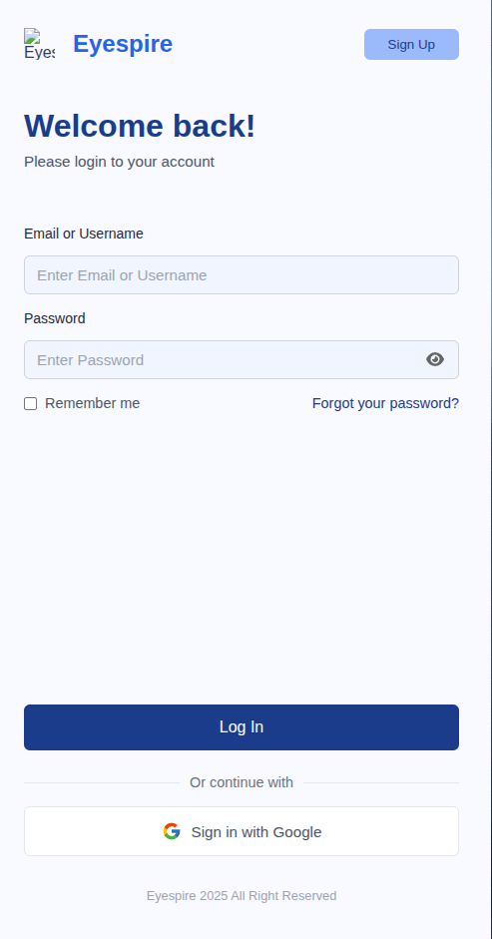

##### Database Access

| **Table** | **CRUD** | **Description** |
| --- | --- | --- |
| User | R | Verify UserName & Password information |

##### SQL Commands:

***"Spring Data JPA, utilizing Hibernate as its JPA provider, adheres to the Object-Relational Mapping (ORM) structure. This abstraction allows developers to interact with the database through entity classes, thereby eliminating the need to write raw SQL commands manually."***

### 1.2 Sign out

### 1.3 Register

##### UI Design

##### 

##### 

##### Database Access

| **Table** | **CRUD** | **Description** |
| --- | --- | --- |
| User | C | Create new field in table User |

##### SQL Commands:

"Spring Data JPA, utilizing Hibernate as its JPA provider, adheres to the Object-Relational Mapping (ORM) structure. This abstraction allows developers to interact with the database through entity classes, thereby eliminating the need to write raw SQL commands manually."

### 1.4 Forgot Password

##### UI Design

##### Database Access

| **Table** | **CRUD** | **Description** |
| --- | --- | --- |
| User | U | Create new field password in table User |

##### SQL Commands:

"Spring Data JPA, utilizing Hibernate as its JPA provider, adheres to the Object-Relational Mapping (ORM) structure. This abstraction allows developers to interact with the database through entity classes, thereby eliminating the need to write raw SQL commands manually."

### 1.5 View Profile

##### UI Design

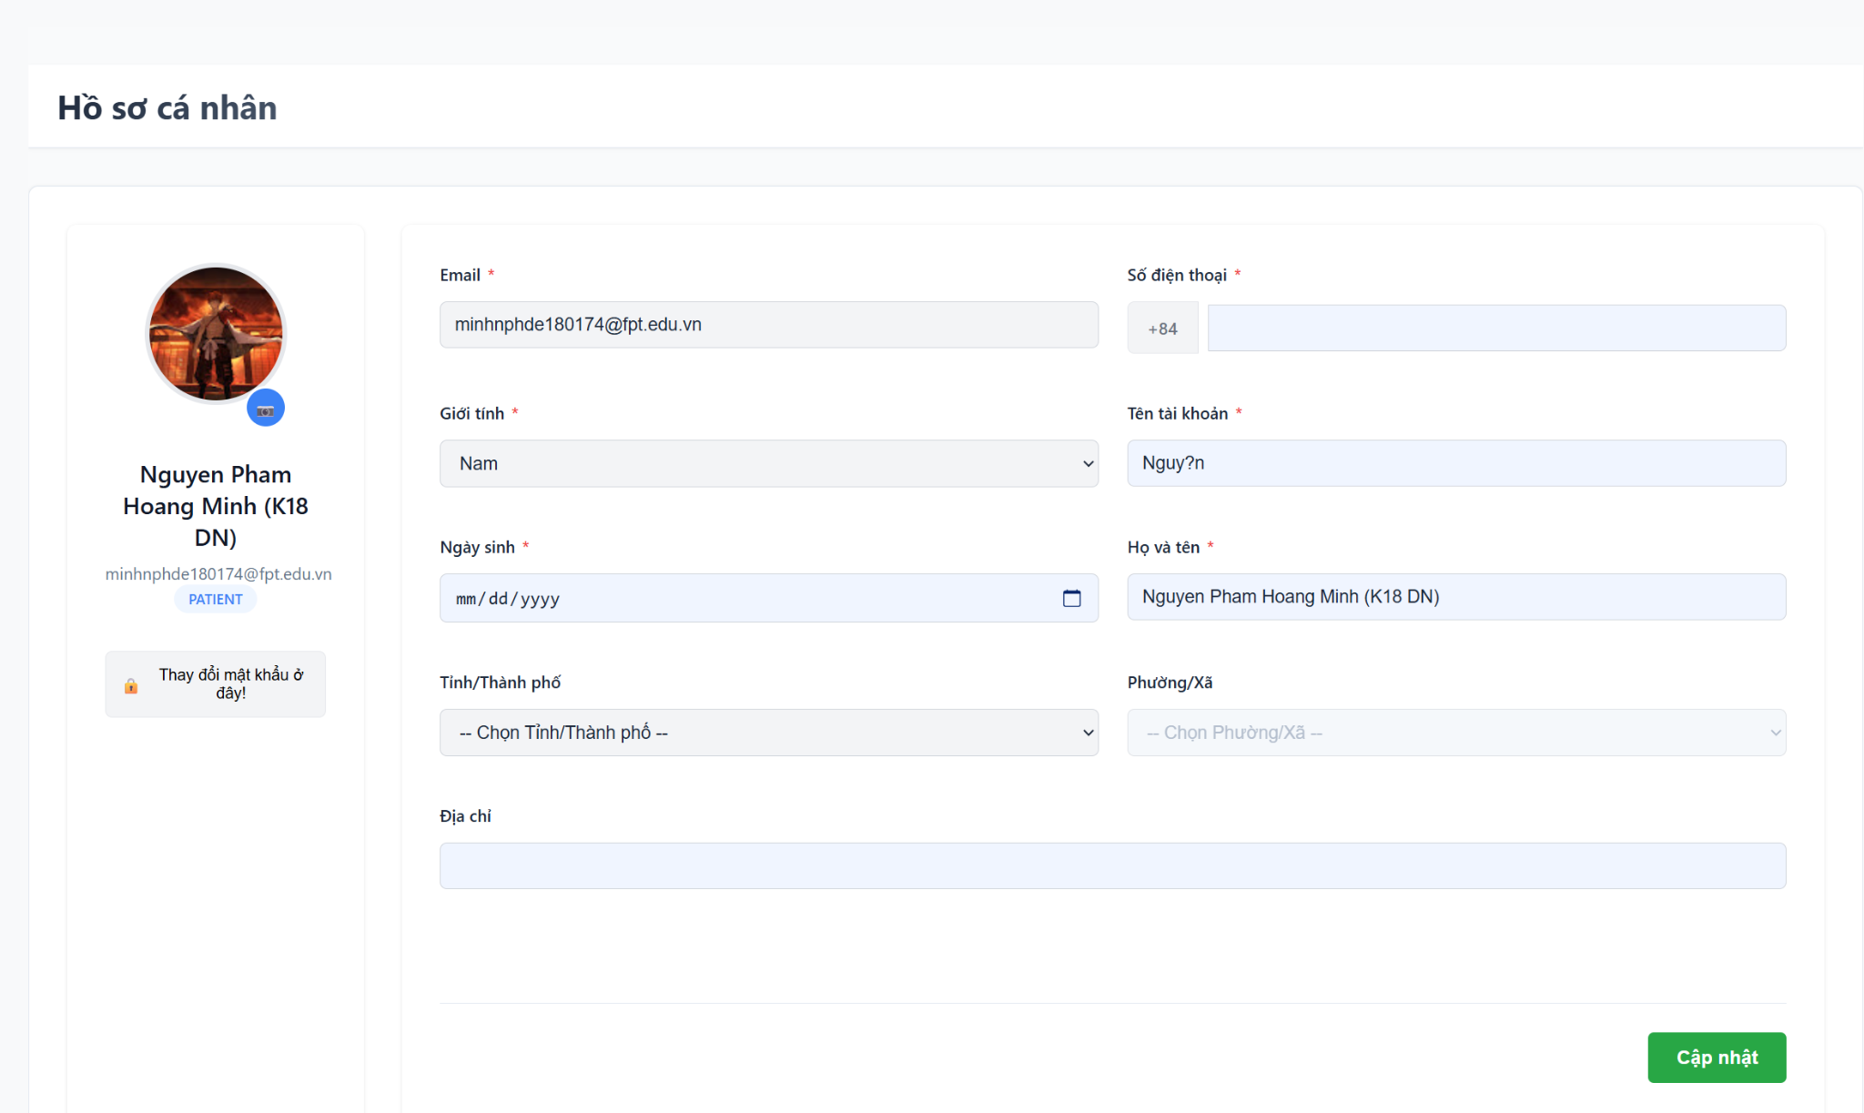

##### Database Access

| **Table** | **CRUD** | **Description** |
| --- | --- | --- |
| User | R | Create new field in table User |

##### SQL Commands:

"Spring Data JPA, utilizing Hibernate as its JPA provider, adheres to the Object-Relational Mapping (ORM) structure. This abstraction allows developers to interact with the database through entity classes, thereby eliminating the need to write raw SQL commands manually."

### 1.6 Change Password

##### UI Design

##### Database Access

| **Table** | **CRUD** | **Description** |
| --- | --- | --- |
| User | U | Update column password for user with email |

##### SQL Commands:

"Spring Data JPA, utilizing Hibernate as its JPA provider, adheres to the Object-Relational Mapping (ORM) structure. This abstraction allows developers to interact with the database through entity classes, thereby eliminating the need to write raw SQL commands manually."

### 1.7 Update Profile

##### UI Design

##### Database Access

| **Table** | **CRUD** | **Description** |
| --- | --- | --- |
| User | U | Update fields relation User profile in table User |

##### SQL Commands:

"Spring Data JPA, utilizing Hibernate as its JPA provider, adheres to the Object-Relational Mapping (ORM) structure. This abstraction allows developers to interact with the database through entity classes, thereby eliminating the need to write raw SQL commands manually."

##### 

## 2. Appointments

### 2.1 Book an appointments

##### UI Design

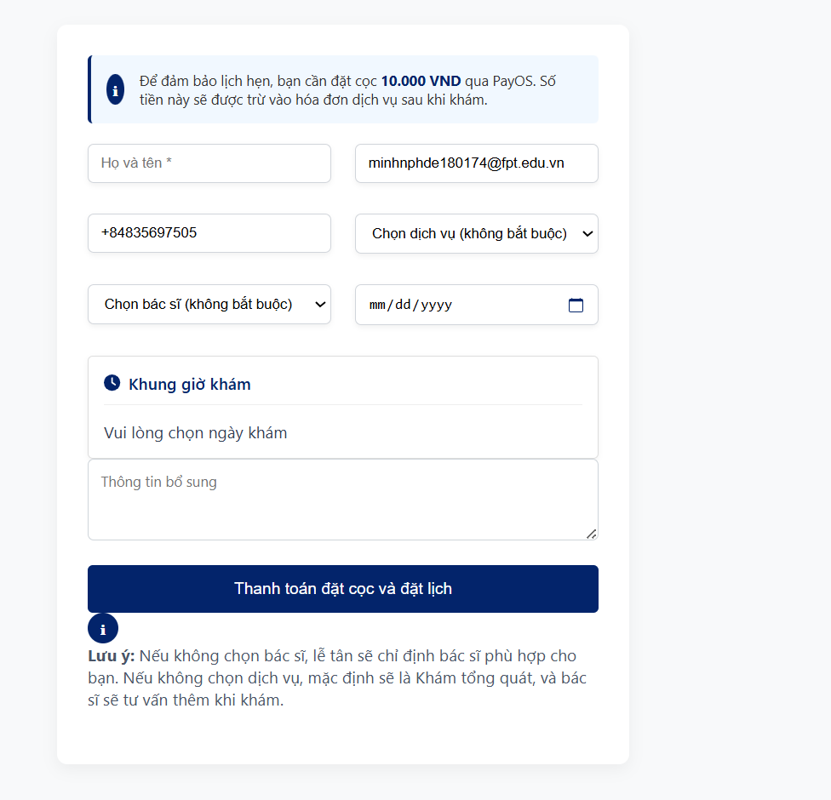

##### Database Access

| **Table** | **CRUD** | **Description** |
| --- | --- | --- |
| User | R | Get UserID to save in table Appointment |
| Appointment | C | Create a record in table Appointment |

##### SQL Commands:

"Spring Data JPA, utilizing Hibernate as its JPA provider, adheres to the Object-Relational Mapping (ORM) structure. This abstraction allows developers to interact with the database through entity classes, thereby eliminating the need to write raw SQL commands manually.**"**

### 2.2 View Appointment List

##### UI Design

##### 

##### Database Access

| **Table** | **CRUD** | **Description** |
| --- | --- | --- |
| Appointment | R | Create a record in table Appointment |

##### 

##### SQL Commands:

"Spring Data JPA, utilizing Hibernate as its JPA provider, adheres to the Object-Relational Mapping (ORM) structure. This abstraction allows developers to interact with the database through entity classes, thereby eliminating the need to write raw SQL commands manually."

### 2.3 View appointment Detail

##### UI Design

##### 

##### Database Access

| **Table** | **CRUD** | **Description** |
| --- | --- | --- |
| Appointment | R | Get data about Appointment |
| MedicalService | E | Get data about MedicalService |

##### SQL Commands:

"Spring Data JPA, utilizing Hibernate as its JPA provider, adheres to the Object-Relational Mapping (ORM) structure. This abstraction allows developers to interact with the database through entity classes, thereby eliminating the need to write raw SQL commands manually."

### 2.4 Update appointment status

##### UI Design

##### 

##### Database Access

| **Table** | **CRUD** | **Description** |
| --- | --- | --- |
| Appointment | U | Update field status in table Appointment |

##### SQL Commands:

"Spring Data JPA, utilizing Hibernate as its JPA provider, adheres to the Object-Relational Mapping (ORM) structure. This abstraction allows developers to interact with the database through entity classes, thereby eliminating the need to write raw SQL commands manually."

### 2.5 Arrange doctor's appointments **UI Design**

##### 

##### Database Access

| **Table** | **CRUD** | **Description** |
| --- | --- | --- |
| Doctor | R | Get doctorID in table Doctor to save in Appointment |
| Appointment | U | Update doctorID to Appointment |

##### SQL Commands:

"Spring Data JPA, utilizing Hibernate as its JPA provider, adheres to the Object-Relational Mapping (ORM) structure. This abstraction allows developers to interact with the database through entity classes, thereby eliminating the need to write raw SQL commands manually."

### 

### 2.6 Edit doctor work schedule

##### UI Design

##### 

##### Database Access

| **Table** | **CRUD** | **Description** |
| --- | --- | --- |
| DoctorSchedule | U | Update schedule in table DoctorScheduler |

##### SQL Commands:

"Spring Data JPA, utilizing Hibernate as its JPA provider, adheres to the Object-Relational Mapping (ORM) structure. This abstraction allows developers to interact with the database through entity classes, thereby eliminating the need to write raw SQL commands manually."

### 2.7 Create doctor's schedule

##### UI Design

##### 

##### Database Access

| **Table** | **CRUD** | **Description** |
| --- | --- | --- |
| DoctorSchedule | C | Create a new record in table DoctorSchedule. |

##### SQL Commands:

"Spring Data JPA, utilizing Hibernate as its JPA provider, adheres to the Object-Relational Mapping (ORM) structure. This abstraction allows developers to interact with the database through entity classes, thereby eliminating the need to write raw SQL commands manually."

### 2.8 Filter appointment list

##### UI Design

##### 

##### Database Access

| **Table** | **CRUD** | **Description** |
| --- | --- | --- |
| Appointment | R | Filter appointments follow conditions. |

##### SQL Commands:

"Spring Data JPA, utilizing Hibernate as its JPA provider, adheres to the Object-Relational Mapping (ORM) structure. This abstraction allows developers to interact with the database through entity classes, thereby eliminating the need to write raw SQL commands manually."

### 2.9 Search appointment

##### UI Design

##### 

##### Database Access

| **Table** | **CRUD** | **Description** |
| --- | --- | --- |
| Appointment | R | Search Appointment follow term |

##### SQL Commands:

"Spring Data JPA, utilizing Hibernate as its JPA provider, adheres to the Object-Relational Mapping (ORM) structure. This abstraction allows developers to interact with the database through entity classes, thereby eliminating the need to write raw SQL commands manually."

### 

## 3. Treatment

### 3.1 Create Medical Records

##### UI Design

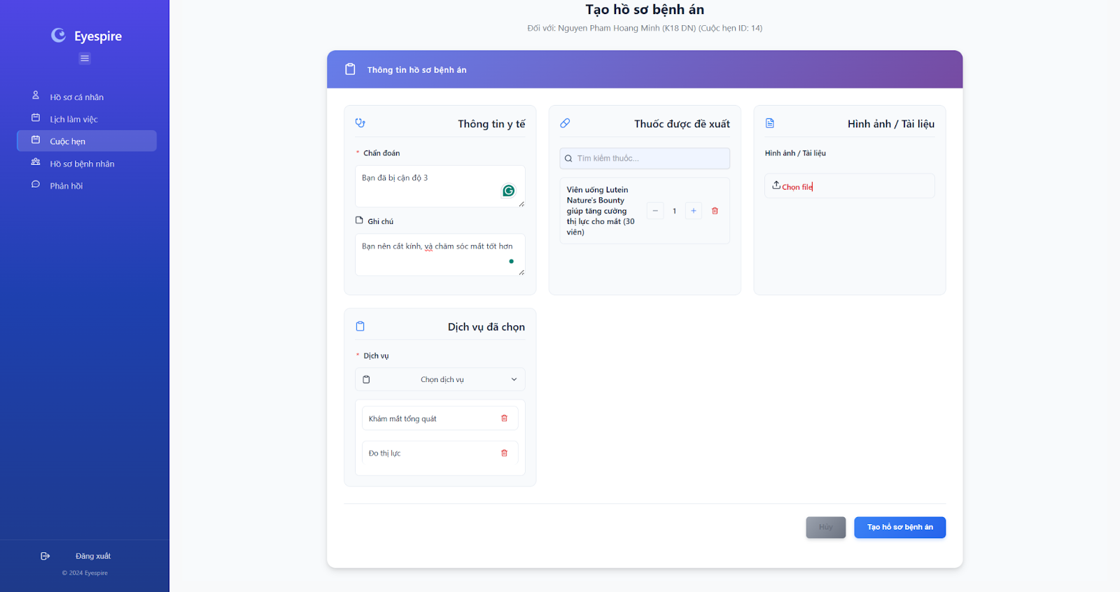

##### Database Access

| **Table** | **CRUD** | **Description** |
| --- | --- | --- |
| Appointment | R | Get appointment align with Medical Record |
| MedicalRecord | C | Create a new field in table MedicalRecord. |

##### SQL Commands:

"Spring Data JPA, utilizing Hibernate as its JPA provider, adheres to the Object-Relational Mapping (ORM) structure. This abstraction allows developers to interact with the database through entity classes, thereby eliminating the need to write raw SQL commands manually."

### 3.2 Update Medical Records

**UI Design**

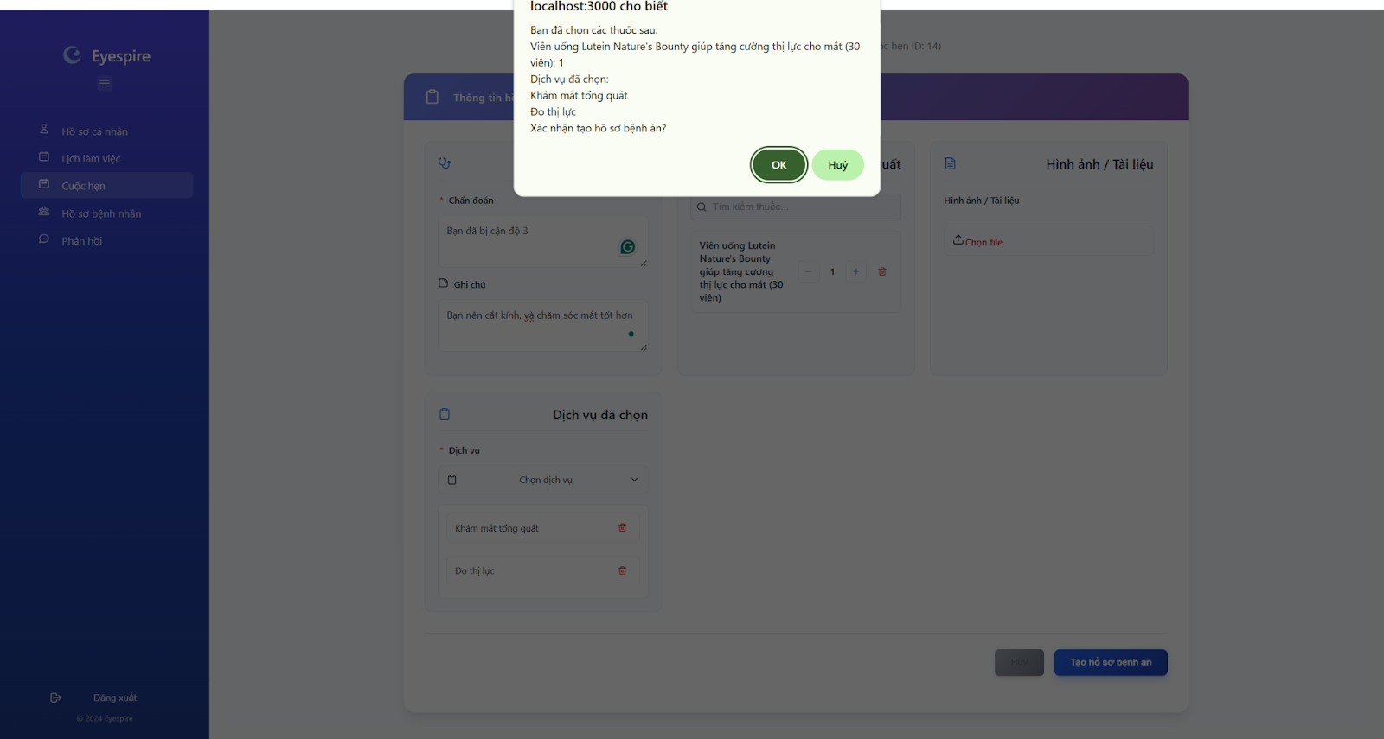

##### Database Access

| **Table** | **CRUD** | **Description** |
| --- | --- | --- |
| MedicalRecord | U | Update field in MedicalRecord |

##### SQL Commands:

"Spring Data JPA, utilizing Hibernate as its JPA provider, adheres to the Object-Relational Mapping (ORM) structure. This abstraction allows developers to interact with the database through entity classes, thereby eliminating the need to write raw SQL commands manually.**"**

### 3.3 View Medical Records

**UI Design**

##### 

##### Database Access

| **Table** | **CRUD** | **Description** |
| --- | --- | --- |
| MedicalRecord | R | View Record of User |
| User | R | Get userID to check in MedicalRecord |

##### SQL Commands:

"Spring Data JPA, utilizing Hibernate as its JPA provider, adheres to the Object-Relational Mapping (ORM) structure. This abstraction allows developers to interact with the database through entity classes, thereby eliminating the need to write raw SQL commands manually."

### 3.4 View Patient Medical Record History

#### UI Design

##### 

##### Database Access

| **Table** | **CRUD** | **Description** |
| --- | --- | --- |
| MedicalRecord | R | View List Record of User |
| User | R | Get userID to check in MedicalRecord |

##### 

##### SQL Commands:

"Spring Data JPA, utilizing Hibernate as its JPA provider, adheres to the Object-Relational Mapping (ORM) structure. This abstraction allows developers to interact with the database through entity classes, thereby eliminating the need to write raw SQL commands manually."

## 4. Order

### 4.1 Add products to Cart

##### UI Design

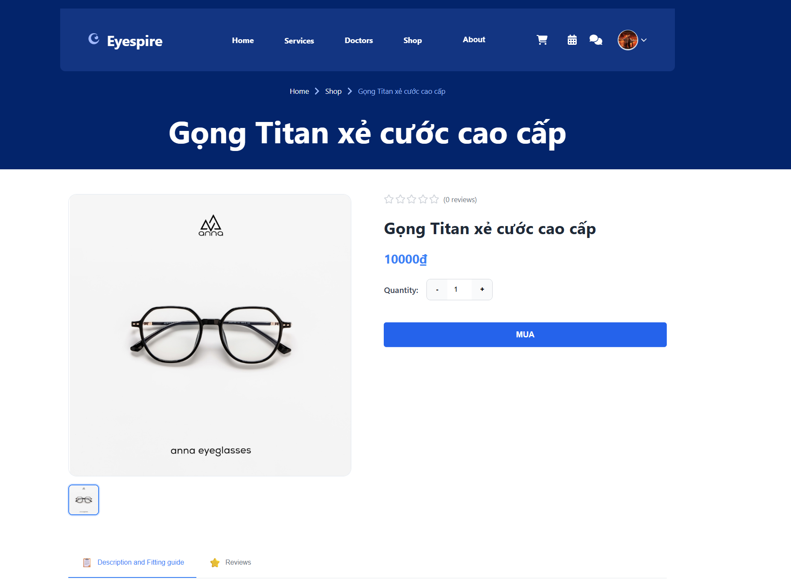

##### 

##### Database Access

| **Table** | **CRUD** | **Description** |
| --- | --- | --- |
| Cart | R | Take cartID to align with product |
| CartItem | C | Create field save cartId and Product |
| Product | R | Take Product to align with Cart |

##### SQL Commands:

"Spring Data JPA, utilizing Hibernate as its JPA provider, adheres to the Object-Relational Mapping (ORM) structure. This abstraction allows developers to interact with the database through entity classes, thereby eliminating the need to write raw SQL commands manually."

### 4.2 View Card List

**UI Design**



##### Database Access

| **Table** | **CRUD** | **Description** |
| --- | --- | --- |
| Cart | R | Take cartID to check in CartItem |
| CartItem | R | Get ProductID to find Product |
| Product | R | Take Product to Show in cart Interface |

##### 

##### SQL Commands:

"Spring Data JPA, utilizing Hibernate as its JPA provider, adheres to the Object-Relational Mapping (ORM) structure. This abstraction allows developers to interact with the database through entity classes, thereby eliminating the need to write raw SQL commands manually."

### 4.3 Clear Cart

##### 

**UI Design**

##### 

##### Database Access

| **Table** | **CRUD** | **Description** |
| --- | --- | --- |
| Cart | R | Take cartID to check cartItems |
| CartItems | D | Delete all item with carID |

##### SQL Commands:

"Spring Data JPA, utilizing Hibernate as its JPA provider, adheres to the Object-Relational Mapping (ORM) structure. This abstraction allows developers to interact with the database through entity classes, thereby eliminating the need to write raw SQL commands manually."

### 4.4 View Order List

### 

**UI Design**

##### 

##### Database Access

| **Table** | **CRUD** | **Description** |
| --- | --- | --- |
| Order | R | Get list Order show in Order Interface |

##### SQL Commands:

"Spring Data JPA, utilizing Hibernate as its JPA provider, adheres to the Object-Relational Mapping (ORM) structure. This abstraction allows developers to interact with the database through entity classes, thereby eliminating the need to write raw SQL commands manually."

### 4.5 View Order Status

### 

**UI Design**

##### 

##### Database Access

| **Table** | **CRUD** | **Description** |
| --- | --- | --- |
| Order | R | Get Order Status show in Order Interface |

##### 

##### SQL Commands:

"Spring Data JPA, utilizing Hibernate as its JPA provider, adheres to the Object-Relational Mapping (ORM) structure. This abstraction allows developers to interact with the database through entity classes, thereby eliminating the need to write raw SQL commands manually."

### 4.6 View Order Details

### 

**UI Design**

##### 

##### Database Access

| **Table** | **CRUD** | **Description** |
| --- | --- | --- |
| Order | R | Get ORderID |
| OrderItem | R | Get ProductID with orderID in table Order |
| Product | R | Get Product In Order |

##### SQL Commands:

"Spring Data JPA, utilizing Hibernate as its JPA provider, adheres to the Object-Relational Mapping (ORM) structure. This abstraction allows developers to interact with the database through entity classes, thereby eliminating the need to write raw SQL commands manually.**"**

### 4.7 Update Order

### 

**UI Design**

##### 

##### Database Access

| **Table** | **CRUD** | **Description** |
| --- | --- | --- |
| Order | U | Update order Status or Address |

##### SQL Commands:

**"Spring Data JPA, utilizing Hibernate as its JPA provider, adheres to the Object-Relational Mapping (ORM) structure. This abstraction allows developers to interact with the database through entity classes, thereby eliminating the need to write raw SQL commands manually."**

### 4.8 Create Order

**UI Design**

##### 

##### Database Access

| **Table** | **CRUD** | **Description** |
| --- | --- | --- |
| Order | C | Create a new field Order |
| OrderItem | C | Create field to save orderID and OrderItem |
| User | R | Get UserID to save in Order |
| Product | R | Get Product to align OrderItem |

##### SQL Commands:

**"**Spring Data JPA, utilizing Hibernate as its JPA provider, adheres to the Object-Relational Mapping (ORM) structure. This abstraction allows developers to interact with the database through entity classes, thereby eliminating the need to write raw SQL commands manually."

## 5 .Discussing

### 5.1 Chat with Chatbox

##### UI Design

##### 

##### Database Access

| **Table** | **CRUD** | **Description** |
| --- | --- | --- |
| ChatBoxSession | C | Create new field in ChatBoxSession |

##### SQL Commands:

"Spring Data JPA, utilizing Hibernate as its JPA provider, adheres to the Object-Relational Mapping (ORM) structure. This abstraction allows developers to interact with the database through entity classes, thereby eliminating the need to write raw SQL commands manually."

### 5.2 View Message

##### UI Design

##### 

##### Database Access

| **Table** | **CRUD** | **Description** |
| --- | --- | --- |
| Message | R | Reader field in table |

##### SQL Commands:

"Spring Data JPA, utilizing Hibernate as its JPA provider, adheres to the Object-Relational Mapping (ORM) structure. This abstraction allows developers to interact with the database through entity classes, thereby eliminating the need to write raw SQL commands manually."

### 5.3 Send Message

##### UI Design

##### 

##### Database Access

| **Table** | **CRUD** | **Description** |
| --- | --- | --- |
| Message | C | Create new field in table Message |

##### SQL Commands:

"Spring Data JPA, utilizing Hibernate as its JPA provider, adheres to the Object-Relational Mapping (ORM) structure. This abstraction allows developers to interact with the database through entity classes, thereby eliminating the need to write raw SQL commands manually."

### 5.4 View Contact List

##### UI Design

##### 

##### Database Access

##### 

##### SQL Commands:

"Spring Data JPA, utilizing Hibernate as its JPA provider, adheres to the Object-Relational Mapping (ORM) structure. This abstraction allows developers to interact with the database through entity classes, thereby eliminating the need to write raw SQL commands manually."

### 5.5 Search Contact

##### UI Design

##### 

##### Database Access

| **Table** | **CRUD** | **Description** |
| --- | --- | --- |
| Message | R | Reader User from table Message |

##### SQL Commands:

"Spring Data JPA, utilizing Hibernate as its JPA provider, adheres to the Object-Relational Mapping (ORM) structure. This abstraction allows developers to interact with the database through entity classes, thereby eliminating the need to write raw SQL commands manually."

### 6. Payment

#### 6.1 Make Payment

##### UI Design

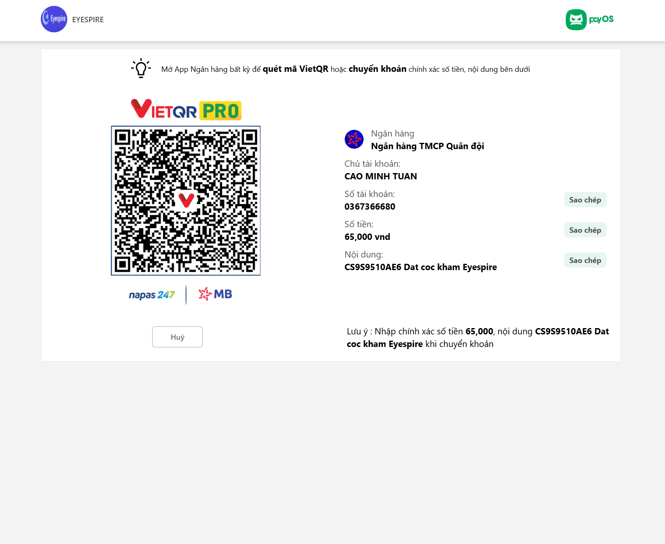

##### Database Access

| **Table** | **CRUD** | **Description** |
| --- | --- | --- |
| Payment | C | Create new field in table Payment |

##### SQL Commands:

"Spring Data JPA, utilizing Hibernate as its JPA provider, adheres to the Object-Relational Mapping (ORM) structure. This abstraction allows developers to interact with the database through entity classes, thereby eliminating the need to write raw SQL commands manually."

### 6.2 View Payment List

##### UI Design

##### 

##### Database Access

| **Table** | **CRUD** | **Description** |
| --- | --- | --- |
| Payment | R | Get all field form table Payment |

##### 

##### 

##### SQL Commands:

"Spring Data JPA, utilizing Hibernate as its JPA provider, adheres to the Object-Relational Mapping (ORM) structure. This abstraction allows developers to interact with the database through entity classes, thereby eliminating the need to write raw SQL commands manually."

### 6.3 View Payment Detail

##### UI Design

##### 

##### Database Access

| **Table** | **CRUD** | **Description** |
| --- | --- | --- |
| Payment | R | Get Payment Record from table Payment |

##### SQL Commands:

"Spring Data JPA, utilizing Hibernate as its JPA provider, adheres to the Object-Relational Mapping (ORM) structure. This abstraction allows developers to interact with the database through entity classes, thereby eliminating the need to write raw SQL commands manually."

### 6.4 Make Repayment

##### UI Design

##### 

##### Database Access

| **Table** | **CRUD** | **Description** |
| --- | --- | --- |
| RePayment | R | Read Payment which can refund |

##### SQL Commands:

"Spring Data JPA, utilizing Hibernate as its JPA provider, adheres to the Object-Relational Mapping (ORM) structure. This abstraction allows developers to interact with the database through entity classes, thereby eliminating the need to write raw SQL commands manually."

### 

### 6.5 View Repayment List

##### UI Design

##### 

##### Database Access

| **Table** | **CRUD** | **Description** |
| --- | --- | --- |
| RePayment | C | List RePayment show to Inteface |

##### SQL Commands:

"Spring Data JPA, utilizing Hibernate as its JPA provider, adheres to the Object-Relational Mapping (ORM) structure. This abstraction allows developers to interact with the database through entity classes, thereby eliminating the need to write raw SQL commands manually."

### 

## 7.Feedback

### 7.1 Provide Appointment Feedback

##### UI Design

##### 

##### Database Access

| **Table** | **CRUD** | **Description** |
| --- | --- | --- |
| Appointment | R | Get Appointment from table Appointment |
| AppointmentFeedback | C | Create AppointmentFeedback align with Appoint |

##### SQL Commands:

"Spring Data JPA, utilizing Hibernate as its JPA provider, adheres to the Object-Relational Mapping (ORM) structure. This abstraction allows developers to interact with the database through entity classes, thereby eliminating the need to write raw SQL commands manually."

### 7.2 View Appointment Feedback

##### UI Design

##### 

##### Database Access

| **Table** | **CRUD** | **Description** |
| --- | --- | --- |
| Appointment | R | Get Appointment from table Appointment |
| AppointmentFeedback | C | Read AppointmentFeedback align with Appoint |

##### 

##### SQL Commands:

"Spring Data JPA, utilizing Hibernate as its JPA provider, adheres to the Object-Relational Mapping (ORM) structure. This abstraction allows developers to interact with the database through entity classes, thereby eliminating the need to write raw SQL commands manually."

### 7.3 Provide Product Feedback

### 

##### UI Design

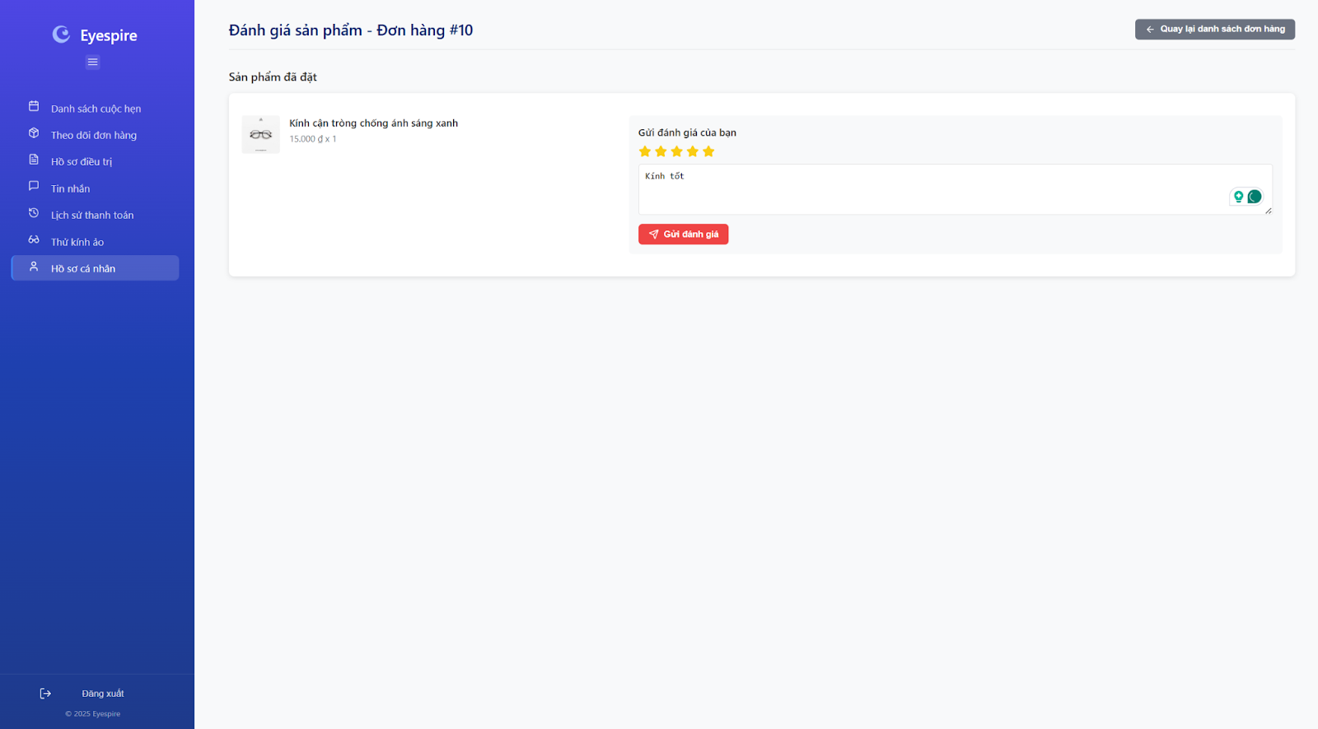

##### Database Access

| **Table** | **CRUD** | **Description** |
| --- | --- | --- |
| Product | R | Get Product from table Product |
| ProductFeedback | C | Read ProductFeedback align with ProductFeedback |

##### 

##### SQL Commands:

"Spring Data JPA, utilizing Hibernate as its JPA provider, adheres to the Object-Relational Mapping (ORM) structure. This abstraction allows developers to interact with the database through entity classes, thereby eliminating the need to write raw SQL commands manually."

### 7.4 View Product Feedback

### 

##### UI Design

##### 

##### Database Access

| **Table** | **CRUD** | **Description** |
| --- | --- | --- |
| ProductFeedback | R | Read ProductFeedback from ProductFeedback |

##### SQL Commands:

"Spring Data JPA, utilizing Hibernate as its JPA provider, adheres to the Object-Relational Mapping (ORM) structure. This abstraction allows developers to interact with the database through entity classes, thereby eliminating the need to write raw SQL commands manually."

### 

## 8. Medical Service

### 8.1 Create Medical Service

##### UI Design

##### 

##### Database Access

| **Table** | **CRUD** | **Description** |
| --- | --- | --- |
| MedicalService | C | Create new field in table MedicalService |

##### SQL Commands:

"Spring Data JPA, utilizing Hibernate as its JPA provider, adheres to the Object-Relational Mapping (ORM) structure. This abstraction allows developers to interact with the database through entity classes, thereby eliminating the need to write raw SQL commands manually."

### 8.2 Update Medical Service

##### UI Design

##### 

##### Database Access

| **Table** | **CRUD** | **Description** |
| --- | --- | --- |
| MedicalService | U | Update field in table MedicalService |

##### 

##### SQL Commands:

"Spring Data JPA, utilizing Hibernate as its JPA provider, adheres to the Object-Relational Mapping (ORM) structure. This abstraction allows developers to interact with the database through entity classes, thereby eliminating the need to write raw SQL commands manually."

### 8.3 Delete Medical Service

##### UI Design

##### 

##### Database Access

| **Table** | **CRUD** | **Description** |
| --- | --- | --- |
| MedicalService | D | Delete new field in table MedicalService |

##### 

##### SQL Commands:

"Spring Data JPA, utilizing Hibernate as its JPA provider, adheres to the Object-Relational Mapping (ORM) structure. This abstraction allows developers to interact with the database through entity classes, thereby eliminating the need to write raw SQL commands manually."

### 8.4 View List Medical Service

##### UI Design

##### 

##### Database Access

| **Table** | **CRUD** | **Description** |
| --- | --- | --- |
| MedicalService | R | View field list in table MedicalService |

##### 

##### SQL Commands:

"Spring Data JPA, utilizing Hibernate as its JPA provider, adheres to the Object-Relational Mapping (ORM) structure. This abstraction allows developers to interact with the database through entity classes, thereby eliminating the need to write raw SQL commands manually."

### 8.5 View Medical Service Details

##### UI Design

##### 

##### Database Access

| **Table** | **CRUD** | **Description** |
| --- | --- | --- |
| MedicalService | R | Get field in table MedicalService |

##### 

##### SQL Commands:

"Spring Data JPA, utilizing Hibernate as its JPA provider, adheres to the Object-Relational Mapping (ORM) structure. This abstraction allows developers to interact with the database through entity classes, thereby eliminating the need to write raw SQL commands manually."

### 8.6 Search Medical Services

##### UI Design

##### 

##### Database Access

| **Table** | **CRUD** | **Description** |
| --- | --- | --- |
| MedicalService | R | Reader filed in table MedicalService with condition |

##### SQL Commands:

"Spring Data JPA, utilizing Hibernate as its JPA provider, adheres to the Object-Relational Mapping (ORM) structure. This abstraction allows developers to interact with the database through entity classes, thereby eliminating the need to write raw SQL commands manually."

### 

## 

## 9. Store

### 

### 9.1 Search Product

##### UI Design

##### 

##### Database Access

| **Table** | **CRUD** | **Description** |
| --- | --- | --- |
| Product | R | Read field in table product with condition |

##### SQL Commands:

"Spring Data JPA, utilizing Hibernate as its JPA provider, adheres to the Object-Relational Mapping (ORM) structure. This abstraction allows developers to interact with the database through entity classes, thereby eliminating the need to write raw SQL commands manually."

### 

### 9.2 Filter Product List

##### UI Design

##### 

##### Database Access

| **Table** | **CRUD** | **Description** |
| --- | --- | --- |
| Product | R | Read Product List with condition |

##### SQL Commands:

"Spring Data JPA, utilizing Hibernate as its JPA provider, adheres to the Object-Relational Mapping (ORM) structure. This abstraction allows developers to interact with the database through entity classes, thereby eliminating the need to write raw SQL commands manually."

### 

### 9.3 View Product List

##### UI Design

##### 

##### Database Access

| **Table** | **CRUD** | **Description** |
| --- | --- | --- |
| Product | R | Read all field in table Product |

##### SQL Commands:

"Spring Data JPA, utilizing Hibernate as its JPA provider, adheres to the Object-Relational Mapping (ORM) structure. This abstraction allows developers to interact with the database through entity classes, thereby eliminating the need to write raw SQL commands manually."

### 

### 9.4 Add Products to Store

##### UI Design

##### 

##### Database Access

| **Table** | **CRUD** | **Description** |
| --- | --- | --- |
| Product | C | Create new field in table Product |

##### SQL Commands:

"Spring Data JPA, utilizing Hibernate as its JPA provider, adheres to the Object-Relational Mapping (ORM) structure. This abstraction allows developers to interact with the database through entity classes, thereby eliminating the need to write raw SQL commands manually."

### 

### 9.5 Delete Products From Store

##### UI Design

##### 

##### Database Access

| **Table** | **CRUD** | **Description** |
| --- | --- | --- |
| Product | D | Delete field in table Product |

##### SQL Commands:

"Spring Data JPA, utilizing Hibernate as its JPA provider, adheres to the Object-Relational Mapping (ORM) structure. This abstraction allows developers to interact with the database through entity classes, thereby eliminating the need to write raw SQL commands manually."

### 

### 9.6 Edit Product

##### UI Design

##### 

##### Database Access

| **Table** | **CRUD** | **Description** |
| --- | --- | --- |
| Product | U | Update field in table Product |

##### SQL Commands:

"Spring Data JPA, utilizing Hibernate as its JPA provider, adheres to the Object-Relational Mapping (ORM) structure. This abstraction allows developers to interact with the database through entity classes, thereby eliminating the need to write raw SQL commands manually."

## 10. System Management

### 10.1 View User Statistics

##### UI Design

##### 

##### Database Access

| **Table** | **CRUD** | **Description** |
| --- | --- | --- |
| User | R | Read User information to create statistics |
| User | C | Add field last_login, created_at, updated_at |

##### SQL Commands:

"Spring Data JPA, utilizing Hibernate as its JPA provider, adheres to the Object-Relational Mapping (ORM) structure. This abstraction allows developers to interact with the database through entity classes, thereby eliminating the need to write raw SQL commands manually."

### 

### 10.2 View Account Detail

##### UI Design

##### 

##### Database Access

| **Table** | **CRUD** | **Description** |
| --- | --- | --- |
| User | R | Read User account details |
| User | U | Update User account status (lock/ unlock) |

##### SQL Commands:

"Spring Data JPA, utilizing Hibernate as its JPA provider, adheres to the Object-Relational Mapping (ORM) structure. This abstraction allows developers to interact with the database through entity classes, thereby eliminating the need to write raw SQL commands manually."

### 

### 10.3 View Usage Statistics

##### UI Design

##### 

##### Database Access

| **Table** | **CRUD** | **Description** |
| --- | --- | --- |
| Appointment | R | Appointment statistics |
| AppointmentInvoice | R | Calculate appointment revenue |
| Order | R | Order and revenue statistics |
| User | R | Customer statistics |

##### SQL Commands:

"Spring Data JPA, utilizing Hibernate as its JPA provider, adheres to the Object-Relational Mapping (ORM) structure. This abstraction allows developers to interact with the database through entity classes, thereby eliminating the need to write raw SQL commands manually."

### 

### 10.4 Update Account Status

##### UI Design

##### 

##### Database Access

| **Table** | **CRUD** | **Description** |
| --- | --- | --- |
| User | U | Update field status |
| User | U | Update field updated_at |

##### SQL Commands:

Using Spring DATA JPA( Hibernate+ JPA) follow ORM structure so We do not have to write SQL commands

### 

### 10.5 View Store Statistics

##### UI Design

##### 

##### Database Access

| **Table** | **CRUD** | **Description** |
| --- | --- | --- |
| Product | R | Product and inventory statistics |
| Order | R | Sales statistics |
| OrderItem | R | Chi tiết sản phẩm bán |

##### SQL Commands:

Using Spring DATA JPA( Hibernate+ JPA) follow ORM structure so We do not have to write SQL commands

### 

### 10.6 Create Staff

##### UI Design

##### 

##### Database Access

| **Table** | **CRUD** | **Description** |
| --- | --- | --- |
| User | C | Create a new employee account |
| Doctor | C | Create doctor information (if role = DOCTOR) |

##### SQL Commands:

"Spring Data JPA, utilizing Hibernate as its JPA provider, adheres to the Object-Relational Mapping (ORM) structure. This abstraction allows developers to interact with the database through entity classes, thereby eliminating the need to write raw SQL commands manually."

### 10.7 View Appointment Statistics Reports

##### UI Design

##### 

##### Database Access

| **Table** | **CRUD** | **Description** |
| --- | --- | --- |
| Appointment | R | Appointment statistics |
| Doctor | R | Doctor information |
| MedicalService | R | Service is booked |
| AppointmentInvoice | R | Payment information |

##### SQL Commands:

"Spring Data JPA, utilizing Hibernate as its JPA provider, adheres to the Object-Relational Mapping (ORM) structure. This abstraction allows developers to interact with the database through entity classes, thereby eliminating the need to write raw SQL commands manually."

### 10.8 View Product Sales Statistics

##### UI Design

##### 

##### Database Access

| **Table** | **CRUD** | **Description** |
| --- | --- | --- |
| Order | R | Order statistics |
| OrderItem | R | Details of products sold |
| Product | R | Product information |

##### SQL Commands:

"Spring Data JPA, utilizing Hibernate as its JPA provider, adheres to the Object-Relational Mapping (ORM) structure. This abstraction allows developers to interact with the database through entity classes, thereby eliminating the need to write raw SQL commands manually."

# IV. Appendix

## 1. Assumptions & Dependencies

*[Record any assumptions that were made when conceiving the project and writing this vision and scope document. Note any major dependencies the project must rely upon for success, such as specific technologies, third-party vendors, development partners, or other business relationships.]*

<<Sample:

AS-1: Systems with appropriate user interfaces will be available for cafeteria employees to process the expected volume of meals ordered.

AS-2: Cafeteria staff and vehicles will be available to deliver all meals for specified delivery time slots within 15 minutes of the requested delivery time.

DE-1: If a restaurant has its own on-line ordering system, the Cafeteria Ordering System must be able to communicate with it bi-directionally.

>>

## 2. Limitations & Exclusions

*[Identify any product features or characteristics that a stakeholder might anticipate, but which are not planned to be included in the new product]*

## 3. Business Rules

| **ID** | **Business Rule** | **Business Rule Description** |
| --- | --- | --- |
| BR-1 | Role-based appointment viewing | Only users with the role of "admin" or "receptionist" can view all appointments. |
| BR-2 | Real-time appointment updates | Appointment data must be updated in real time. |
| BR-3 | Restricted modification of appointments | Completed or cancelled appointments cannot be modified (unless the user has special permissions). |
| BR-4 | Appointment rejection permissions | Only users with the role of “receptionist” can reject appointments. |
| BR-5 | Restricted modification of rejected appointments | Once rejected, appointments cannot be modified without special permissions. |
| BR-6 | Appointment detail updates | Only receptionists or admins can update appointment details. |
| BR-7 | Modification of completed/canceled appointments | Appointments that are completed or canceled can only be modified with special rights. |
| BR-8 | Doctor schedule alignment | The assignment of a doctor must align with the doctor’s schedule. |
| BR-9 | Doctor availability for appointments | The selected doctor to confirm the appointment must be available at the designated time. |
| BR-10 | Doctor schedule modification | Only Admin/Receptionist is permitted to modify a doctor’s schedule. |
| BR-11 | Conflict-free schedule changes | Changes must not conflict with existing appointments (unless an override is allowed). |
| BR-12 | Doctor schedule creation | Only admins or receptionists can create Doctor’s schedules. |
| BR-13 | No duplicate schedules | Duplicate scheduling with an existing schedule is not allowed. |
| BR-14 | Real-time filter application | Filters must be applied in real time. |
| BR-15 | Role-based filter access | Only admin or receptionist roles can use the filtering function. |
| BR-16 | Patient appointment selection | Patients can choose date/time, doctor, or service. |
| BR-17 | Pending appointment status | Appointments must be marked "Pending" until reviewed by the receptionist. |
| BR-18 | Real-time appointment detail updates | The system must ensure appointment details are updated in real-time. |
| BR-19 | User account requirements | Users must have an account with a unique email/username and password, or a linked Gmail account. |
| BR-20 | Account security enforcement | The system must enforce password complexity and account security (e.g., multi-factor authentication if enabled). |
| BR-21 | Role-based access control | Access rights are role-based (Doctor, Patient, Store Manager) and restrict users to their designated functionalities. |
| BR-22 | Gmail authentication compliance | Gmail authentication must comply with the Gmail Authentication Service’s security protocols. |
| BR-23 | Sign-out permissions | Only authenticated users can initiate a sign-out action. |
| BR-24 | Secure session termination | The system must securely terminate the session and clear all sensitive data. |
| BR-25 | Logout availability | Logout must be available from all user interfaces (e.g., dashboard, settings). |
| BR-26 | Terms of service agreement | The user must agree to the terms of service before completing the registration. |
| BR-27 | Email verification requirement | The account must require email verification to activate the account (email confirmation is mandatory). |
| BR-28 | Unverified account restrictions | Unverified accounts will not be allowed to log in or will have limited privileges. |
| BR-29 | Valid contact for account recovery | The user must provide a valid email address or phone number associated with an existing account. |
| BR-30 | Expiring reset links/OTPs | Password reset links and OTPs must expire after a set time (e.g., 30 minutes). |
| BR-31 | Single-use reset links | If the reset link is used, it can only be used once. |
| BR-32 | Profile viewing permissions | The user can only view their own profile, except for Admin users, who can view all user profiles. |
| BR-33 | Admin profile management | Admins should have the ability to view and edit other users’ profiles for management purposes. |
| BR-34 | Password change verification | The user must provide the correct current password to change their password. |
| BR-35 | Account deletion permissions | Only the user who owns the account can delete it (except in cases where Admin has specific permissions). |
| BR-36 | Account restoration period | Once deleted, the account can be restored for 30 days before being permanently deleted. |
| BR-37 | Deletion failure handling | If the deletion process fails due to a system or network issue, the user must be informed and allowed to retry. |
| BR-38 | Profile update permissions | Only the profile owner (or an Admin with management rights) is allowed to update the profile. |
| BR-39 | Profile data validation | Updated data must be validated (format checks, required fields, etc.). |
| BR-40 | Message delivery to receptionist | The system must ensure that the message is successfully delivered to the receptionist. |
| BR-41 | Two-way messaging support | The user must be able to reply; two-way messaging support is essential. |
| BR-42 | New message notifications | The user should be notified when a new message is received. |
| BR-43 | ChatBox query handling | The ChatBox should respond to common queries related to services, appointment scheduling, and product inquiries. |
| BR-44 | ChatBox escalation | If the ChatBox cannot answer a question, it should escalate the issue appropriately (e.g., offering to connect the user with a human representative). |
| BR-45 | ChatBox interaction logging | The system should log all ChatBox interactions for analysis, training purposes, or future reference. |
| BR-46 | Efficient search query processing | The system must process search queries efficiently and return relevant services from the database. |
| BR-47 | Search filter support | The system should allow for basic keyword search and may support advanced search filters (e.g., price range, category). |
| BR-48 | Empty search query handling | The system must handle empty search queries gracefully and prompt the user to provide a valid input. |
| BR-49 | Active service display | Only services marked as "active" in the database are displayed. |
| BR-50 | Healthcare regulation compliance for services | Service details must comply with healthcare regulations (e.g., no misleading information). |
| BR-51 | Detailed information compliance | Detailed information must comply with healthcare regulations (e.g., accurate cost and duration, no misleading information). |
| BR-52 | Public access to service list | Guests and Patients have the same level of access to the service list and detail (no authentication required). |
| BR-53 | Feedback eligibility | Only patients who have received a service can provide feedback. |
| BR-54 | Feedback requirements | Feedback must include a rating; comments are optional. |
| BR-55 | Feedback association | Feedback must be associated with the correct service in the database. |
| BR-56 | Medical record access | Only patients with authenticated access can access and download their medical records. |
| BR-57 | Medical record content | The record must include all relevant medical data (e.g., diagnosis, treatment history) and comply with privacy regulations. |
| BR-58 | Medical record security | The system must encrypt the PDF file during download to ensure data security. |
| BR-59 | Appointment cancellation permissions | Only patients with authenticated access can cancel their appointments. |
| BR-60 | Cancellation policy compliance | Cancellations must adhere to the healthcare provider’s policy (e.g., a minimum notice period). |
| BR-61 | Cancellation notifications | The system must notify relevant staff or update schedules after a cancellation. |
| BR-62 | Order placement permissions | Only patients with authenticated access can place orders. |
| BR-63 | Real-time inventory for orders | Orders must reflect real-time inventory availability. |
| BR-64 | Payment and shipping compliance | The system must comply with payment and shipping regulations (e.g., secure transactions). |
| BR-65 | Search function access | The search function is available only to Patients who are logged into the system. |
| BR-66 | Real-time inventory in search | Search results must reflect real-time inventory availability. |
| BR-67 | Multiple search methods | The system must support multiple search methods (e.g., keywords, categories). |
| BR-68 | Personalized search recommendations | Search activity may be linked to the patient’s profile for personalized recommendations. |
| BR-69 | Active product display | Only products marked as "active" and in stock are displayed. |
| BR-70 | Real-time product list updates | The system must ensure the product list is updated in real-time. |
| BR-71 | Tailored product list | The product list may be tailored based on the patient’s medical history or preferences (if applicable). |
| BR-72 | Real-time cart inventory | The cart must reflect real-time inventory availability. |
| BR-73 | Cart quantity limits | The system must limit the quantity added based on stock levels. |
| BR-74 | Cart modification permissions | Only the patient can modify their own cart. |
| BR-75 | Product availability after removal | Removed products are immediately available for other users. |
| BR-76 | Order status visibility | Only the patient can view their own order status. |
| BR-77 | Accurate order status | Order status must be up-to-date and accurate. |
| BR-78 | Order details visibility | Only the patient can view their own order details. |
| BR-79 | Accurate order details | Order details must be accurate and complete. |
| BR-80 | Order feedback eligibility | Only patients with completed orders can provide feedback. |
| BR-81 | Order feedback requirements | Feedback must include a rating; comments are optional. |
| BR-82 | Order status update permissions | Only the Store Manager can update order status. |
| BR-83 | Order status workflow | Status changes must follow a predefined workflow (e.g., Processing → Shipped → Delivered). |
| BR-84 | Product addition permissions | Only the Store Manager can add products to the store. |
| BR-85 | Unique product names | Each product must have a unique name. |
| BR-86 | Product deletion permissions | Only the Store Manager can delete products from the store. |
| BR-87 | Product deletion restrictions | Products with active orders cannot be deleted. |
| BR-88 | Product detail editing | Only the Store Manager can edit product details. |
| BR-89 | Product detail validation | Updated details must comply with system validation rules (e.g., positive price). |
| BR-90 | Product feedback association | Feedback must be associated with a valid product. |
| BR-91 | Product feedback deletion | Only the Store Manager can delete product feedback. |
| BR-92 | Permanent feedback deletion | Deleted feedback is permanently removed from the system. |
| BR-93 | User account banning | Only Admins with appropriate permissions can ban user accounts. |
| BR-94 | Banned user restrictions | Banned users must not be allowed to log in under any circumstances. |
| BR-95 | Audit trail for banning | All banning actions must be recorded in the audit trail, including timestamp and the Admin who performed the action. |
| BR-96 | Unique service names | Service names must be unique. |
| BR-97 | Service detail requirements | All services must include a valid price and category. |
| BR-98 | Service creation/modification permissions | Only Admins can create or modify services. |
| BR-99 | Service deletion restrictions | Services currently in use cannot be deleted. |
| BR-100 | Deletion action logging | Deletion actions must be logged with timestamp and admin ID. |
| BR-101 | Unique email requirement | Email must be unique in the system. |
| BR-102 | Role assignment permissions | Admin can assign roles (e.g., Doctor, Nurse, Receptionist, Pharmacist). |
| BR-103 | Password security policy | Passwords must meet the security policy. |
| BR-104 | Staff account deletion | Only Admins can delete staff accounts. |
| BR-105 | Staff account deletion restrictions | Staff linked to ongoing appointments or tasks must be reassigned before deletion. |
| BR-106 | Report access permissions | Only Admin can access and view full reports. |
| BR-107 | Real-time report updates | Report data must reflect real-time updates. |
| BR-108 | Sales data synchronization | Sales data must be synchronized with completed orders. |
| BR-109 | Patient record creation | Only authorized doctors can create new patient records. |
| BR-110 | Unique patient ID | Patient ID must be unique and auto-generated by the system. |
| BR-111 | Doctor feedback visibility | Doctors can only view feedback related to services they provided. |
| BR-112 | Feedback modification restrictions | Feedback cannot be edited or deleted by doctors. |
| BR-113 | Medical record updates | Only doctors can update medical records. |
| BR-114 | Medical record update logging | All updates must be logged with user ID and timestamp. |
| BR-115 | Version history maintenance | The system must maintain version history for audit purposes. |
| BR-116 | Record history access | Only authorized doctors can view full record history. |
| BR-117 | Patient record access | Patients have read-only access if permitted by role settings. |
| BR-118 | Historical entry protection | The system must prevent modification of historical entries. |
| BR-119 | Re-examination scheduling | Only doctors can schedule re-examinations. |
| BR-120 | Re-examination conflict prevention | Time slots must not conflict with other appointments. |
| BR-121 | Re-examination notifications | Patients must be notified once the re-examination is scheduled. |
| BR-122 | Service addition during appointments | Only users with the "doctor" role can add services during appointments. |
| BR-123 | Service addition logging | Services added during an appointment must be logged with timestamps and reasons. |
| BR-124 | Service duplication prevention | Services must not be duplicated in the same session unless medically necessary and justified. |
| BR-125 | Patient appointment visibility | Only authenticated patients can view their own appointments. |
| BR-126 | No-appointment notification | If no appointments are scheduled, the system must inform the patient with an appropriate message. |
| BR-127 | Data retrieval failure handling | If the system fails to retrieve data, it must display a clear error and allow retry. |
| BR-128 | Appointment view navigation | Patients can freely exit the appointment view section or navigate back to previous sections without affecting session or data. |
| BR-129 | Only patients can access cart | Only users with the “Patient” role can access and modify their cart. |
| BR-130 | Real-time price synchronization | Cart prices must reflect the most recent product pricing and availability. |
| BR-131 | Unique cart per patient | Each patient has a unique cart linked to their account. |
| BR-132 | Quantity constraints | Product quantity in cart must not exceed system-defined limits or available stock. |
| BR-133 | Secure session for cart | Cart access and updates must be performed under a valid, secure user session. |
| BR-134 | Product data integrity | All product info in the cart must be retrieved from the verified product database. |
| BR-135 | Payment permission | Only authenticated Patients can make payments for their own invoices in the system. |
| BR-136 | Payment method support | The system must support multiple payment methods, such as credit card, bank transfer, and digital wallet, integrated with a secure Payment Gateway. |
| BR-137 | Payment input validation | The system must validate payment details (e.g., card number, account details) before sending the request to the Payment Gateway. |
| BR-138 | Payment transaction logging | The system must log all payment activities, including timestamp, patient ID, invoice ID, and transaction status, for audit purposes. |
| BR-139 | Invoice status update | The system must update the invoice status to “Paid” upon successful payment completion. |
| BR-140 | Payment confirmation | The system must provide a confirmation to the Patient (e.g., on-screen message or email) upon successful payment. |
| BR-141 | Payment notification | The system must notify relevant parties (e.g., Admin, Store Manager) when a payment is completed, based on system configuration. |
| BR-142 | Payment encryption | The system must ensure that payment data is encrypted during processing and storage to comply with security and privacy regulations. |

## 